Building and sustaining an HPC cluster as a bioinformatics resource in resource-limited settings: principles and practice from the UVRI experience
Edward Lukyamuzi¹, Timothy Kimbowa Wamala¹, Alfred Ssekagiri¹, Ronald Galiwango², Grace Kebirungi², Atwine Mugume², Mike Nsubuga³, Suresh Maslamoney³, Sumir Panji³, Nicola J Mulder³, Daudi Jjingo², Jonathan Kayondo¹
¹Uganda Virus Research Institute, Entebbe, Uganda
²African Center of Excellence in Bioinformatics and Data Intensive Sciences, Makerere University, Kampala, Uganda.
³Computational Biology Division, Department of Integrative Biomedical Sciences, Institute of Infectious Disease and Molecular Medicine, Faculty of Health Sciences, University of Cape Town, Cape Town, South Africa 7925
Abstract
Building and sustaining a High-Performance Computing (HPC) cluster in resource-limited settings presents unique challenges and opportunities. This article outlines ten key rules derived from the Uganda Virus Research Institute’s (UVRI) experience in establishing an HPC cluster using a mix of previously existing equipment and servers mobilised from different sources including donations from partners. Our journey demonstrates that clusters can be built from diverse repurposed hardware resources combining donated and existing components into a cohesive and functional system. These rules focus on critical aspects to facilitate a home-grown solution such as strategic investment in people, proper planning, leveraging collaborations and adopting open-source tools to ensure sustainability. The article aims to offer practical guidance to institutions facing similar constraints on how to approach HPC infrastructure development strategically and sustainably. By following these basic principles, institutions can build robust HPC clusters and associated technical capacity while ensuring long-term operational success.
Introduction
High-Performance Computing (HPC) has become an indispensable tool for scientific research that enables researchers to perform complex computations and process large datasets. In the realm of human health, fields such as genomic epidemiology, phylogenetics, and image-based diagnostics leverage big data making the computational capabilities of HPC infrastructure essential to cutting-edge research for discovery and the development of disease treatment or control solutions. However, establishing and maintaining HPC clusters in resource-limited environments can be daunting. While utilizing commercial HPC services might seem like a viable alternative, factors such as unreliable internet access, limited local technical support and difficulties in adapting these services to specific research requirements often render this approach impractical. Consequently, establishing in-house HPC infrastructure not only becomes essential but also an opportunity to create sustainable and context-specific solutions. It’s worth noting that, even though not focused on bioinformatics, some efforts had been made to build capacity in HPC on the continent ^{1–3}. However, the development of such infrastructure is often impeded by factors such as insufficient technical expertise, infrastructural deficits and inadequate funding.
The Uganda Virus Research Institute (UVRI), a leading national and regional center of human health and medical research, faced many of these challenges when it embarked on a journey to build an HPC cluster to support research, and product development applications harnessing bioinformatics and genomics. The initiative was driven by the need to develop pathogen and vector genomic surveillance applications, and to facilitate genetic R&D studies for novel vector control tools and pathogen discovery. As a national and regional reference facility for HIV, yellow fever, vaccine-preventable diseases, arboviruses, and viral hemorrhagic fevers (VHFs) testing, as well as a hub for vector genomics, UVRI also aimed to establish a robust bioinformatics resource (Figure 1) capable of supporting the growing genomics needs of the scientific community at the institute and in the region. With start-up hardware and technical capacity upgrade from H3ABioNet ⁴ together with a generous donation of servers from the Francis Crick Institute ⁵ through the Makerere University/UVRI Infection and Immunity Research Training Programme (MUII) ⁶, we were able to overcome two major start-up hurdles: high capital costs and a local skills gap. These inputs removed the financial, infrastructural and technical‑expertise barriers that usually delay first‑time HPC deployments in low-resource settings.
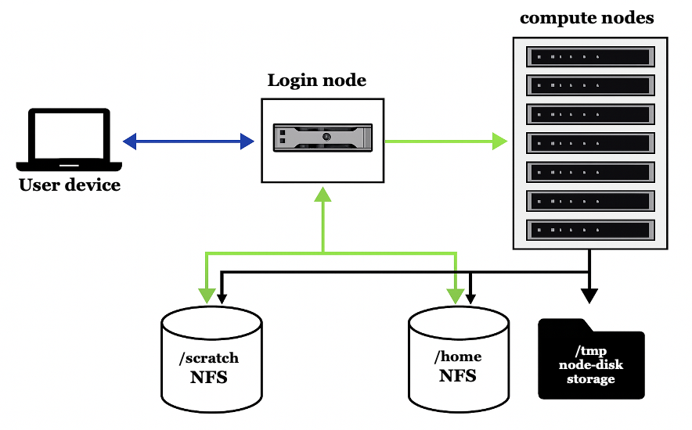
Figure 1: Architecture of the UVRI HPC cluster. Users connect from their devices via SSH to the login node (blue arrow), which provides access to compute resources and shared storage. The compute nodes execute jobs scheduled from the login node and have access to shared /home and /scratch directories via NFS (green arrows) as well as local /tmp storage on each node. This setup enables efficient job submission, shared data access and modular scaling.
However, the process of setting up the cluster with sustainability considerations required careful planning, collaborating and strategically managing the available resources. In this article, we share an account of the process, and ten simple rules derived from our experience at UVRI in building and sustaining a High-Performance Computing (HPC) cluster. These principles are organized across two implementation phases: planning and execution and grouped by four domains critical to success: people, collaboration, technical and strategy (Figure 2). The conceptual map serves as a guide for institutions navigating the complexities of deploying bioinformatics infrastructure under constrained conditions. These rules are not only applicable to institutions in low-income settings but can also serve as practical guidelines for any organization looking to build and sustain HPC infrastructure. From strategies for investing in human capital and leveraging collaborations to adopting open-source technologies and developing a sustainability plan, we provide an account of the steps we took and the lessons we learned along the way. Our aim is to provide a blueprint for other research institutions facing similar challenges to guide them in building HPC clusters that are functional, scalable and sustainable.
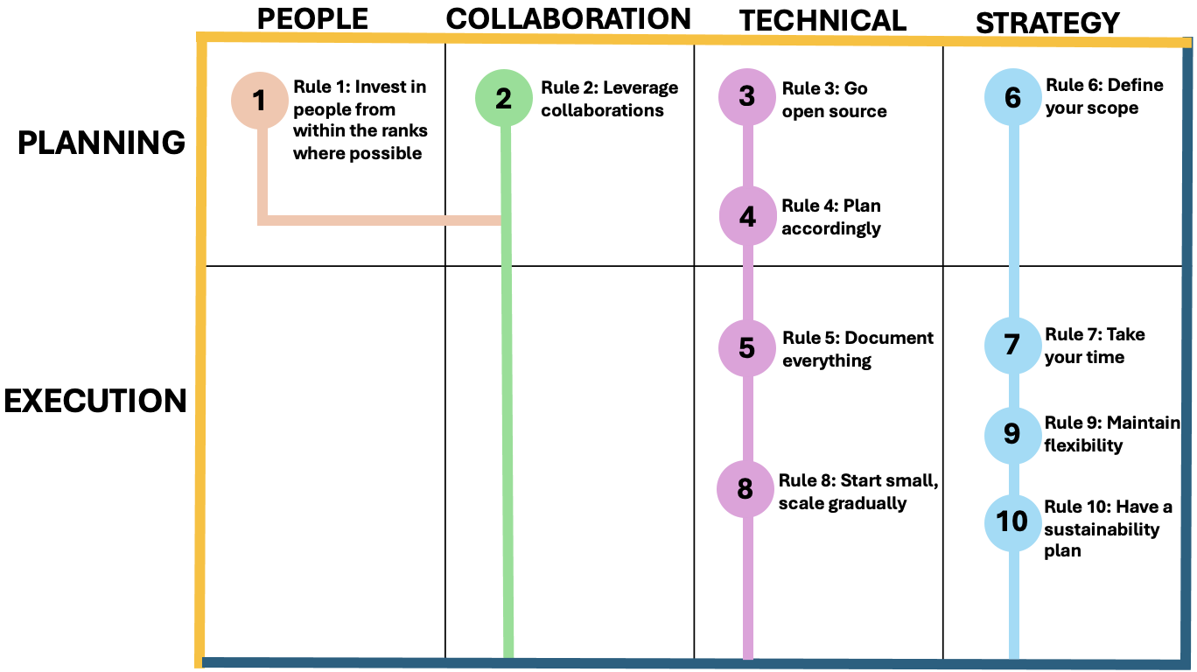
Figure 2: Conceptual map of 10 practical rules for building and sustaining an HPC cluster as a bioinformatics resource in resource-limited settings. Rules are categorized across four thematic domains: people, collaboration, technical and strategy and positioned along two implementation phases: planning and execution. This framework reflects lessons learned from UVRI’s experience, emphasizing local capacity, collaboration, open-source, flexibility and sustainability.
Rule 1: Invest in people from within the ranks where possible
The backbone of any successful High-Performance Computing (HPC) project is the people behind it. At UVRI, we adopted a home-grown capacity-building strategy, focusing on developing a core team of well-trained individuals from within our existing staff rather than recruiting skilled experts from the market. While this approach takes longer, it ultimately decreases reliance on expensive consultants or professional bioinformaticians while building local capacity to sustain efforts even when project funding ceases. This includes providing technical training and encouraging staff to continuously expand their knowledge through workshops, reading, and engaging with the broader HPC community. It's important to make these activities part of their deliverables. Attending seminars, technical meetups, and hands-on workshops enhances their expertise and ensures that the HPC cluster evolves with the latest trends and technologies. Institutions should treat this as an ongoing investment, where nurturing local talent pays off in long-term operational stability and innovation.
Our team at UVRI participated in various training opportunities to enhance their technical expertise and align with global HPC trends. Our team’s first hands‑on training started where every HPC journey begins, inside Linux. Owing to the institute’s sponsorship to Linux workshops and a significant dose of self‑study, we spent weeks tinkering with user management, job schedulers, shared storage and basic monitoring on a sandbox of freely available compute nodes, slowly demystifying the moving parts of a production‑grade system. The real breakthrough, though, came when we plugged into the quarterly virtual workshops for system administrators hosted by the HPC Ecosystems Project ³ at the Centre for High‑Performance Computing ⁷ (CHPC) in South Africa. These workshops provided hands-on experience with deploying a three-node virtual cluster using the OpenHPC2.x software stack https://events.chpc.ac.za/event/130/. Participants gained essential skills, including parallel computing concepts, compiling software and deploying a fully functional OpenHPC management server which could be migrated to a physical system. This program is delivered in a virtual classroom environment which allowed our staff to participate asynchronously, fitting neatly around their own time constraints and workloads. In addition to CHPC training, our team members took the CS6290: High-Performance Computer Architecture course ⁸ offered by the Georgia Institute of Technology as part of their Online Master of Science in Computer Science (OMSCS) program. This course covered advanced topics such as branch prediction, out-of-order execution, multi-level caches, and many-core processors. It equipped our team with the knowledge to optimize both software design and hardware architecture for improved performance. Investing in people has allowed us to build a team capable of adapting to new challenges and innovations to ensure long-term operational stability and growth.
Rule 2: Leverage collaborations
In resource-constrained settings, collaboration may be the lifeline that transforms an ambitious plan into a sustainable reality. Partnerships can provide access to equipment, technical expertise and support that would otherwise be beyond reach. Northern institutions often upgrade their equipment regularly, leaving behind used but still powerful machines that could be invaluable to institutions in the South. We experienced this firsthand when UVRI received servers from the Francis Crick Institute through the MUII program. These slightly used but highly functional servers were a major upgrade to our infrastructure that enabled us to build the foundation of our HPC cluster without the massive upfront costs of new equipment.
Notably, our bioinformatics infrastructure journey began with startup capacity provided by H3ABioNet, a network of African bioinformatics centers focused on building infrastructure and capacity for genomics research. Additionally, H3ABioNet made a significant contribution to the cluster by investing in critical upgrades to enhance the HPC's performance and capacity to ensure it could effectively handle the growing demands of genomic research in our ecosystem. However, collaborations are about much more than just receiving hardware donations. The long-term value of partnerships lies in the exchange of knowledge and expertise. For example, we leveraged our partnership with the H3ABioNet through the infrastructure working group. This working group provided valuable insights into how to design, manage and sustain HPC infrastructure in environments like ours. Their shared experiences, best practices and technical support have been instrumental in addressing challenges such as cluster configuration, software management and end-user support. H3ABioNet also developed consortium-wide guidance on optimal bandwidth requirements to support cross-consortium genomic analysis and data handling. UVRI adopted this guidance which became a critical element in ensuring that our infrastructure was equipped to handle large-scale genomic data collaborations effectively. We also established a close relationship with the HPC Ecosystems Project, an initiative that focuses on facilitating the deployment of HPC resources across Africa and providing training for HPC system administrators. Through this connection, UVRI gained access to vital technical support and training resources including quarterly virtual workshops on OpenHPC deployment and system management.
These collaborations extended beyond immediate technical support. They provided us with access to communities of experts who were facing or had already overcome the challenges we were grappling with. Additionally, these partnerships helped us navigate potential pitfalls by learning from the experiences of others. Partnerships with more advanced institutions turned what could have been a daunting resource-heavy endeavour into a manageable scalable success. From our experience, partnerships are vital not just for what they provide in the short term, but for the long-term knowledge exchange and community support that sustains HPC operations over time.
Rule 3: Go open source
Open-source software presents a compelling option for organizations in resource-constrained environments as it offers dual advantage: it is cost saving and offers access to vibrant supportive communities. At UVRI, choosing open-source solutions was a strategic decision driven by both financial considerations and the need to stay at the forefront of cutting-edge technology. While the lack of expensive licensing fees was an initial draw, the long-term benefits went far beyond cost.
One of the most significant advantages of open-source software is the community behind it. These communities are constantly evolving, with new tools being developed, tested and improved by a global network of users and contributors. After weighing our options, we opted for OpenHPC ⁹, an open-source platform that integrates various management and user tools into a comprehensive modular HPC solution. The decision was largely based on the extensive community support, ongoing development and the modularity of the OpenHPC framework. The OpenHPC community is particularly active in Africa through initiatives like the HPC Ecosystems Project. OpenHPC allowed us to build and manage a system that meets our immediate needs while providing the flexibility to scale as our research demands grew.
Beyond OpenHPC, we also embraced other open-source tools that supported the broader HPC ecosystem: a) Containerization - For containerized computing, we adopted Singularity ¹⁰, an open-source tool built for HPC environments that allows users to run applications in isolated environments. b) Monitoring the health and performance - we chose Ganglia ¹¹, another open-source tool to monitor our cluster in real time. Its lightweight nature and scalability made it ideal for our setup, providing a clear view of system load, network traffic, and resource utilization. c) To monitor usage patterns, benchmark performance and ensure the cluster was being utilized effectively, we deployed XD Metrics on Demand ¹² (XDMoD). This tool gives us insights into how users are engaging with the cluster and helps us allocate resources better.
The beauty of open-source software lies in the collaborative environment it fosters. At UVRI, being part of the OpenHPC community provided us with a wealth of knowledge, troubleshooting support and a continuous stream of updates that allowed our system to evolve with the latest advancements in HPC management. The support from such communities was particularly invaluable given our limited internal IT resources. Open source not only kept our operational costs low but also provided access to global expertise and innovations we would not have been able to achieve on our own. Ultimately, our decision to embrace open-source solutions allowed us to build a flexible, cost-effective HPC infrastructure that could grow and adapt over time, aligning with both our research goals and the needs of our users. It also reinforced our belief in the power of collaborative community-driven development which shall help sustain and enhance our HPC project well into the future.
Rule 4: Plan accordingly
The success of any HPC deployment hinges on thorough planning, with the end-goal in mind. It’s not enough to secure the right hardware; you also need to account for the environmental and operational conditions that will support it. For instance, do you have reliable power and cooling systems? What about human expertise to manage the cluster? It’s essential to anticipate these factors from the outset. At UVRI, we spent significant time understanding our technical infrastructure needs as well as the capacity of our IT team and end users. Planning also involves knowing who will be using the cluster and for what purposes, to ensure that the design meets those specific research demands. We conducted an extensive review of the types of research being conducted at the institute, including that coming in from collaborators, and the kinds of projects the HPC would need to support. This included projects related to genomics, bioinformatics, epidemiology and other computationally intensive domains. Our goal was to design an HPC system that would meet not just the needs of current users but could scale to accommodate future research directions as well. A crucial part of our planning was developing a business plan that outlined clear objectives, milestones, a phased-implementation approach and potential areas for expansion. The phased approach (discussed in detail in rule 9) allowed us to implement the cluster in stages, ensuring that each phase was feasible within our available resources while planning for future growth.
One of the first major challenges we faced was ensuring we had the right environmental infrastructure to support the cluster. HPC systems are power-hungry and generate a significant amount of heat which can lead to overheating and hardware failure if not managed properly. We are in a region where power fluctuations and outages are common, thus needed to make sure we had a reliable power supply including backup solutions before deploying our cluster. This involved setting up a solar-powered battery bank solution with two input feeds; the mains and the solar to ensure the cluster could continue running uninterrupted during power cuts but also with Uninterruptible Power Supply (UPS) functionality to protect the cluster from voltage surges. Cooling was another major consideration. Servers generate significant heat and without proper cooling systems, the risk of overheating could degrade the performance or even damage the equipment. Our planning included assessing airflow in the server room, calculating the cooling load and subsequently implementing a redundant robust cooling system to ensure that if one unit failed, another would take over.
Given the intensive data processing needs of genomic research and other computational tasks, having a fast and reliable network was critical to the success of the HPC cluster. Before deploying the servers, we upgraded our internal network infrastructure to support the high-speed data transfers that would be required. This involved installing a 10-gigabit Ethernet network to ensure low-latency communication between nodes. Our planning also took into account the data storage needs of the cluster. Genomic datasets are massive, often reaching terabytes in size. To manage this, we set up a high-performance hot storage system with sufficient capacity to handle current and scalability capacity to accommodate future research data. To ensure no data is lost in case of hardware failure, we have set-up a redundant data backup system. In addition to storage and networking, we also had to consider how data would be transferred to and from the cluster. Genomic projects often involve moving large datasets, sometimes from collaborators across institutional or national boundaries. We needed to plan for reliable and secure data transfer mechanisms and explored more efficient transfer tools, particularly Globus ¹³ and Aspera ¹⁴, which are designed for high-speed, secure and reliable transfers of large datasets. Another consideration was data retention. HPC storage is expensive and finite, and without proper retention policies, old data can accumulate and strain resources. We are developing guidelines for researchers on data lifecycle management; defining what should be kept long-term, what can be archived and what must be deleted after a certain period to ensure the system remains usable and sustainable over time.
Another key component of our plan involved ensuring we had the right people with the right skills to manage and operate the HPC cluster. At UVRI, we had IT staff who were proficient in basic system administration but managing an HPC system requires specialized knowledge in cluster management, workload scheduling and parallel computing. We realized early on that we needed to invest in building the necessary human capacity to run the cluster efficiently. To address this, we took advantage of several training opportunities within the HPC community. Beyond technical training, we also intend to emphasize cross-training within the broader UVRI research community. Our researchers are to be introduced to basic HPC usage, parallel computing concepts and how to submit jobs to the cluster to ensure they make efficient use of the system. Bringing researchers and IT into a shared understanding of the HPC system shall reduce the likelihood of operational bottlenecks and improve overall productivity.
Rule 5: Document everything
Proper documentation extends beyond recording technical setups, it is also about sharing experiences, challenges and solutions. At UVRI, we recognized early on that documentation would be key to the sustainability and long-term success of our HPC cluster. Our documentation process started during the initial planning phase and continued through deployment, training and daily operations. We created a wide range of materials, including: 1) User Manuals - To provide step-by-step guides for end users on how to interact with the HPC cluster. From basic job submissions to advanced parallel computing workflows, the user manuals cater to both novice and experienced users. 2) System Administrator Guides - To document everything from cluster setup and management to troubleshooting common issues. This documentation is not only invaluable as we onboard new team members so they can get up to speed quickly and independently but also facilitate a smooth handover in the event of staff changes. 3) Policy Documents - In addition to technical guides, we developed clear policy documents that govern the usage of the HPC resources. These policies defined acceptable use of the cluster, user access privileges, resource allocation and job scheduling priorities. To ensure equitable access to the HPC resources, the policies help users understand their responsibilities and the best practices for using the HPC cluster efficiently. 4) Training Materials - To complement our written documentation, we are currently developing a range of training materials including presentations, video tutorials and hands-on workshop content. Making these resources readily available empowers users to resolve issues independently reducing the burden on the IT team. 5) Troubleshooting Logs and FAQs - As our team navigated the challenges of deploying and managing an HPC cluster, we encountered various technical and operational issues. Rather than viewing these challenges as setbacks, we saw them as opportunities to build institutional knowledge. We kept a detailed log of all issues encountered including configuration errors, network failures, software bugs and hardware glitches. For each issue, we documented the troubleshooting steps taken and the eventual solutions, allowing us to create a comprehensive FAQ and troubleshooting guide. This resource will not only streamline future problem-solving but also contribute to our goal of knowledge sharing within the broader HPC community.
Good documentation is vital for ensuring continuity especially in environments with high staff turnover or limited technical expertise. At UVRI, we saw this as essential to maintaining the operational stability of our HPC cluster. By maintaining thorough records of our infrastructure, processes, and policies, we created a robust institutional memory. This ensures that even if key personnel leave, the knowledge they have gained remains within the organization, reducing the risk of operational disruptions and costly downtime. When new staff members or researchers join UVRI, they can refer to our comprehensive documentation to quickly familiarize themselves with the system, its policies and best practices. This reduces the learning curve and allows new team members to become productive much faster. Additionally, as new technologies and software are introduced to the cluster, we intend to update the documentation to ensure that the system remains relevant and continues to meet the needs of the user community.
Rule 6: Define your scope
Clear boundaries help prevent the HPC cluster from becoming overburdened and misused. It's essential to define who your target users are and which types of projects you will support. For UVRI, this meant identifying research areas that would benefit the most from HPC and ensuring that the infrastructure served those needs without spreading resources too thin. The cluster was designed to serve the following primary user groups and research areas: 1) Genomics and bioinformatics research - the primary users of the UVRI HPC cluster are researchers working on genomics and bioinformatics, particularly those involved in high-throughput sequencing data processing and analysis. This includes genome-wide association studies (GWAS), whole-genome sequencing (WGS), transcriptomics (RNA-seq) and variant calling for pathogen genomics. In addition to pathogen genomics, the HPC cluster also supports research in Malaria molecular surveillance (MMS) particularly in vector genomic investigations such as assessing population structure, identification of cryptic species and investigation of spread of mutations/ or variants conferring insecticide resistance. This work, which contributes to the growing field of vector control by genomic insights, is an under-serviced area that adds significant value to the cluster’s impact in public health research in the context of Malaria.
The scope extends to processing complex bioinformatics workflows that require intensive computation. 2) Infectious disease research - As UVRI is a key player in infectious disease research, the HPC cluster supports epidemiological and pathogen studies with a particular focus on diseases relevant to Uganda and the broader region. 3) Collaborative regional research initiatives - UVRI's HPC infrastructure also supports external collaborative research initiatives. These include eLWAZI ¹⁵, PANGEA ¹⁶, East African Vector Surveillance project - a joint UVRI, Kenya Medical Research Institute, Wellcome Sanger Institute and Liverpool School of Tropical Medicine research collaboration on embedding genomic surveillance into vector control trials and interventions where UVRI contributes computational resources to large-scale region-wide studies on population genetics, genomics of disease vectors and surveillance data. UVRI leverages the HPC cluster to support partner institutions that may not have local HPC resources particularly for collaborative analyses and bioinformatics capacity-building efforts. This includes projects where data sharing and multi-institutional analysis are key components of the research. 4) High-Performance Computing education and training - The cluster also serves as a training platform for building local capacity in computational biology, bioinformatics, and HPC system administration. Through partnerships and regional collaborations, the cluster can be used for hands-on training sessions. These include training for bioinformatics students and early-career researchers in using HPC for biological data analysis and technical workshops for IT staff in HPC administration. 5) Data-driven public health research - With the rise of data-driven research in public health, UVRI's HPC cluster is set up to also support projects that analyze large datasets for public health interventions. Computational modeling of disease outbreaks, health informatics and machine learning-driven public health studies are also supported.
Some of the key considerations in defining our scope included 1) Prioritization of critical research. We focused our computational resources on projects with high public health impact and relevance to Uganda and Africa to ensure the cluster is used efficiently for strategic research areas. 2) Controlled access and fair usage. To prevent the cluster from being overburdened, usage policies were implemented with clear criteria for access, prioritization based on project alignment with UVRI's strategic goals and resource allocation guidelines. 3) Modular expansion. Our scope allows for gradual scaling of the infrastructure. As new projects and collaborations emerge, additional resources can be planned for based on demand and funding availability, to ensure the cluster remains flexible but targeted in its purpose.
Rule 7: Take your time
Building an HPC cluster particularly in resource-limited settings is a time-consuming process and unrealistic deadlines often lead to suboptimal solutions. At UVRI, we adopted a patient approach, consulting widely and deeply at every stage of the process. This allowed us to gather feedback, assess various options and ultimately select solutions tailored to our specific needs and constraints.
Taking a measured and patient approach during the HPC cluster deployment process proved essential for ensuring long-term success. We discuss here two specific examples where this approach was applied: 1) Consulting with regional and international experts before configuring the hardware for the HPC cluster. We spent considerable time consulting with experts from the HPC Ecosystems, the H3ABioNet and RSSE ¹⁷. This provided us with invaluable insights into HPC design and deployment best practices for resource-constrained environments. These consultations included advice on hardware, optimal configurations and operational challenges. By taking time to gather this knowledge, we avoided common pitfalls such as selecting incompatible hardware components that could have increased costs and complexity. The result was a tailored infrastructure that fits the institute’s research needs without overshooting its operational capacity. 2) Phased rollout. We chose to adopt a phased rollout for the HPC cluster instead of deploying all available hardware and software at once. Initially, only a small number of servers from the machines donated by the Francis Crick Institute were deployed. This allowed the IT team to familiarize with managing the smaller setup, perform extensive testing and troubleshoot issues before scaling up to full capacity. This slow deliberate approach helped refine the system architecture, optimize resource allocation and ensure proper training for the IT staff in maintaining the system. As a result, by the time we scaled up to full capacity, we had built a stable and reliable foundation for ongoing operations.
Rule 8: Start small, scale gradually
Excitement about having a large, high-powered cluster can sometimes lead to overambitious plans. However, starting small allows for careful testing, learning and scaling as needed. At UVRI, we started with a small cluster of 5 nodes and used that initial setup to identify our actual computational needs. This approach not only reduced upfront costs but also provided a lighting phase where we could identify challenges and fine-tune the infrastructure. Starting small allows for a phased growth where you can scale the cluster in a modular way based on research demands and funding availability.
By adopting this strategy, we could make targeted upgrades over time to ensure each component of the system aligned with user requirements and available resources. A key part of our success was bringing on board other UVRI groups, which was made possible by having a conceptualized development plan in place and demonstrating our initial capacity on the ground. This created buy-in and showed the broader organization that the infrastructure could support not just genomics and bioinformatics research, but also other computationally intensive domains. Here’s how this strategy worked in our case (Figure 3).
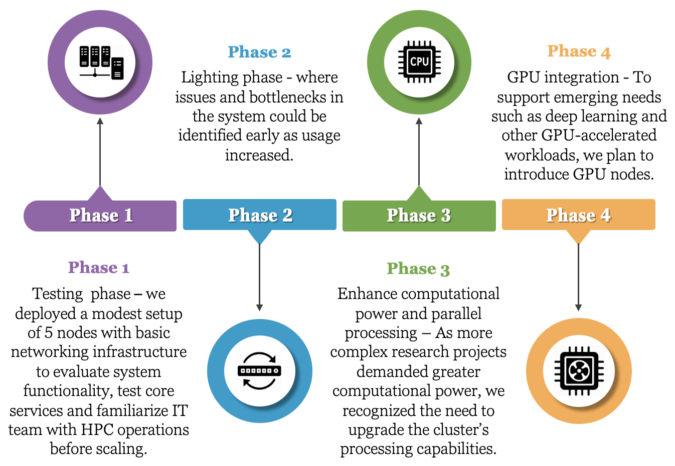
Figure 3: HPC growth strategy at UVRI. This diagram illustrates our four-phase approach to developing HPC infrastructure. The strategy began with a testing phase (Phase 1) using a modest 5-node setup to establish core functionality and build team capacity. Phase 2 involved fine-tuning the infrastructure in response to growing demand, including network upgrades and improved storage. In Phase 3, the focus shifted to enhancing computational power through gradual CPU upgrades for improved parallel processing. Phase 4 anticipates the integration of GPU nodes to support advanced workloads such as deep learning and image analysis.
Phase 1: Basic networking and a small number of nodes - In the initial phase, we deployed a modest setup of 5 nodes with basic networking infrastructure. This allowed us to test the waters by running simple computational tasks and ensuring that the foundational elements such as node communication and data transfer were functioning smoothly. The networking configuration was basic with all management services such as job scheduling and user authentication, hosted on a single node. This compact setup reduced complexity and allowed the IT team to get acquainted with managing the cluster before scaling up. Phase 2: Incremental upgrades as needs evolved - The second phase served as a "lighting phase," where issues and bottlenecks in the system could be identified early. For instance, as more researchers began to use the cluster, we observed challenges with networking speeds due to increased traffic between nodes. In response, we focused on upgrading the networking infrastructure by adding a 10gb ethernet switch and optimizing the network layout to improve data throughput and reduce latency between nodes. This phase also involved fine-tuning the storage setup to accommodate larger datasets, a need identified as users started running more data-intensive workflows. Phase 3: Enhancing computational power and parallel processing - As more complex research projects demanded greater computational power, we recognized the need to upgrade the cluster's processing capabilities. We intend to gradually replace older processors with more advanced multi-core CPUs to improve parallel processing performance. The approach allows us to scale up computational capacity incrementally without overwhelming the existing infrastructure. Phase 4: Introducing GPU nodes for specialized workloads - Once we reach a point where researchers need to run computationally intensive tasks involving machine learning and other GPU-optimized algorithms, we shall have entered the GPU phase. Rather than immediately invest in an expensive and fully-fledged GPU setup, the cluster will be expanded with a few specialized GPU nodes. This shall allow the research teams to begin exploring GPU-accelerated computing for specific tasks such as large-scale simulations and image analysis without overburdening the cluster with unnecessary hardware.
Each upgrade, whether related to networking, CPU performance or GPU capabilities, is driven by actual demand to reduce the risk of overinvestment and ensure the system is always aligned with user needs. This phased approach would also give the IT team the space to learn and adapt, making sure that when the time comes for each new phase, they have the experience and expertise to implement it effectively. Ultimately, this strategy results in a robust scalable HPC infrastructure that evolves as research needs and technical challenges grow over time.
Rule 9: Maintain flexibility in infrastructure and operations
Building an HPC cluster in a low-resource setting requires a flexible mindset. The needs of your user base, technological advancements and funding sources can shift over time and your infrastructure should be able to adapt to those changes. At UVRI, we quickly realized the importance of maintaining flexibility in both our technical setup and our operational processes. This meant choosing modular infrastructure components that could be easily upgraded and keeping our operational workflows open to adjustments as new technologies and demands emerged. Flexibility ensures that your HPC cluster can evolve alongside the research it supports to remain valuable and efficient over the long term.
Here are two key examples of how flexibility was implemented: From the outset, our HPC setup was designed with modularity in mind. Rather than committing to a rigid large-scale infrastructure from the start, we selected modular components that allowed for seamless upgrades. For instance, when we initially deployed the cluster, we started with a few nodes using basic networking. As the demands on the system grew—such as increased data processing and more users—we were able to add nodes incrementally, upgrade networking infrastructure, and expand storage capacity without needing to redesign the entire system. This modular approach meant we could scale up as needed without disrupting ongoing research or stretching our budget unnecessarily. When GPU-intensive research begins to emerge, we won’t overhaul the entire infrastructure. Instead, we shall add a few GPU nodes to handle specific computationally heavy tasks like deep learning and image analysis, leaving the rest of the system untouched for standard workloads. This allows us to cater to specialized demands without committing to a large investment in GPUs from the outset. On the operational side, we maintained flexibility by allowing our HPC management processes to evolve over time. Initially, we operated with a single management node that handled job scheduling, user management monitoring and data transfer. As the cluster usage increased and workflow systems, like Nextflow ¹⁸, Snakemake ^{19,20} and WDL²¹ for bioinformatics pipelines were introduced, the operational workflows had to be restructured to accommodate more complex needs. We also remained open to feedback from users and adapted our resource allocation policies and job scheduling systems accordingly. For example, when certain research groups require longer computational runtimes for large genomic datasets, we adjust the job scheduling policies to allow for different queue lengths and resource allocations. This flexibility ensures that the cluster remains useful and relevant to all users despite the diversity in their computational needs.
Rule 10: Have a sustainability plan
Sustainability should be baked into the DNA of any HPC project. It’s about more than just keeping the lights on, it’s about understanding your environment, your user base and the scope of your operations. It involves benchmarking against other institutions, especially established ones while tailoring plans to fit your local ecosystem. At UVRI, we recognized that sustainability was about more than just keeping the system operational, it required a multi-faceted strategy balancing between technical capacity, financial planning and community engagement. We benchmarked against other successful HPC initiatives with intent to tailor a sustainability model that would work within our specific context, considering the long-term technical and operational upkeep of the HPC infrastructure. We also focused on understanding our user community’s needs, skills and potential, ensuring that our infrastructure was built to support them in a meaningful, lasting way.
Our long-term sustainability plan translated to a need for a financial model that fits our unique environment. We focused on: 1) A clear pricing model - Drawing from the cost-recovery approaches observed in the benchmarked institutions, we developed a pricing structure for users of the HPC cluster. This was designed to balance affordability with the need to maintain and upgrade the system. One of our key benchmarks was the ACE (Africa Center of Excellence) ²² cluster at the Infectious Diseases Institute (IDI) at Makerere University which provided a close-to-home example of an HPC system serving a similar research community in Uganda. The ACE cluster's sustainability plan is built on a robust cost-recovery model. 2) Institutional buy-in - Securing the support of UVRI leadership was a crucial element of our sustainability plan. The key to this was bringing on board other UVRI groups which was made possible by having a conceptualized development plan in place and demonstrating our initial capacity on the ground. This created buy-in and showed the broader organization that the infrastructure could support not just genomics and bioinformatics research but also other computationally intensive domains. By demonstrating the potential impact of the HPC cluster on research output and grant acquisition, we were able to secure both financial backing and administrative support for its ongoing operation. Additionally, we leveraged the HPC resource to attract grants and establish partnerships, staging the cluster as an integral part of UVRI’s broader research ecosystem and future growth. 3) Knowledge management - we also drew significant insights from the CHPC. The CHPC operates on a large scale, serving as a regional HPC hub for various African research institutions but their focus on sustainability through community-building and skills transfer was particularly inspiring. Through the HPC Ecosystems Project, CHPC emphasized not just the deployment of hardware but also the training of HPC professionals in partner institutions to foster long-term sustainability through knowledge transfer. UVRI adopted this approach by investing in the training of system administrators to ensure that local capacity could manage and grow the cluster over time. 4) Long-term planning - Our sustainability plan also accounted for the evolving needs of our user base. As more researchers at UVRI and partner institutions began utilizing the HPC cluster for larger complex projects, we anticipated that demand for compute resources would increase. We structured our pricing and operational plans to be flexible to allow for phased expansion of the cluster based on research needs and funding availability.

Applications in bioinformatics
The UVRI cluster was purpose-built to support the increasing computational demands of genomic research in Africa, particularly in the fields of vector biology, pathogen surveillance, and public health genomics. Since its deployment, it has become a key resource enabling scientific discovery, workforce development, and health systems strengthening. We describe three representative use cases that highlight its direct scientific impact.

1. Viral metagenomics for emerging and re-emerging pathogen surveillance
The high-performance computing (HPC) infrastructure at UVRI has supported a range of viral genomics applications enabling early detection and monitoring of emerging and re-emerging viral pathogens in Uganda which is key in outbreak preparedness and response. It powered the analysis of SARS-CoV-2 genomic data to track viral evolution, including studies that documented the rapid replacement of earlier lineages by the Delta variant and the subsequent emergence of Omicron ²³. The platform has also been instrumental in pathogen surveillance efforts. In 2023, metagenomic analyses conducted on the cluster identified anthrax as the cause of a previously unexplained deaths in Uganda ²⁴. Similarly, it enabled assembly of Mpox virus genomes from the first confirmed Mpox cases during the 2024 outbreak in Uganda ²⁵. Beyond outbreak response, the platform has supported researchers working on HIV vaccines studies to conduct structural modelling to identify clade-specific HIV-1 in African children ²⁶. The platform has been used for development of portable tools for analysis of next-generation sequencing (NGS)-based HIV drug resistance testing data ^{27,28}.

2. Amplicon sequencing for Malaria molecular surveillance
The cluster is routinely used to analyze targeted deep sequencing data generated for the molecular surveillance of malaria. These include investigations of insecticide resistance markers based on Anopheles gambiae s.l. amplicons ²⁹. An automated pipeline co-developed with colleagues at LSTM using Snakemake, papermill and Jupyterbook manage tasks such as demultiplexing, read alignment, variant calling and rendering of an analyes book used to generate results. These analyses are intended to inform national malaria control strategies and are integral to ongoing genomic surveillance activities in East Africa.

3. Data science initiatives
Among several data science initiatives, of unique value is the testing and implementing GA4GH standards as part of a multi-site collaboration involving UCT (South Africa), ACE-Uganda, ACE-Mali, and UVRI ³⁰. The aim is to set up three interconnected servers that mirror production environments at each site. We're currently working with three core GA4GH standards: Data Connect, DRS, and WES with plans to integrate passports for access control later. For now, access is managed using firewall rules that restrict traffic to just the participating nodes. As a use case, the ACE2 region was selected from the 1000 Genomes Project CRAM files, indexed them and split the dataset into four batches. Each batch is hosted on a DRS server corresponding to a partner site. A central Data Connect server holds access metadata for all CRAM files across the four DRS servers. Users can query this server using fields like sample ID, population group, super population group and sex and then submit selected CRAMs to a WES endpoint for analysis. The WES workflow processes the input and generates a combined MultiQC report.
These real-world applications illustrate our cluster’s foundational role in advancing bioinformatics-driven research, generating actionable insights and supporting the development of computational genomics capacity in Africa.
Conclusion
Building an HPC cluster in a resource-limited setting requires more than just hardware, it requires a clear strategy, collaboration and a commitment to sustainability. The ten rules presented in this article are derived from our experience at UVRI. These rules encapsulate the essential strategies and practices that have enabled us to overcome challenges and achieve success in a resource-constrained setting while offering a practical roadmap for institutions undertaking similar projects. Each rule emphasizes a critical aspect of the process from understanding the importance of a clear identity to the value of partnerships, training and sustainability. From the outset, investing in people, leveraging collaborations and utilizing open-source tools are essential steps in ensuring the success of an HPC cluster. Understanding the environment, strategic planning and defining the scope of operations help to mitigate risks and avoid common pitfalls.
What’s clear is that building an HPC cluster is a marathon, not a sprint. By starting small, scaling gradually and continually engaging with stakeholders, resource-constrained institutions can build resilient and effective HPC environments that serve their research goals. Sustainability, both financial and operational, must be considered at every stage. A well-thought-out sustainability plan that includes capacity building, partnerships and institutional buy-in will ensure that the HPC infrastructure remains relevant and impactful for the foreseeable future. We hope that the insights shared in this article will inspire and guide other institutions as they navigate the complex yet rewarding multifaceted journey of building HPC clusters. With the right approach, even in resource-limited settings, HPC can become a powerful tool for advancing research and innovation.

Key Points
While establishing an HPC cluster in resource-limited settings is feasible, it demands strategic planning, a defined scope of operations and a focus on long term sustainability anchored on local capacity building, community building, institutional buy-in and financial foresight.
Strategic collaborations and leveraging open-source tools play a critical role in overcoming resource constraints while investing in local talent fosters readily available local support that is essential for the effective operation and maintenance of an HPC cluster.
Having a development plan based on a phased approach (start small and scale strategically) helps mitigate risks while enabling institutions to adapt infrastructure to growing research demands.
Our experience provides a roadmap for institutions in similar resource-constrained settings, demonstrating how to navigate challenges and build robust bioinformatics infrastructure.
Through innovative and cost-effective strategies, HPC clusters can significantly strengthen bioinformatics capabilities to galvanize genomics and other data-intensive research agenda in low-resource environments.
Funding
This work was supported through various research and capacity building initiatives over the years including contributions from the following sources: The H3ABioNet from NIH grant numbers 1U41HG006941-01 and U24HG006941; MUII from WT grant numbers 084344 and 100400; MUII-Plus and THRiVe-2 DEL-15-011 DELTAS WT grant number 107743/z/15/z; and funding from the Government of Uganda to UVRI.
Acknowledgments
We extend our heartfelt gratitude to partners and initiatives that have supported our journey in building an HPC cluster at the Uganda Virus Research Institute. We thank the H3ABioNet consortium for their invaluable startup investment, capacity-building efforts and technical support and the eLwazi Open Data Science Platform for fostering collaboration and knowledge sharing. Our appreciation also goes to the DS-I Africa program for its contributions to advancing data science in the region and the MUII Program for its investment in capacity development. We acknowledge the Thrive program for its resource support and the Francis Crick Institute for its generous contributions toward our infrastructure. Special thanks to the Liverpool School of Tropical Medicine (LSTM) and the Bill & Melinda Gates Foundation for their roles in shaping our infrastructure and HPC Ecosystem Project for technical skills development of our HPC management team. Your collective efforts have been instrumental in our progress and success.

References
1. Abiona, O., Onime, C., Cozzini, S. & Hailemariam, S. Capacity building for HPC Infrastructure setup in Africa: The ICTP experience. 2011 IST-Africa Conference Proceedings, IST 2011 (2011).
2. Amolo, G. The Growth of High-Performance Computing in Africa. Comput Sci Eng 20, 21–24 (2018).
3. Johnston, B., Timm, L., Macleod, D. & Poole, J. Ten Years of the HPC Ecosystems Project - Transforming HPC in Africa for the past decade. in Practice and Experience in Advanced Research Computing 2024: Human Powered Computing (Association for Computing Machinery, New York, NY, USA, 2024). doi:10.1145/3626203.3670537.
4. Mulder, N. et al. H3ABioNet, a sustainable Pan-African Bioinformatics Network for Human Heredity and Health in Africa. Genome Res 26, gr.196295.115 (2015).
5. Francis Crick Institute https://www.crick.ac.uk/.
6. MUII program https://www.muii.org.ug/.
7. Centre for High-Performance Computing (CHPC) https://chpc.ac.za/.
8. High-Performance Computer Architecture course, Georgia Institute of Technology https://omscs.gatech.edu/cs-6290-high-performance-computer-architecture.
9. Baird, R., Schulz, K., Simmel, D., Sundararajan, N. & Hensbergen, E. Getting Started with OpenHPC. Preprint at (2023).
10. Kurtzer, G., Sochat, V. & Bauer, M. Singularity: Scientific containers for mobility of compute. PLoS One 12, (2017).
11. Massie, M., Chun, B. & Culler, D. The Ganglia Distributed Monitoring System: Design, Implementation And Experience. Parallel Comput 30, 817–840 (2004).
12. Palmer, J. T. et al. Open XDMoD: A Tool for the Comprehensive Management of High-Performance Computing Resources. Comput Sci Eng 17, 52–62 (2015).
13. Globus. (n.d.). Fast, reliable research data transfer. Retrieved June 2025, from https://www.globus.org/data-transfer.
14. IBM Aspera. (n.d.). High-speed data transfer for the enterprise. Retrieved June 2025, https://www.ibm.com/products/aspera.
15. eLwazi Open Data Science Platform https://elwazi.org/.
16. Pillay, D. et al. PANGEA-HIV: Phylogenetics for generalised epidemics in Africa. The Lancet Infectious Diseases vol. 15 259–261 Preprint at https://doi.org/10.1016/S1473-3099(15)70036-8 (2015).
17. Research Software & Systems Engineers of Africa https://rsse.africa/.
18. Di Tommaso, P. et al. Nextflow enables reproducible computational workflows. Nat Biotechnol 35, 316–319 (2017).
19. Köster, J. & Rahmann, S. Snakemake—a scalable bioinformatics workflow engine. Bioinformatics 34, (2018).
20. Mölder, F. et al. Sustainable data analysis with Snakemake. F1000Res 10, 33 (2021).
21. OpenWDL. Workflow Description Language. https://openwdl.org.
22. ACE – African Center of Excellence in Bioinformatics & Data Sciences https://ace.ac.ug.
23. Bbosa, N. et al. Rapid Replacement of SARS-CoV-2 Variants by Delta and Subsequent Arrival of Omicron, Uganda, 2021. Emerg Infect Dis 28, (2022).
24. Bbosa, N. et al. Identification of Anthrax as the Cause of a Cluster of Unexplained Deaths, Uganda, 2023: The Role of Metagenomic Next-Generation Sequencing and Postmortem Specimens. American Journal of Tropical Medicine and Hygiene 112, 835–839 (2025).
25. Bbosa, N. et al. Case Reports of Human Monkeypox Virus Infections, Uganda, 2024. Emerg Infect Dis 31, (2024).
26. Kyobe, S. et al. Identification of a Clade-Specific HLA-C*03:02 CTL Epitope GY9 Derived from the HIV-1 p17 Matrix Protein. Int J Mol Sci 25, 9683 (2024).
27. Ssekagiri, A. et al. HIVseqDB: A portable resource for NGS and sample metadata integration for HIV-1 drug resistance analysis. Bioinformatics Advances 4, (2024).
28. Ssekagiri, A. et al. QuasiFlow: a Nextflow pipeline for analysis of NGS-based HIV-1 drug resistance data. Bioinformatics Advances 2, (2022).
29. Nagi, S. C. et al. Targeted genomic surveillance of insecticide resistance in African malaria vectors. Preprint at https://doi.org/10.1101/2025.02.14.637727 (2025).
30. https://github.com/elwazi/elwazi-pilot-node-install .

