Hepatitis B Virus Research in Sierra Leone: A Scoping Review Highlighting the lack of Epidemiological Evidence and Research Gaps
Authors and affiliations:
Wachen Newhon Peters ^{1&}, Julian S O Campbell², Abass Wurie², Alhaji U. Njai¹, Isatta M. Wurie¹

Faculty of Medical Laboratory & Diagnostic Sciences, University of Sierra Leone, Sierra Leone; RAMSY Medical Laboratories, Freetown, Sierra Leone; School of Postgraduate Studies, University of Sierra Leone

&Corresponding Author
Wachen Newhon Peters, Faculty of Medical Laboratories & Diagnostic Sciences, School of Post Graduate Studies, University of Sierra Leone; Telephone: +232 99284344; Email: wachenn.peters@usl.edu.sl

Abstract
Introduction: Hepatitis B virus (HBV) remains a major public Health problem in sub-Saharan Africa, where the burden of chronic infection is a major cause of liver cirrhosis and hepatocellular carcinoma. Although Sierra Leone is considered highly endemic for HBV, the extent, characteristics, and evolution of HBV research conducted in the country have not been comprehensively evaluated. This scoping review mapped the available evidence on HBV research in Sierra Leone, identified research trends, and highlighted existing knowledge gaps, particularly in molecular epidemiology and genotypic characterization.
Methods: We use the Arksey and O’Malley’s strategy to conduct a comprehensive scoping review of Hepatitis B literatures using Pubmed, Google Scholar, Semantic Scholar, Oipub, Litmaps, and R. Additional unpublished reports were sought from universities, the Ministry of Health Hepatitis unit, and other relevant sources. HBV-related studies conducted in Sierra Leone and published between 1997 and 2024 were primarily screened for eligibility with limited landmark outside this period included where relevant. The focus of this study was to identify information on study design, methodology, study population, and geographical locations. Findings were extracted into Microsoft excel and descriptively analyzed in RStudio v2026.04.0+526. As this review aimed to map the available evidence, Methodological quality assessment of individual studies was not performed.
Results: Forty-five studies (N=45) on Hepatitis B virus (Table 1) met the inclusion criteria and were reviewed. The research studies increased over time from 1997 to 2024, peaking in 2023 (27%; N=12). The studies showed variation in thematic focus (Figure 10) and the most common theme was prevalence (N=22). This theme was also the most common across region while knowledge assessment, vaccination etc. were concentrated in specific regions (Figure 11). Research was geographically concentrated in Freetown (44.4%; N=20) and Bo (18%, N=8), with a few nationwide studies (11%; N=5). The immunochromatography test method (46%) predominated the studies where the presence of HBsAg indicated positive HBV infection and this method was frequently used to determine prevalence (Figure 12) No study employed HBV genotyping despite the few PCR studies (8%). Reported prevalence ranged from 2% to 35% (median of 12-15%) and outliers up to 70%.
Conclusion: HBV research in Sierra Leone has expanded considerably over the past three decades, particularly in seroepidemiology and public health. However, this study highlights gaps in molecular epidemiology including published evidence on HBV genotype and genomic surveillance. Strengthening molecular diagnostic capacity, expanding PCR and sequencing infrastructure, and integrating molecular surveillance into national Hepatitis programmes should be prioritized to support evidence-based clinical management and progress toward the World Health Organization’s 2030 viral hepatitis elimination targets. This screening provides intending Biomedical researchers in Sierra Leone with the frontline information on where Sierra Leone lies in terms of HBV research and what can be done.

Keywords: Hepatitis B virus, Sierra Leone, scoping review, Genotype, Co-infection, Prevalence, Public Health, Molecular Epidemiology

- Introduction

Hepatitis B virus infection remains one of the leading causes of chronic liver disease worldwide and poses a major public health challenge in countries despite the availability of effective vaccines and antiviral therapies. An estimated 1.5 million new Hepatitis B virus (HBV) infections occur annually, where chronic infection reported as a major cause of liver cirrhosis and hepatocellular carcinoma, globally (HCC) (1,2). HBV remains a leading cause of liver-related morbidity and mortality, accounting for more than 820,000 deaths annually (3).
The burden of HBV is greatest in sub-Saharan Africa and the Western Pacific Region, which together account for the majority of people living with chronic HBV infection (4). Although global vaccination programmes have reduced HBV transmission in many settings, the prevalence of chronic infection remains high across much of West Africa, where several countries continue to meet the World Health Organization(WHO) definition of high endemicity based on hepatitis B surface antigen(HBsAg) prevalence(4-6).
Within West Africa, Sierra Leone continues to experience a high HBV burden (7). Published studies have documented HBV infection across diverse population groups including blood donors, pregnant women, healthcare workers, people living with HIV, and the general population. These studies have contributed important information on HBV seroprevalence, diagnostic approaches, vaccination, and clinical management. However, the overall pattern of HBV research conducted in Sierra Leone, including its geographical distribution, methodological approaches, and thematic focus, have not been reviewed.
In addition, although neighboring West African countries have increasingly incorporated molecular epidemiology into HBV research through polymerase chain reaction (PCR), sequencing, and genotype surveillance, comparable information remains limited in Sierra Leone. Understanding the existing body of HBV research and identifying gaps in molecular characterization are important for guiding future research priorities, strengthening surveillance, informing national hepatitis control programs, and supporting national progress towards the WHO target of eliminating viral hepatitis as a public health threat by 2030.
This scoping review therefore aimed to map the published evidence on HBV research conducted in Sierra Leone, describe research trends and methodological characteristics, and identify key gaps requiring further investigation, with particular emphasis on molecular epidemiology and HBV genotypic research.

- Approach and Methodology
A comprehensive literature search was conducted using six(n=6) electronic databases: Litmaps, R Discovery, Oipub, Pubmed, Google Scholar, and Semantic Scholar. The search strategy combined terms related to hepatitis B virus and Sierra Leone. For Pubmed, Medical Subject Headings(MeSH) and free-text terms were used, including "hepatitis b virus" AND "Sierra Leone". Equivalent keyword searches were done for other databases.
Published HBV-related studies conducted in Sierra Leone between 1997 and 2024, were considered for inclusion in this review. Eligible studies were those primarily focused on hepatitis B virus(HBV) in Sierra Leone, including studies conducted within the country or those reporting HBV-related findings from Sierra Leone. In addition, unpublished reports and relevant documents from universities, the Ministry of health and other available sources were examined to identify additional evidence not indexed in electronic databases. Studies that did not primarily focus on Sierra Leone, were not related to HBV, were duplicate records, or did not contain sufficient information relevant to the objectives of this review were excluded. An initial 53 studies were identified following the literature search. After screening, eight studies were excluded because they were duplicates or were not conducted in Sierra Leone, resulting in 45 relevant studies (Table 1) being included in the study. Information extracted from each eligible study included the study title, authors, year of publication, study design, methodology, study population, geographical location, and principal findings. These data were entered into an Excel spreadsheet for organization and subsequent descriptive analysis.
Descriptive analysis and data visualization were performed using RStudio. For data synthesis, the included studies were grouped according to research themes, study design, diagnostic methodology, study population, geographical location, and year of publication to identify research trends and knowledge gaps in HBV research in Sierra Leone. Because the objective of this scoping review was to map the available body of HBV research conducted in Sierra Leone and identify research gaps, methodological quality assessment of individual studies was not performed.
- Result
Overview of Included Studies
A total of 45 relevant studies (Table 1) on HBV in Sierra Leone, published between 1997 and 2024 were identified and reviewed. Of these, 95% (n=43) were retrieved from Google Scholar, while 13% (n=6) were indexed in both PubMed and Google Scholar, and only one study was exclusive to PubMed. Data was pooled into a Microsoft excel spreadsheet.
3.1 Publication Trends and Research Themes
The publication trend showed a gradual increase in HBV research between 1997 and 2024, with the highest number of studies ( N=12) published in 2023, indicating a growing interest in HBV research in recent years (Figure 1). The most frequent research theme was prevalence (N=22) followed by knowledge assessment and factors influencing treatment (Figure 10).
3.2 Geographic Distribution of Research
This scoping review examined HBV-related studies conducted in Sierra Leone, a West African country with an estimated population of 8.7million people in 2024 (WHO, 2024). Sierra Leone is divided into five administrative regions: Western Area, Northern, Southern, Eastern, and North-Western regions, comprising 16 districts. The major urban cities include Freetown (the Capital), Bo, Kenema, Makeni, and Koidu (Figure 2). The included studies were conducted across several regions of Sierra Leone with Freetown accounting for the highest proportion (44.4%,n=20). Studies conducted in Bo and Nationwide contributed (11.1%, n=18) followed by Kono and Makeni each with (6.7%,n=3) (Figure 3). Two (4.4%) studies were conducted outside Sierra Leone while the remaining studies included multi-region investigations, single studies from Kenema and Tonkolili, one study spanning Sierra Leone, Liberia and Guinea, one web-based study (2.2%).

3.3 Screening and Diagnostic Approaches
Methodology information was available for 43 out of 45 studies included in the review. Immunochromatography was the most frequent (n=17) (Figure 4) methodology followed by secondary data analysis (n=3). Structured questionnaire interviews, immunochromatography combined with PCR and immunochromatography combined with agglutination were each reported in three studies. Chemiluminescent microparticles immunoassay were used in two studies were ELISA , PCR and Immunochromatography combined with ELISA were each reported in this study.
3.4 Populations examined across studies
The studies investigated a broad range of population groups. HBV screening and patient-based studies and HIV screening and people living with Hepatitis B(PWHB) each accounted for the largest proportion of the included studies (13.3%,n=6) followed by blood donors (11.1%,n=5). Antenatal attendees, febrile patients and healthcare workers each represented 8.9 (,n=4) of the studies while adults and children each accounted for 6.7% (n=3). Students and women each contributed 4.4% (n=2). The remaining population including asymptomatic patients, couples, ebola survivors and health care workers, mixed populations, people living with HIV (PLHIV) and youths were each represented by a single study 2.2% (Figure 5).
3.4 HBV prevalence findings across populations and settings
Pooled data from the 45 studies revealed a wide variation in HBV reported prevalence ranging from 0.8% to 70% (Figure 6). The highest prevalence was reported by Yendewa etal. 2023 (70.0%) followed by Yambasu et al. 2023 64.6% while the lowest prevalence was reported by Yi et al. 2019 (0.8%). Most studies reported HBV prevalence estimates below 25%, although substantial variability was observed across study populations and settings (Figure 6).

The studies showed 22 out of 45 studies focused on prevalence of HBV in all major cities (Figure 7). To determine prevalence, seven studies used immunochromatography method, seven used pooled data from secondary data, three used both immunochromatography and agglutination, two used both Immunochromatography and Polymerase chain reaction (PCR),one used both immunochromatography and Enzyme linked immunosorbent assay(ELISA) and two used chemiluminescent microparticle immunoassay(Figure 8) The study also showed that HBV prevalence study has been done in all the major cities in Sierra Leone (Figure 9). A review of the included studies showed that HBV prevalence has been examined across several population groups.. The highest number of prevalence studies focused on blood donors (n=5), followed by health care workers, people living with HIV, individuals screened for HBV, and patient populations (Figure 10).
The distribution of research methodologies across the location is presented in Figure 11. Immunochromatography was the most frequently reported methodology and was predominantly used in studies in Freetown (n=12), with fewer conducted in Bo(n=4) and other locations. Analysis of secondary data was the second most common methodology, with the highest frequency also reported in Freetown(n=4). PCR, ELISA, structured questionnaire interviews, agglutination, chemiluminescent microparticle assay were less frequently reported and were identified in a limited number of geographical locations. Overall, Freetown exhibited the greatest diversity and frequency of research methodologies among the included studies.
- Discussion
This review examined a broad spectrum of HBV-related literature in Sierra Leone, covering multiple research themes, testing methods, geographic locations, and population groups. Collectively, the studies have contributed to understanding the epidemiology, diagnosis, and clinical implications of HBV across the country. The reviewed literature included cross-sectional, prospective, retrospective, longitudinal, meta-analytic, and review studies, with topics ranging from HBV seroprevalence and diagnostic approaches to knowledge assessment, treatment-related factors, and HBV co-infection.
The number of HBV-related publications in Sierra Leone increased steadily over the review period, with the greatest research output occurring in 2023. This upward trend suggests increasing national and international interest in HBV following expansion of the viral hepatitis programmes, improved research collaborations, and greater recognition of HBV as a significant public health problem. The increase in publication output is encouraging and reflects growing research capacity within the country, although sustained investment will be required to maintain the momentum.
Most HBV studies were conducted in Freetown, followed by Bo, while comparatively few investigations originated from other districts. The geographical concentration reflects the location of major referral hospitals, universities, diagnostic laboratories, and teaching hospitals within these urban centers. Consequently, populations living in several rural districts remain underrepresented in the published literatures, limiting the availability of nationally representative epidemiological data. Future multicenter studies involving all regions in Sierra Leone would provide a comprehensive understanding of HBV distribution across the country.
The reviewed studies included diverse population groups, with the greatest emphasis placed on HBV screening and patient populations, people living with HIV, blood donors, healthcare workers and pregnant women. These groups are recognised as important populations for HBV screening because of their increased risk of infection, transmission, or disease progression. However, relatively few community-based investigations involving the general populations, children and adolescents were identified. Broader population-based studies are therefore required to better define the national epidemiology of HBV in Sierra Leone.
Across the literature, HBV has been studied in diverse population groups, including adults, children, health care workers, people living with HIV or HBV, pregnant women, blood donors, and other patient populations. The studies used several diagnostic and analytical approaches, including immunochromatography, agglutination, ELISA, PCR, and secondary data analysis. The findings highlight both the progress of HBV research in Sierra Leone and the growing contribution of Sierra Leone-based evidence to broader questions about HBV epidemiology, diagnosis, and treatment.
Serological assays, particularly immunochromatography HBsAg testing represented the predominant diagnostic approach across the reviewed studies. Although several investigations incorporated ELISA or PCR for confirmatory testing, molecular techniques were rarely employed. The widespread dependence on serological methods reflects the limited availability of molecular diagnostic infrastructure in Sierra Leone during much of the study period. While these approaches are appropriate for routine screening and prevalence estimation, they cannot provide information on viral genotype, genomic diversity, antiviral resistance and transmission dynamics. This diagnostic limitation largely explains the absence of published molecular epidemiological studies identified in this review.
This pattern differs from trends reported in parts of West Africa. For example, HBV prevalence in neighboring Liberia and Guinea have been reported as 10% (8) and 7.54-21.665% (9), respectively; however, both countries have over the years mostly used serological detection methods. Similarly, The Gambia, Nigeria, Ghana, and Senegal have also contributed significant HBV epidemiological research data from seroprevalence to molecular analysis including HBV genotypes (10-12). Nonetheless, this scoping review shows a significant gap in Hepatitis B virus (HBV) research in Sierra Leone, particularly regarding molecular characterization and genotypic data. While seroprevalence studies have been significantly represented in the country, with most research concentrated in Freetown and Bo, there remains an absence in genotype–focused studies.
This disparity highlights both an opportunity and a challenge: Sierra Leone’s HBV burden has been documented through serological studies, but the evidence of the country’s molecular HBV landscape remains unknown. As other West African countries begin integrating molecular biology into HBV surveillance and treatment programs, Sierra Leone risks falling further behind in meeting the WHO 2030 HBV elimination targets. In response, the Ministry of Health in Sierra Leone released a national viral hepatitis B strategic plan in 2024, which aims to eliminate HBV as a public health threat by 2030 and reduce the national burden to 50% (13).
The implications of this evidence gap extend beyond Sierra Leone. Increasing regional and international travel, migration and cross-border activities facilitates the movement of HBV across national boundaries, underscoring the need for robust surveillance systems. Although the risk of transmission may vary across population due to epidemiological settings, previous studies have reported that strengthening HBV surveillance, screening, and molecular characterisation among mobile populations is an important strategy for achieving the World Health Organization’s 2030 goal(4). Consequently, strengthening molecular epidemiological surveillance in Sierra Leone would not only support national hepatitis control efforts but also contribute to regional surveillance and the broader global objective of eliminating viral hepatitis as a public health threat by 2030.
Conclusion
This scoping review demonstrates progress in HBV research in Sierra Leone over the past three decades, with studies spanning multiple research themes, methodologies, geographical regions and populations groups. However, it also identifies a critical gap in HBV molecular epidemiology, with no published studies reporting HBV genotype, genomic variation or molecular surveillance despite the country’s high endemicity.
This shortfall limits clinical precision and undermines the national strategic plan of Sierra Leone. Drawing from broader regional trend, it is evident that countries making progress towards HBV control and elimination have invested in national PCR and sequencing infrastructure, multicenter genotyping surveillance studies and integration of molecular findings into clinical findings and vaccine programs. To align with this and meet the countries’ national strategic key action 2.1.3 which focuses on increasing testing and access to care, Sierra Leone must prioritize molecular HBV surveillance. Ultimately, without shift towards genotype-informed HBV research and management, Sierra Leone risks perpetuating a gap between knowledge and action. Bridging this divide will require sustained scientific investment and collaborative networks to ensure that every case of HBV in the country is diagnosed, genotyped, and treated according to international best practices.
Competing Interest
The authors declare no competing interests
- Author’s Contribution
Conceptualization: Wachen Newhon Peters, Alhaji Njai, Isatta Wurie; Data Collection: Wachen Newhon Peters; Data Analysis: Wachen Newhon Peters, Julian S O Campbell, Abass N S Wurie; Funding Acquisition: Alhaji Njai, Isatta Wurie; Investigation: Wachen Newhon Peters; Methodology: Wachen Newhon Peters, Alhaji Njai, Isatta Wurie; Project Administration: Wachen Newhon Peters, Alhaji Njai, Isatta Wurie; Supervision: Alhaji Njai, Isatta Wurie; Validation: Alhaji Njai, Isatta Wurie; Writing-Original Draft: Wachen Newhon Peters; Writing- Review and Editing: Wachen Newhon Peters, Alhaji Njai, Isatta Wurie, Julian S.O. Campbell, Abass N.S. Wurie. This manuscript has been read, reviewed, and approved by all authors listed above.
- Acknowledgement
All funding for this study was provided by the West Africa Health Organization (WAHO), ECOWAS. The authors would like to thank the administration of College of Medicine and Allied Health Science, University of Sierra Leone and the Management and staff of RAMSY Medical Laboratory where the data collection and validation were done. The authors would also like to thank Professor Kehinde S. Oluwadiya for his immense contribution in reviewing and validating this document.
- Figures
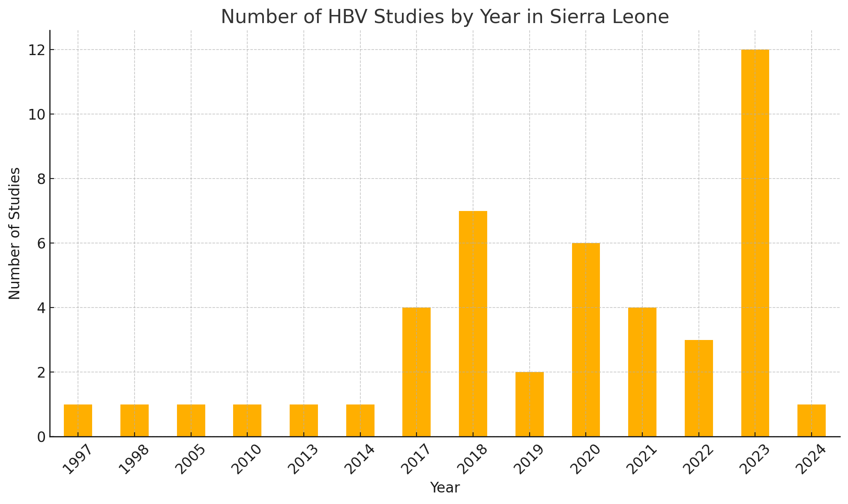
Figure 1: Publication trends of HBV-related studies in Sierra Leone

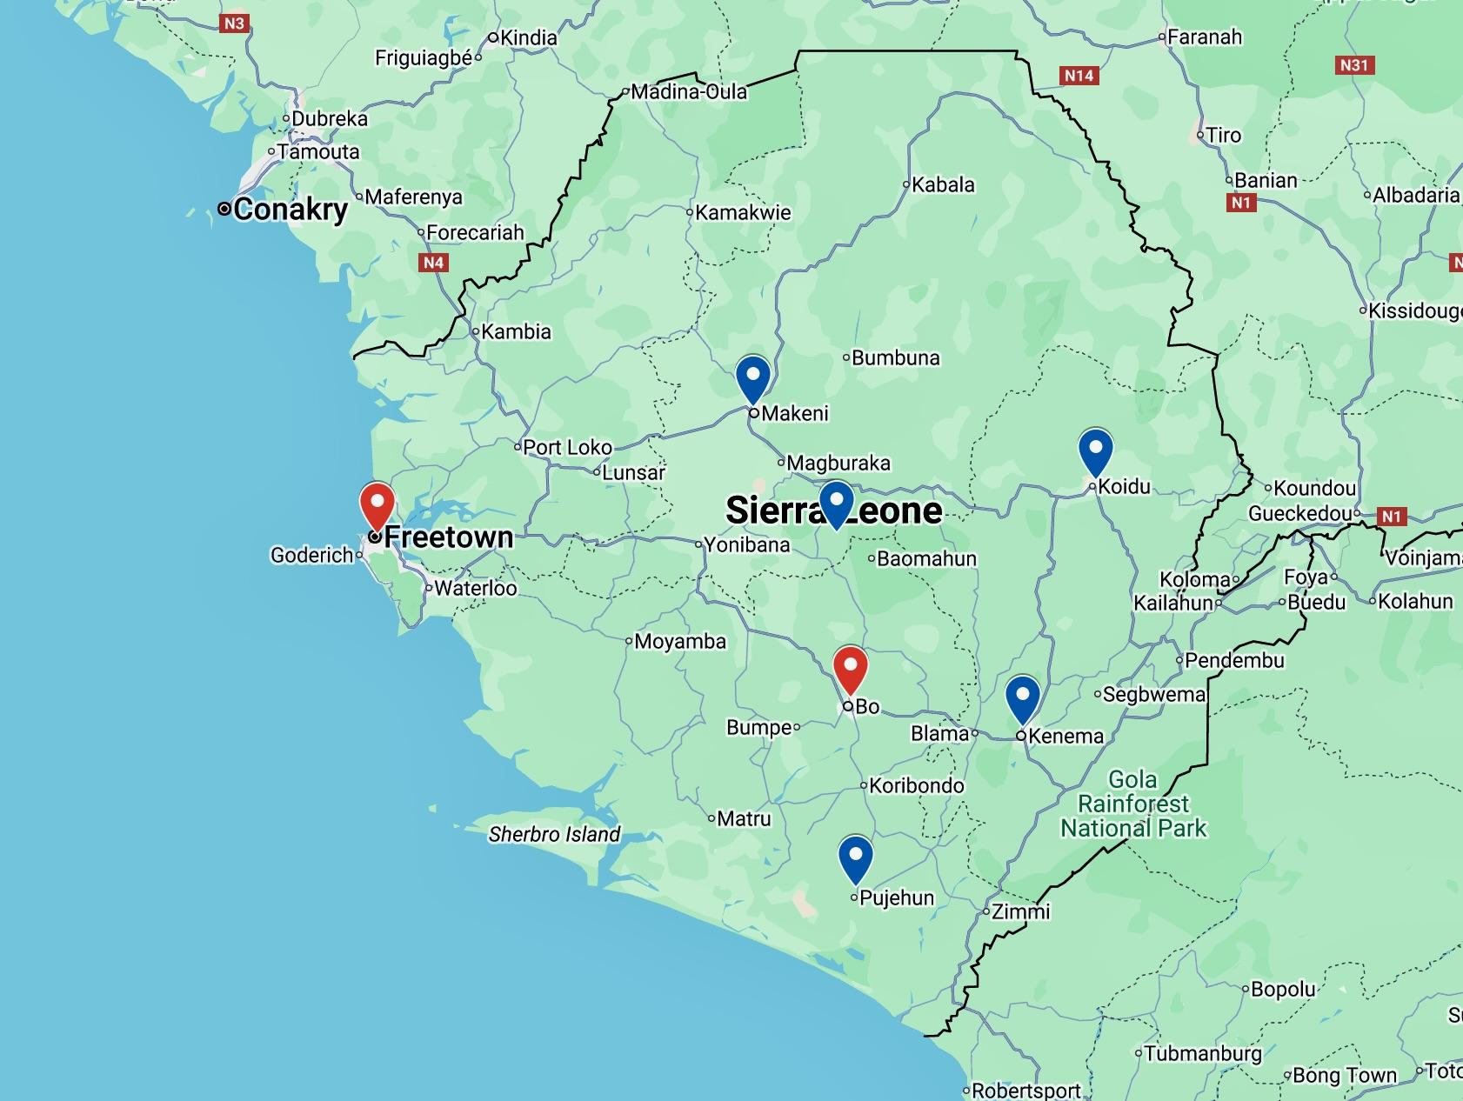
Figure 2: Map of Sierra Leone showing the major urban cities included in the geographical analysis. Cities with the highest number of HBV-related studies are highlighted in red.

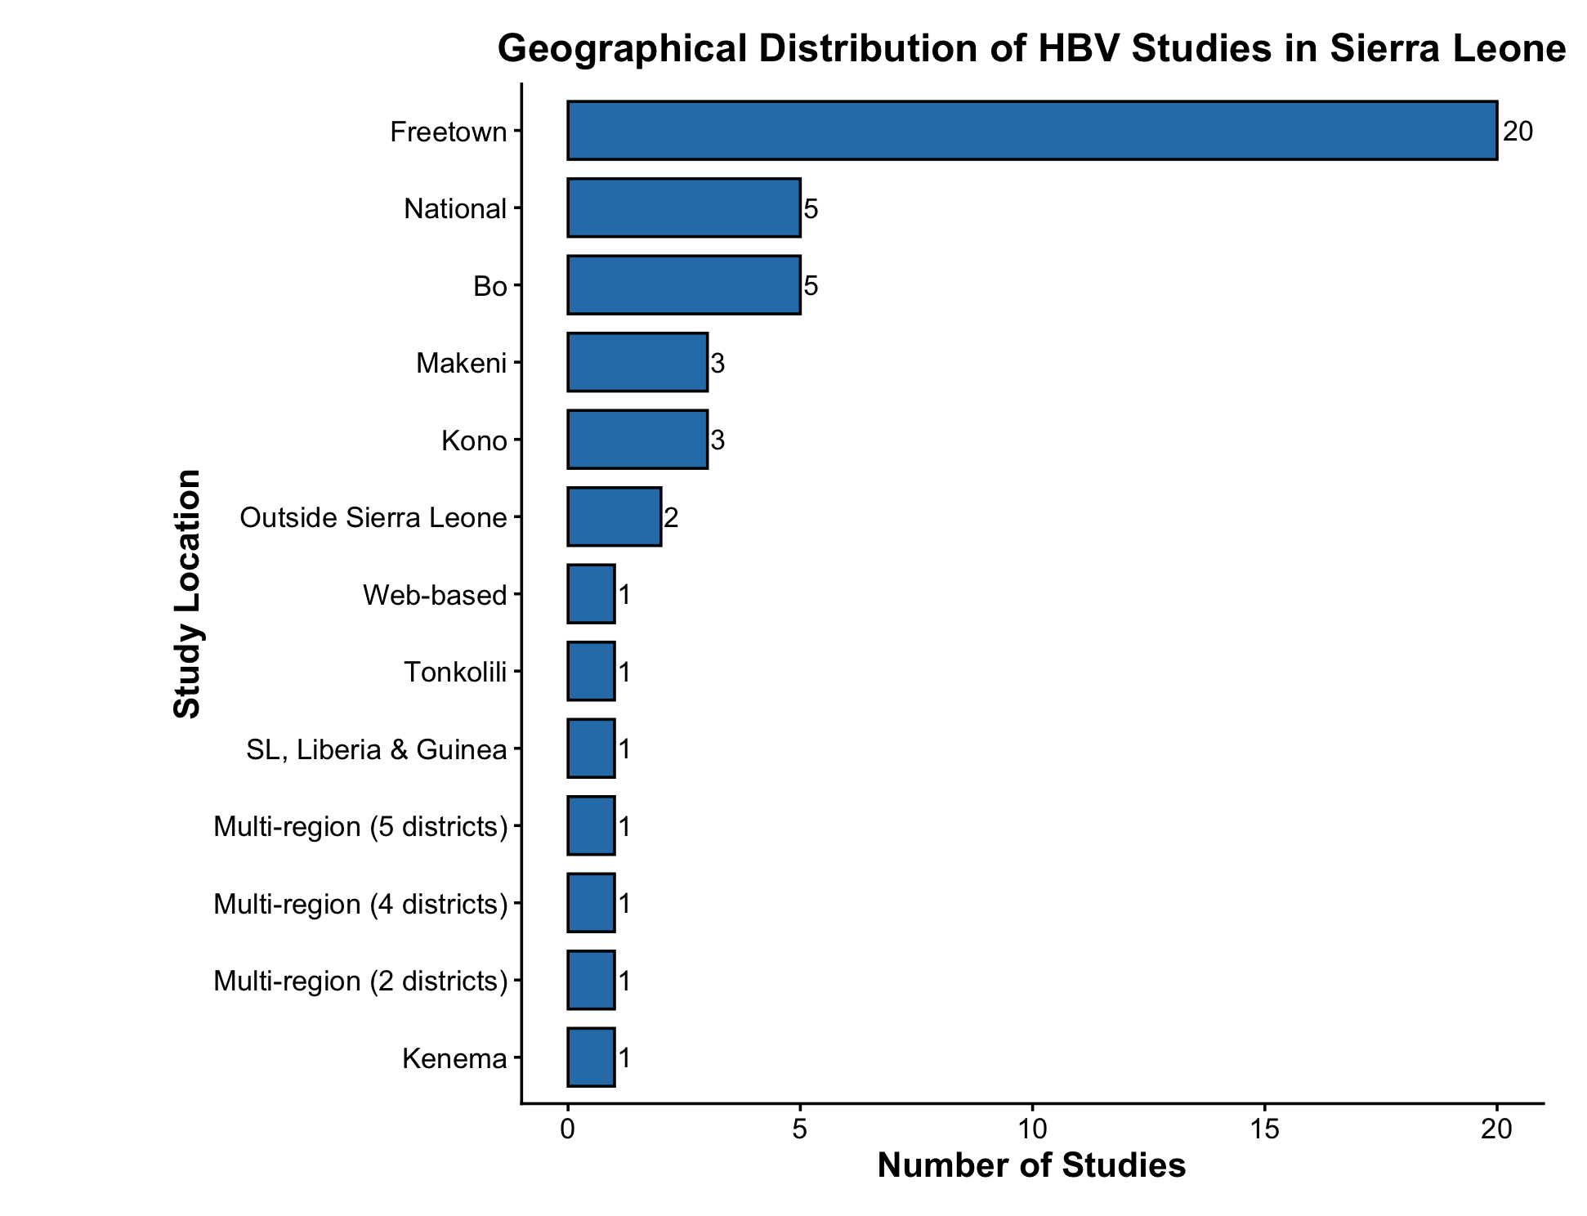
Figure 3: Geographical distribution of HBV-related studies conducted in Sierra Leone between 1997-2024. Distribution of the 45 studies included in the scoping review according to the geographical location(s) reported in the original publication.

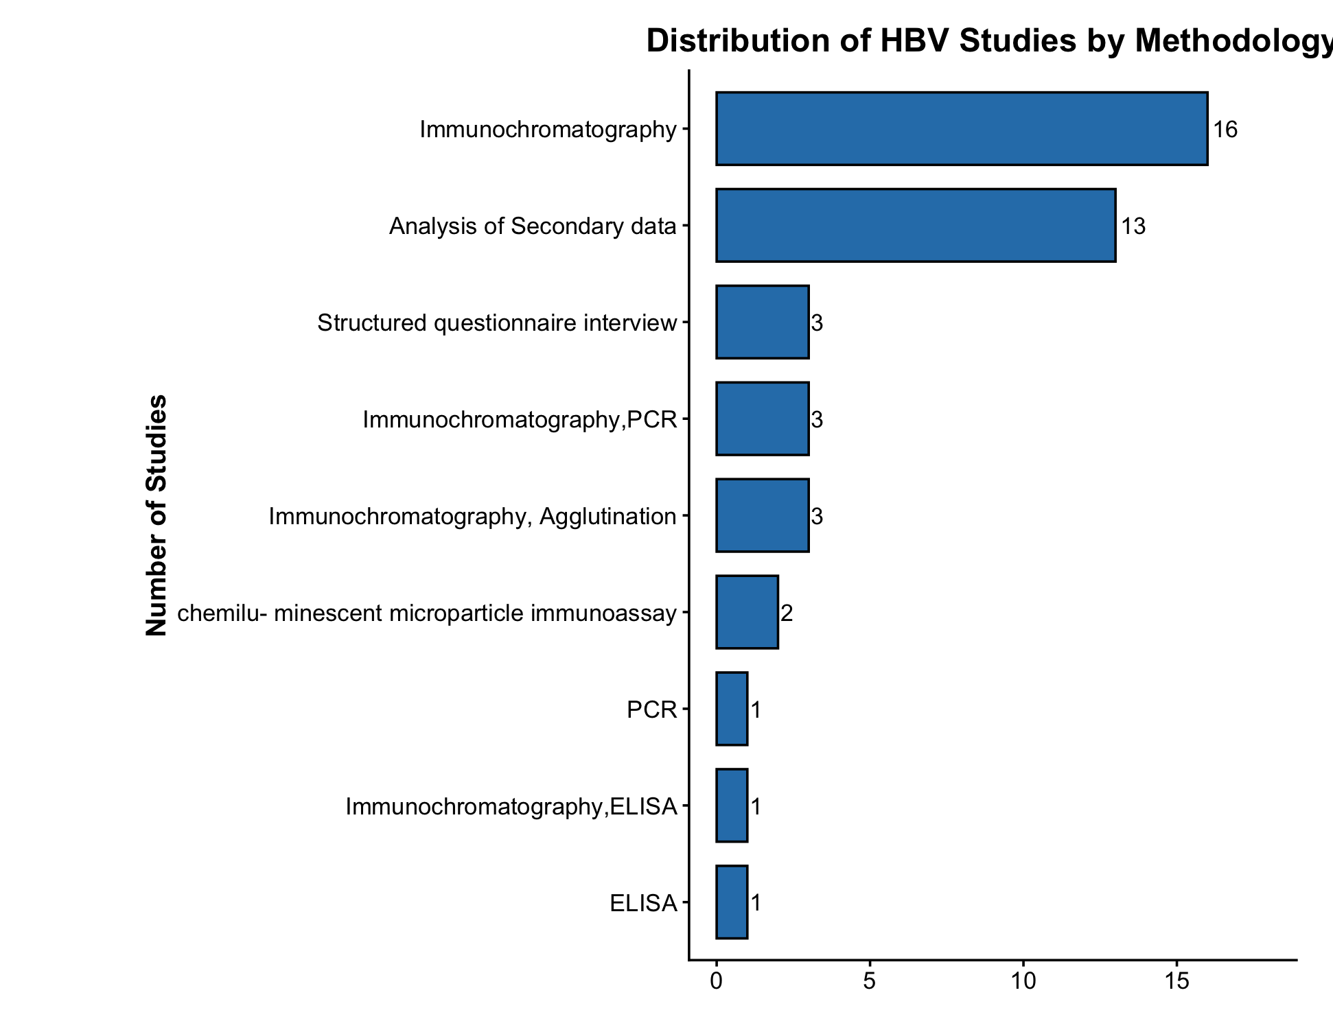
Figure 4: Distribution of HBV-related studies by Methodology in Sierra Leone(1997-2024)
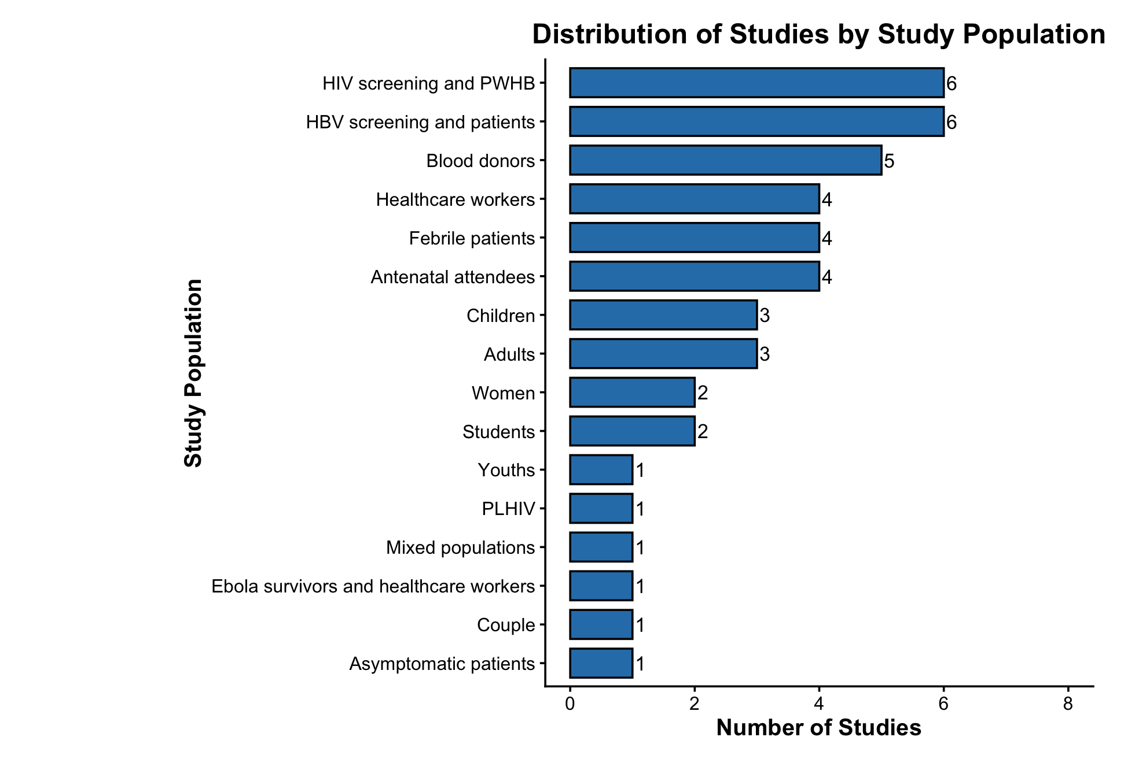
Figure 5: Distribution of HBV-related studies by Study Population in Sierra Leone(1997-2024)

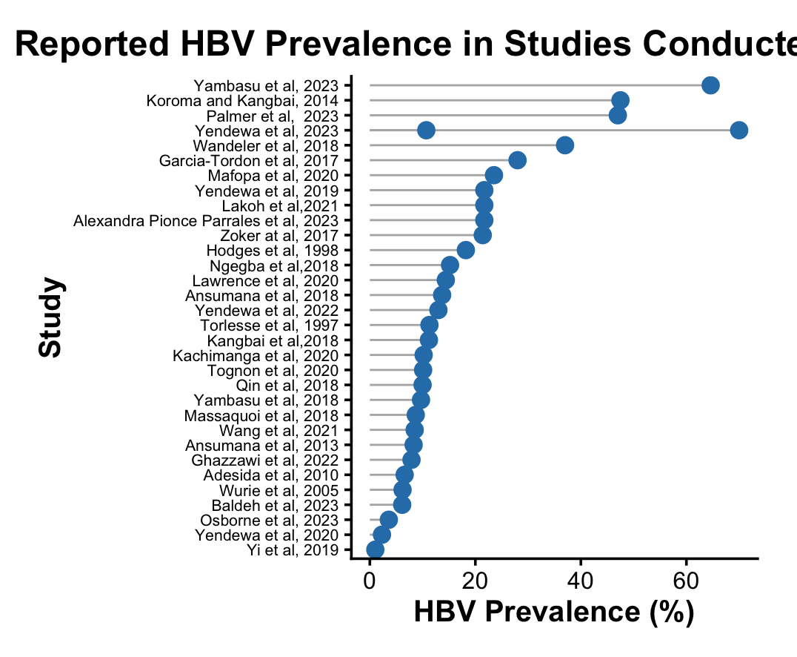
Figure 6: Reported HBV prevalence across the studies included in the scoping review
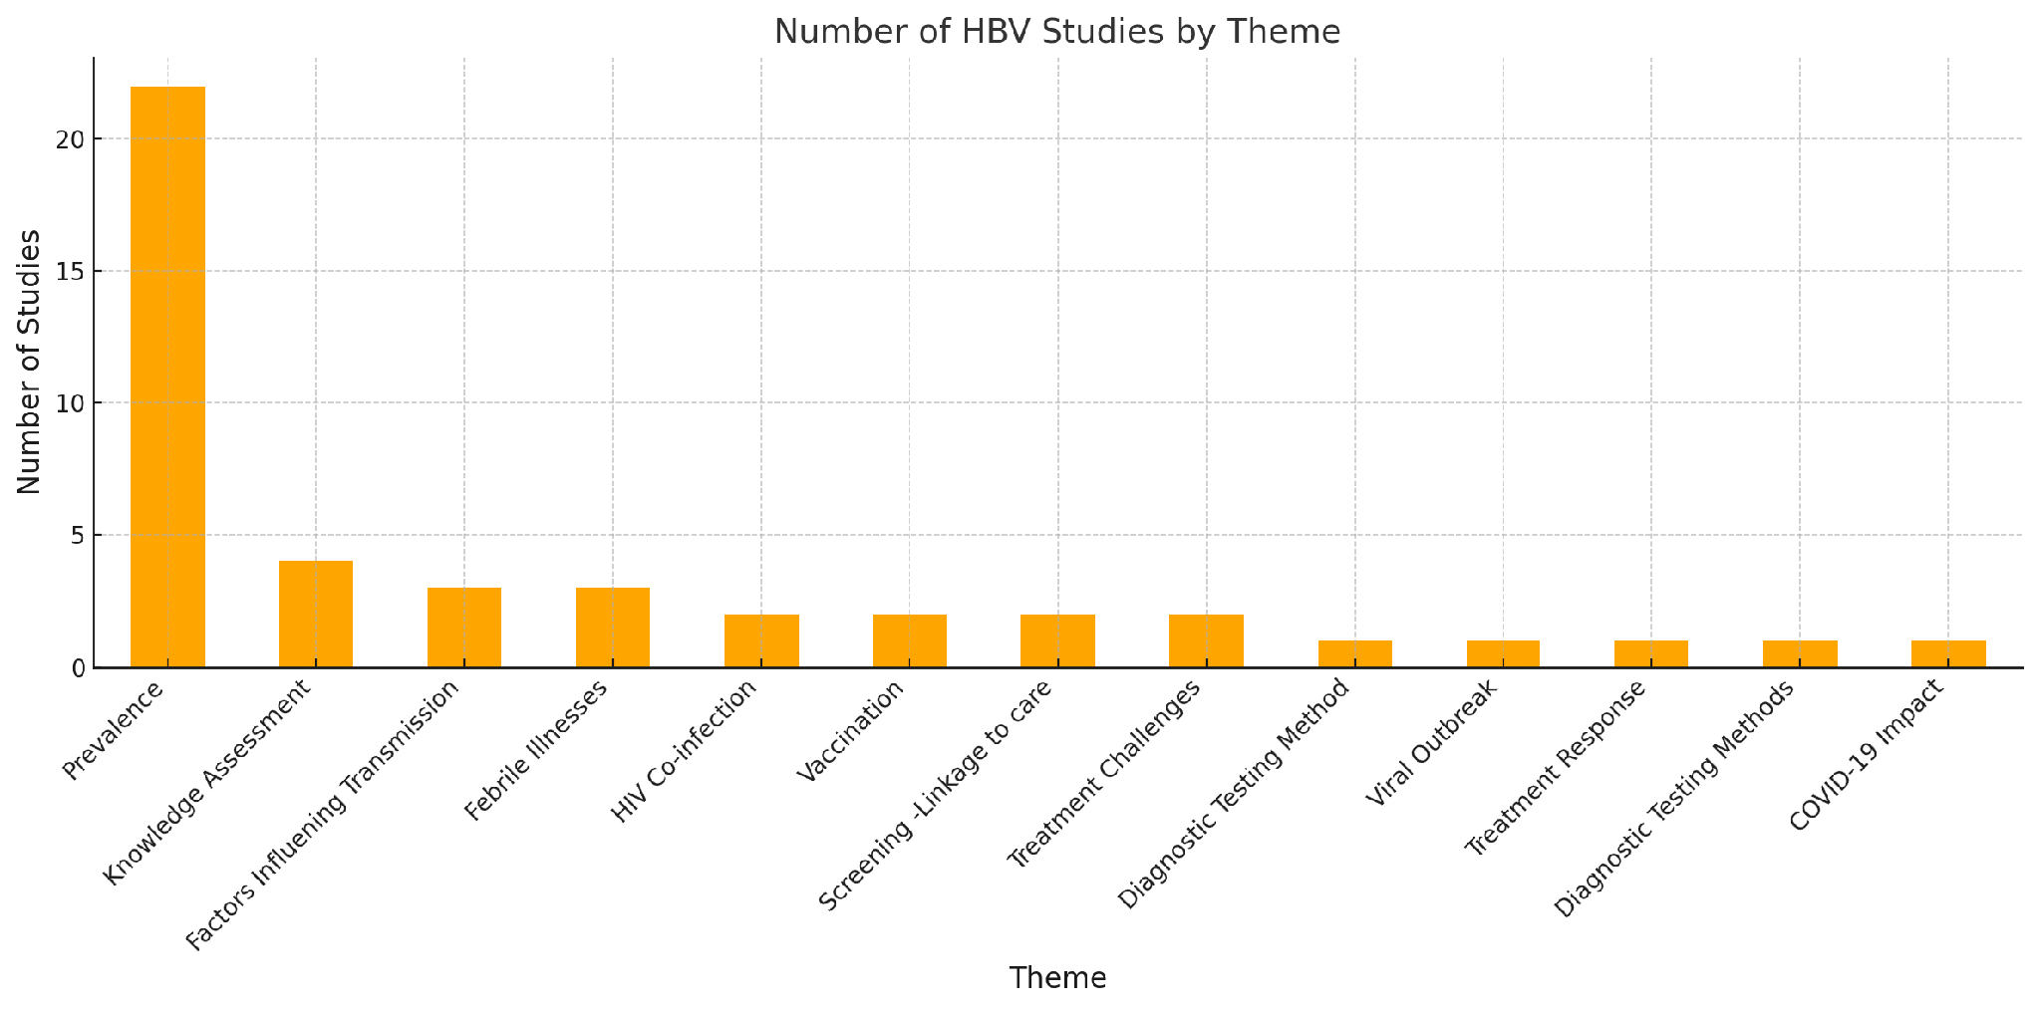
Figure 7:The Distribution of study themes
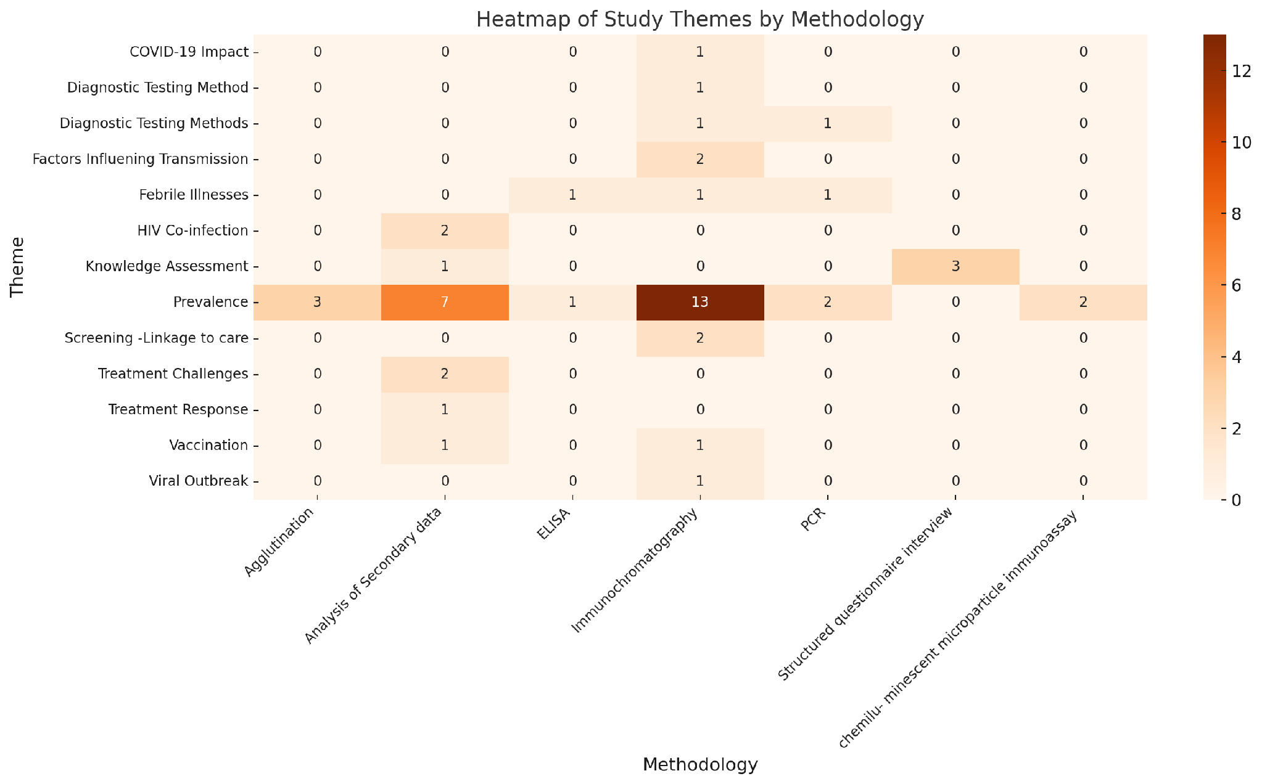
Figure 8: A heatmap showing the relationship between the Study themes and Study Methodologies

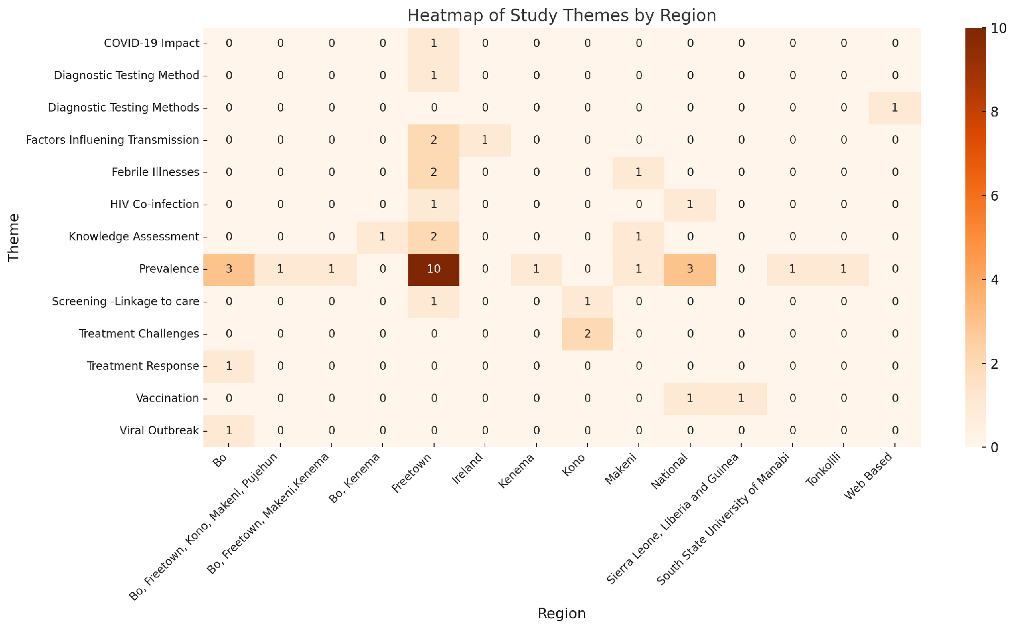
Figure 9: The Distribution of study themes across the different study regions

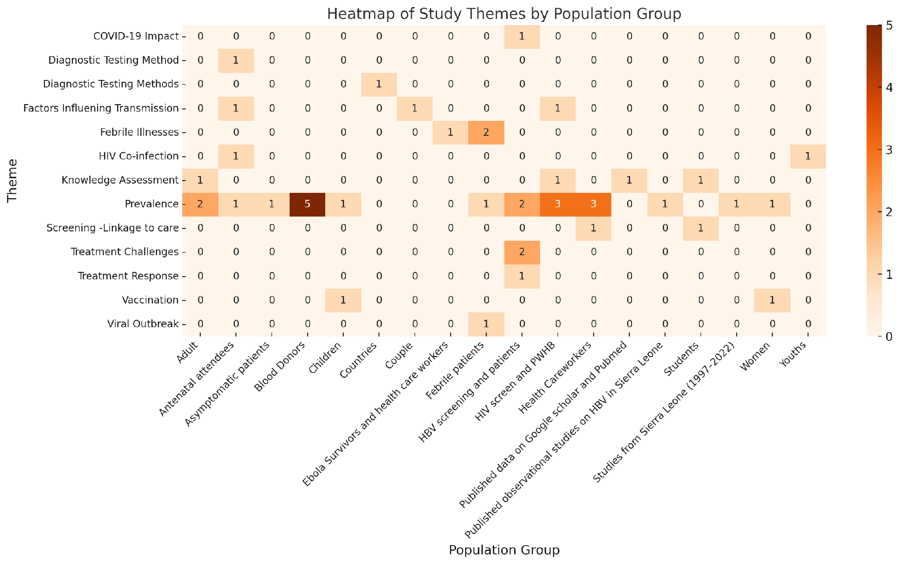
Figure 10: A heatmap showing the relationship between the Study themes and Study Population groups

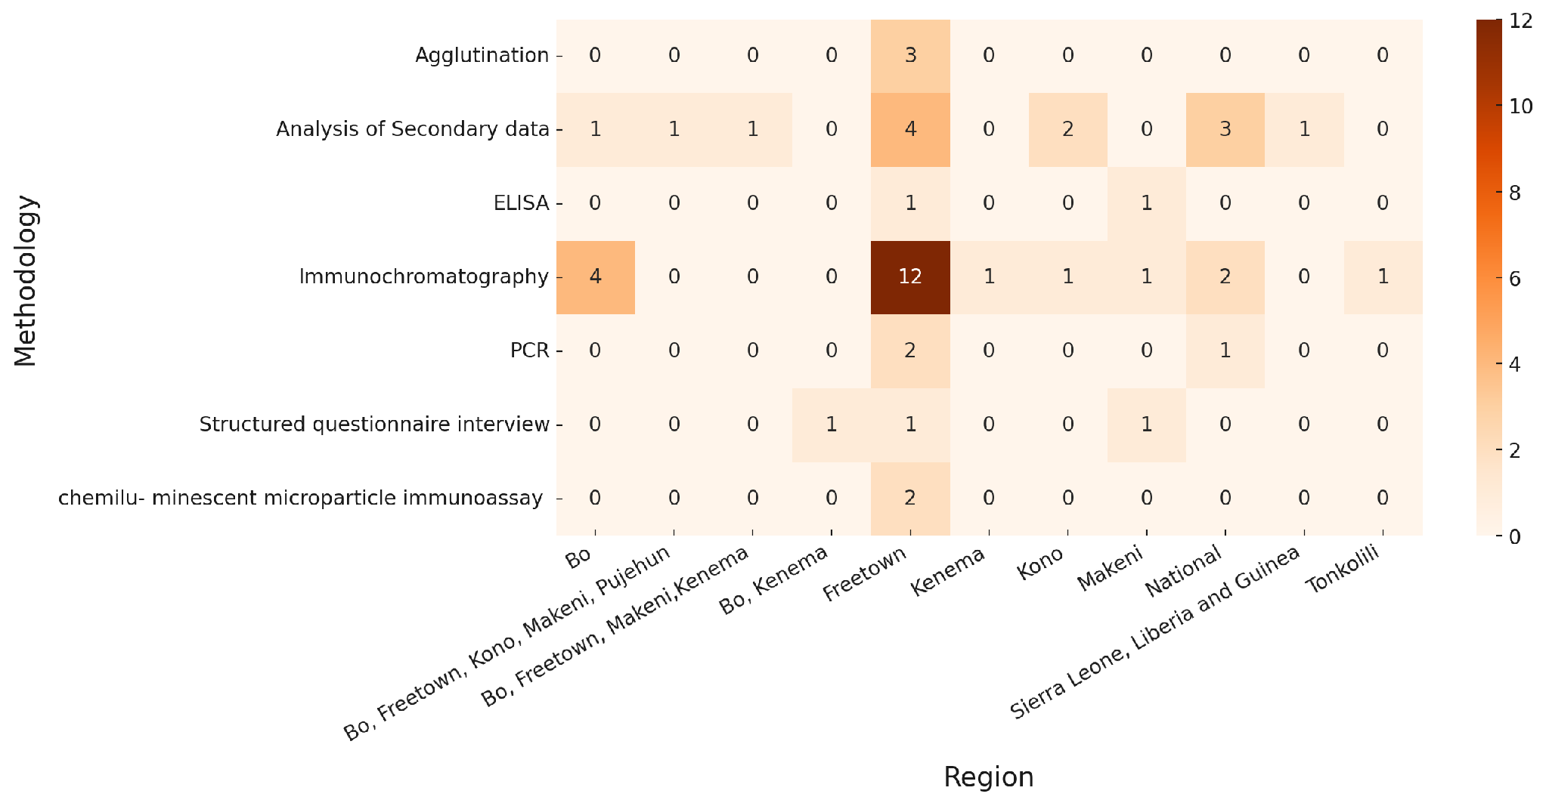 Figure 11: Heat map showing the frequency of methodology in the studies reviewed across locations

Table1: List of Hepatitis B Virus (HBV) related studies and their respective authors included in the review
SN | Title | Author
1 | The use of immunochromatography test cards in the diagnosis of hepatitis B surface antigen among pregnant women in West Africa. | Torlesse, H., Wurie, I. M., & Hodges, M. (1997). The use of immunochromatography test cards in the diagnosis of hepatitis B surface antigen among pregnant women in West Africa. British Journal of Biomedical Science, 54(4), 256–259.
2 | Seroprevalence of hepatitis markers; HAV, HBV, HCV and HEV amongst primary school children in Freetown, Sierra Leone. | Hodges, M., Sanders, E., & Aitken, C. (1998). Seroprevalence of hepatitis markers; HAV, HBV, HCV and HEV amongst primary school children in Freetown, Sierra Leone. West African Journal of Medicine, 17(1), 36–37.
3 | Seroprevalence of HBV among middle to high socio-economic antenatal population in Sierra Leone | Wurie, I., Wurie, A., & Gevao, S. (2005). Sero-prevalence of Hepatitis B virus among middle to high socio-economic antenatal population in Sierra Leone. West African Journal of Medicine, 24(1), 18–20. https://doi.org/10.4314/wajm.v24i1.28156
4 | Seroprevalence of HIV and HBV among patients at a health facility in Freetown, Sierra leone | Solayide, A., Gevao, T., Foday, S., & Gevao, M. (2010). Seroprevalence of Human Immunodeficiency and Hepatitis B Viruses among Patients at a Health Facility in Freetown, Sierra Leone. Sierra Leone Journal of Biomedical Research, 2(1), 28–31. https://doi.org/10.4314/sljbr.v2i1.56595
5 | Reemergence of Chikungunya Virus in Bo, Sierra Leone | Ansumana, R., Jacobsen, K. H., Leski, T. A., Covington, A. L., Bangura, U., Hodges, M. H., Lin, B., Bockarie, A. S., Lamin, J. M., Bockarie, M. J., & Stenger, D. A. (2013). Reemergence of chikungunya virus in Bo, Sierra Leone. Emerging Infectious Diseases, 19(7), 1108–1110. https://doi.org/10.3201/eid1907.121563
6 | Seroprevalence of HBsAg Among Female Patients seeking healthcare in Bo Government Hospital, Southern Sierra Leone:14-Months Database Study | Koroma, M. (2014). Seroprevalence of HBsAg among Female Patients Seeking Healthcare in Bo Government Hospital, Southern Sierra Leone: 14-Months Database Study. International Journal of TROPICAL DISEASE & Health, 4(6), 713–722. https://doi.org/10.9734/IJTDH/2014/7951
7 | Prevalence of HBV and HCV in Blood Donors in Tonkolili Province, Sierra Leone | García-Tardón, N., Gresnigt, T. M., Fofanah, A. B., & Grobusch, M. P. (2017). Hepatitis B and C in Tonkolili Province, Sierra Leone. The Lancet, 390(10101), 1485. https://doi.org/10.1016/S0140-6736(17)32390-5
8 | Virologic Response and Survival Analysis of 281 HBsAg Treatment Naive Patients on Lamivudine Monotherapy in Sierra Leone | Kangbai, J. B. (2017). Virologic Response and Survival Analysis of 281 HbsAg Treatment Naive Patients on Lamivudine Monotherapy in Sierra Leone. International Journal of Virology and AIDS, 4(1). https://doi.org/10.23937/2469-567X/1510029
9 | Transmission of a Homogeneous Hepatitis B Virus Population of A1896 -Containing Strains Leading to Mild Resolving Acute Hepatitis and Seroconversion to Hepatitis B e Antigen Antibodies in an Adult | Mphahlele, M. J., Shattock, A. G., Boner, W., Quinn, J., McCormick, P. A., & Carman, W. F. (1997). Transmission of a homogenous hepatitis B virus population of A1896-containing strains leading to mild resolving acute hepatitis and seroconversion to hepatitis B e antigen antibodies in an adult. Hepatology, 26(3), 743–746. https://doi.org/10.1002/hep.510260329
10 | Seroprevalence of Hepatitis B surface antigen in urban Bo, Sierra Leone | Zoker, E., Sundufu, A., & Jacobsen, K. (2017). Seroprevalence of hepatitis B surface antigen in urban Bo, Sierra Leone. Tropical Journal of Medical Research, 20(1), 41. https://link.gale.com/apps/doc/A477729113/AONE?u=anon~2b84d8b5&sid=googleScholar&xid=29975c7a
11 | Cross-Sectional Study of Chronic Hepatitis B Prevalence Among Healthcare Workers in an Urban Setting, Sierra Leone | Massaquoi, T. A., Burke, R. M., Yang, G., Lakoh, S., Sevalie, S., Li, B., Jia, H., Huang, L., Deen, G. F., Beynon, F., & Sahr, F. (2018). Cross sectional study of chronic hepatitis B prevalence among healthcare workers in an urban setting, Sierra Leone. PLOS ONE, 13(8), e0201820. https://doi.org/10.1371/journal.pone.0201820
12 | Prevalence and associated knowledge of Hepatitis B infection among Helathcare workers in Freetown, Sierra Leone | Chinese Military Medical Experts Group in Sierra Leone, Qin, Y.-L., Li, B., Zhou, Y.-S., Zhang, X., Li, L., Song, B., Liu, P., Yuan, Y., Zhao, Z.-P., Jiao, J., Li, J., Sun, Y., Sevalie, S., Kanu, J. E., Song, Y.-J., Jiang, J.-F., Sahr, F., & Jiang, T.-J. (2018). Prevalence and associated knowledge of hepatitis B infection among healthcare workers in Freetown, Sierra Leone. BMC Infectious Diseases, 18(1), 315. https://doi.org/10.1186/s12879-018-3235-1
13 | Seroprevalence of Hepatitis B surface antigen (HBsAg) in Bo, Sierra Leone, 2012-2013 | Ansumana, R., Dariano, D. F., Jacobsen, K. H., Leski, T. A., Lamin, J. M., Lahai, J., Bangura, U., Bockarie, A. S., Taitt, C. R., Yasuda, C., Bockarie, M. J., & Stenger, D. A. (2018). Seroprevalence of hepatitis B surface antigen (HBsAg) in Bo, Sierra Leone, 2012–2013. BMC Research Notes, 11(1), 113. https://doi.org/10.1186/s13104-018-3218-8
14 | Hidden dangers-prevalence of blood borne pathogens, hepatitis B, C,HIV and syphilis, among blood donors in Sierra Leone in 2016:opportunities for improvement: a retrospective, cross-sectional study | Yambasu, E. E., Reid, A., Owiti, P., Manzi, M., Sia Murray, M. J., & Edwin, A. K. (2018). Hidden dangers-prevalence of blood borne pathogens, hepatitis B, C, HIV and syphilis, among blood donors in Sierra Leone in 2016: Opportunities for improvement: a retrospective, cross-sectional study. Pan African Medical Journal, 30. https://doi.org/10.11604/pamj.2018.30.44.14663
15 | Epidemiological Markers for HIV Infection among First-Time An- tenatal Attendees in Sierra Leone: 2012-2015 Longitudinal Study | Jia Bainga, K., Isata Victoria, M., Matilda, K., Josephine Alpha, R., & Sulaiman Lansanah, M. (2018). Epidemiological Markers for HIV Infection among First-Time Antenatal Attendees in Sierra Leone: 2012-2015 Longitudinal Study. Journal of Infectious Diseases and Epidemiology, 4(1). https://doi.org/10.23937/2474-3658/1510049
16 | Issues with measuring hepatitis prevalence in resource-limited settings | Wandeler, G., Coffie, P. A., Kuniholm, M. H., Ocama, P., & Egger, M. (2018). Issues with measuring hepatitis prevalence in resource-limited settings. The Lancet, 391(10123), 835–836. https://doi.org/10.1016/S0140-6736(18)30463-X
17 | Disproportionate HBsAg seroprevalence rates among healthy blood donors in six health care facilities in Sierra Leone, 2012-2016 | Ngegba, M. A., Roberts, G. M., Kangbai, J. B., Keittel, S., & Ansumana, R. (2018). Disproportionate HBsAg seroprevalence rates among healthy blood donors in six health care facilities in Sierra Leone, 2012-2016. Sierra Leone j. biomed. res.(Online), 17-22.
18 | Seroprevalence of HBV, HCV, and HTLV Among HIV-Infected Patients in Sierra Leone | Yendewa, G. A., Sahr, F., Aguilera, A., Lakoh, S., Sesay, M., Deen, G. F., Patiño, L., Poveda, E., & Salata, R. A. (2019). Seroprevalence of Hepatitis B, Hepatitis C, and Human T-Cell Lymphotropic Virus Infections in HIV-Infected Patients in Sierra Leone. The American Journal of Tropical Medicine and Hygiene, 100(6), 1521–1524. https://doi.org/10.4269/ajtmh.18-1001
19 | Next-generation Sequencing Study of Pathogens in Serum from Patients with Febrile Jaundice in Sierra Leone | ZHANG, Y., YE, F., XIA, L. X., ZHU, L. W., IDRISSA, L. K., HUANG, K. Q., ZHANG, Y., LIU, J., BRIMA, K., WANG, J., LIANG, M. F., SONG, J. D., MA, X. J., & WU, G. Z. (2019). Next-generation Sequencing Study of Pathogens in Serum from Patients with Febrile Jaundice in Sierra Leone. Biomedical and Environmental Sciences, 32(5), 363–370. https://doi.org/10.3967/bes2019.048
20 | A Comparative Study on the Seroprevalence of Hepatitis B Virus among Patients and Blood Donors at the Regional Government Referral Hospital in Kenema, Eastern Sierra Leone | Lawrence, S. B., Edmond, J. S., & Daniel, B. K. (2020). A comparative study on the seroprevalence of hepatitis B virus among patients and blood donors at the regional government referral hospital in Kenema, Eastern Sierra Leone. J Infect Dis Pathog, 2(101), 2.
21 | Seroprevalence of Hepatitis B and Hepatitis C Among Blood Donors in Sierra Leone: A Multi-Year Retrospective Study | Tognon, F., Sevalie, S., Gassimu, J., Sesay, J., Hann, K., Sheku, M., Bearse, E., Di Gennaro, F., Marotta, C., Pellizzer, G., Putoto, G., Lado, M., Franke, M. F., Dibba, Y., Gevao, S., Beynon, F., & Mesman, A. W. (2020). Seroprevalence of hepatitis B and hepatitis C among blood donors in Sierra Leone: A multi-year retrospective study. International Journal of Infectious Diseases, 99, 102–107. https://doi.org/10.1016/j.ijid.2020.07.030
22 | Prevalence of Hepatitis B surface antigen and serological markers of other endemic inifections in HIV-infected children, adolescentand pregnant women in SIerra Leone: A corss scetional study | Yendewa, G. A., Lakoh, S., Yendewa, S. A., Bangura, K., Lawrence, H., Patiño, L., Jiba, D. F., Vandy, A. O., Murray, M. J. S., Massaquoi, S. P., Deen, G. F., Sahr, F., Hoffmann, C. J., Jacobson, J. M., Poveda, E., Aguilera, A., & Salata, R. A. (2021). Prevalence of hepatitis B surface antigen and serological markers of other endemic infections in HIV-infected children, adolescents and pregnant women in Sierra Leone: A cross-sectional study. International Journal of Infectious Diseases, 102, 45–52. https://doi.org/10.1016/j.ijid.2020.09.1459
23 | Assessing the impact of the routine childhood Hepatitis B immunization and the need for Hepatitis B vaccine Birth dose in Sierra Leone,2018 | Breakwell et al, 2020 Breakwell, L., Marke, D., Kaiser, R., Tejada-Strop, A., Pauly, M. D., Jabbi, S., Yambasu, S., Kabore, H. J., Stewart, B., Sesay, T., Samba, T. T., Hayden, T., Kamili, S., Jambai, A., Drobeniuc, J., Singh, T., Tohme, R. A., & Wasley, A. (2022). Assessing the impact of the routine childhood hepatitis B immunization program and the need for hepatitis B vaccine birth dose in Sierra Leone, 2018. Vaccine, 40(19), 2741–2748. https://doi.org/10.1016/j.vaccine.2022.03.049
24 | Screening and Linkage to Care for Medical Students with Hepatitis B Virus Infection in Sierra Leone | Kachimanga, C., Bangura, M., Nyama, E., Mhango, M., Reed, V., Rodriguez, M. P., & Lado, M. (2020). Screening and linkage to care for medical students with hepatitis B virus infection in Sierra Leone. Heliyon, 6(8), e04673. https://doi.org/10.1016/j.heliyon.2020.e04673
25 | Viral Hepatitis B and C Detection among Ebola Survivors and Health Care Workers in Makeni, Sierra Leone | Mafopa, N. G., Giovanetti, M., Wadoum, R. E. G., Minutolo, A., Yinda, C. K., Russo, G., ... & Montesano, C. (2020). Viral hepatitis B and C detection among Ebola survivors and health care workers in Makeni, Sierra Leone. Journal of Biosciences and Medicines, 8(10), 18-32.
26 | Screening, Vaccination Uptake and linkage to care for Hepatitis B Virus Health Care Workers in Rural Sierra Leone | Bangura, M., Frühauf, A., Mhango, M., Lavallie, D., Reed, V., Rodriguez, M. P., Smith, S. J., Lakoh, S., Ibrahim-Sayo, E., Conteh, S., Lado, M., & Kachimanga, C. (2021). Screening, Vaccination Uptake and Linkage to Care for Hepatitis B Virus among Health Care Workers in Rural Sierra Leone. Tropical Medicine and Infectious Disease, 6(2), 65. https://doi.org/10.3390/tropicalmed6020065
27 | Prevalence of Sero-Markers and non-invasive assessment of Liver Cirrhosis in Patients with Hepatitis B virus infection in Freetown, Sierra Leone: a cross sectional study | Lakoh, S., Firima, E., Jiba, D. F., Kamara, M. N., Gashau, W., Deen, G. F., Adekanmbi, O., & Yendewa, G. A. (2021). Prevalence of sero-markers and non-invasive assessment of liver cirrhosis in patients with Hepatitis B virus infection in Freetown, Sierra Leone: A cross-sectional study. BMC Gastroenterology, 21(1), 320. https://doi.org/10.1186/s12876-021-01892-5
28 | Prevalence of Viral Hepatitis B and C in Sierra Leone – Current Knowledge and Knowledge Gaps: A Narrative Review | Lakoh, S., García-Tardón, N., Adekanmbi, O.Van Der Valk, M., Smith, S. J., & Grobusch, M. P. (2021). Prevalence of viral hepatitis B and C in Sierra Leone—current knowledge and knowledge gaps: A narrative review. Transactions of The Royal Society of Tropical Medicine and Hygiene, 115(10), 1106–1113. https://doi.org/10.1093/trstmh/trab054
29 | A Prospective Study of Etiological Agents Among Febrile Patients in Sierra Leone | Wang, H., Zhao, J., Xie, N., Wang, W., Qi, R., Hao, X., Liu, Y., Sevalie, S., Niu, G., Zhang, Y., Wu, G., Lv, X., Chen, Y., Ye, Y., Bi, S., Moseray, M., Cellessy, S., Kalon, K., Baika, D. I., & Luo, Q. (2021). A Prospective Study of Etiological Agents Among Febrile Patients in Sierra Leone. Infectious Diseases and Therapy, 10(3), 1645–1664. https://doi.org/10.1007/s40121-021-00474-y
30 | Hepatitis B Virus and Tuberculosis are associated with increased noncommunicable diseases risk among treatment naive people with HIV : Opportunities for prevention, Early detection, and Management of Comorbidities in Sierra Leone | Yendewa, G. A., Lakoh, S., Jiba, D. F., Yendewa, S. A., Barrie, U., Deen, G. F., Samai, M., Jacobson, J. M., Sahr, F., & Salata, R. A. (2022). Hepatitis B Virus and Tuberculosis Are Associated with Increased Noncommunicable Disease Risk among Treatment-Naïve People with HIV: Opportunities for Prevention, Early Detection and Management of Comorbidities in Sierra Leone. Journal of Clinical Medicine, 11(12), 3466. https://doi.org/10.3390/jcm11123466
31 | Factors associated with HBsAg seropositivity among pregnant women receiving Antenatal care at 10 Community Health Centers in Freetown, Sierra Leone: A Cross Sectional Study | Ghazzawi, M., James, P. B., Massaquoi, S. P., Yendewa, S. A., Salata, R. A., & Yendewa, G. A. (2022). Factors Associated with HBsAg Seropositivity among Pregnant Women Receiving Antenatal Care at 10 Community Health Centers in Freetown, Sierra Leone: A Cross-Sectional Study. Pathogens, 11(2), 243. https://doi.org/10.3390/pathogens11020243
32 | Prevalence and Burden of Chronic Hepatitis B Virus Infection in Sierra Leone, 1997-2022: Evidence from a 25-Year Systematic Review and Meta-Analysis | Yendewa, G. A., Wang, G.-M., James, P. B., Massaquoi, S. P. E., Yendewa, S. A., Ghazawi, M., Babawo, L. S., Ocama, P., Russell, J. B. W., Deen, G. F., Sahr, F., Kabba, M., Tatsuoka, C., Lakoh, S., & Salata, R. A. (2022). Prevalence and Burden of Chronic Hepatitis B Virus Infection in Sierra Leone, 1997-2022: Evidence from a 25-Year Systematic Review and Meta-Analysis. Infectious Diseases (except HIV/AIDS). https://doi.org/10.1101/2022.11.16.22282393
33 | Prevalence and viral suppression of Hepatitis B virus infection among people living with HIV on antiretroviral therapy in Sierra Leone | Song, J.-W., Lakoh, S., Chen, S.-Y., Jalloh, M. B., Sevalie, S., Baldeh, M., Nyambe, M. K., Nicholas, V. D., Yendewa, G., Wang, F.-S., & Yang, G. (2024). Prevalence and viral suppression of hepatitis B virus infection among people living with HIV on antiretroviral therapy in Sierra Leone. Sexually Transmitted Infections, 100(5), 264–270. https://doi.org/10.1136/sextrans-2023-056042
34 | Childhood HBV Immunization Coverage and Barriers in Sierra Leone, Liberia, and Guinea. Analysis of National Surveys(2018-2020) | Yendewa, G. A., James, P. B., Mohareb, A. M., Barrie, U., Massaquoi, S. P. E., Yendewa, S. A., Ghazzawi, M., Bockarie, T., Cumming, P. E., Diallo, I. S., Johnson, A., Vohnm, B., Babawo, L. S., Deen, G. F., Kabba, M., Sahr, F., Lakoh, S., & Salata, R. A. (2023). Childhood Hepatitis B Immunization Coverage and Barriers in Sierra Leone, Liberia, and Guinea: Analysis of National Surveys (2018-2020). Public and Global Health. https://doi.org/10.1101/2023.03.16.23287374
35 | Analysis of the Prevalence and Factors Associated with Hepatitis B Infection Among Adults Seeking Care at Makeni Government Regional Hospital, Sierra Leone | Palmer, P., Bangura, B. J., Ukaegbu, E. U., Kanu, L., & Kamara, J. P. (2023). Analysis of the prevalence and factors associated with Hepatitis B infection among adults seeking care at Makeni Government Regional Hospital, Sierra Leone. Sierra Leone Journal of Biomedical Research, 14(2), 11–26. https://doi.org/10.4314/sljbr.v14i2.4
36 | Knowledge, prevalence, and risk factors for self-reported sexually transmitted diseases among university students in Sierra Leone | Osborne, A., James, P. B., Bangura, C., Williams, S. M. T., Wadsworth, R., & Lebbie, A. (2023). Knowledge, prevalence, and risk factors for self-reported sexually transmitted diseases among University Students in Sierra Leone. Sierra Leone Journal of Biomedical Research, 14(2), 81–91. https://doi.org/10.4314/sljbr.v14i2.11
37 | Seroprevalence of Hepatitis B among health care workers in COnnaught Hospital, Sierra Leone | Yambasu, A. R., Kangbai, J., Karim, S., Zoker, E. M., Kamara, I. H., & Karimu, M. (2023). Seroprevalence of Hepatitis B among healthcare workers in Connaught Hospital, Sierra Leone.
38 | Prevalence of Chronic HBV infection in Sierra Leone, 1997-2022: A Systematic Review and Meta-Analysis | Yendewa, G. A., Wang, G. M., James, P. B., Massaquoi, S. P. E., Yendewa, S. A., Ghazawi, M., Babawo, L. S., Ocama, P., Russell, J. B. W., Deen, G. F., Sahr, F., Kabba, M., Tatsuoka, C., Lakoh, S., & Salata, R. A. (2023). Prevalence of Chronic Hepatitis B Virus Infection in Sierra Leone, 1997-2022: A Systematic Review and Meta-Analysis. The American journal of tropical medicine and hygiene, 109(1), 105–114. https://doi.org/10.4269/ajtmh.22-0711
39 | Assessment of Knowledge, Stigmatizing attitudes, and Health-Seeking Behavior regarding Hepatitis B Virus Infection in a Pharmacy and community setting in Sierra Leone: A cross sectional Study | Ghazzawi, M., Yendewa, S. A., James, P. B., Massaquoi, S. P., Babawo, L. S., Sahr, F., Deen, G. F., Kabba, M., Ocama, P., Lakoh, S., Salata, R. A., & Yendewa, G. A. (2023). Assessment of Knowledge, Stigmatizing Attitudes and Health-Seeking Behaviors Regarding Hepatitis B Virus Infection in a Pharmacy and Community Setting in Sierra Leone: A Cross-Sectional Study. Healthcare, 11(2), 177. https://doi.org/10.3390/healthcare11020177
40 | Measuring Stigma Associated with Hepatitis B Virus Infection in Sierra Leone: Validation of an Abridged Berger HIV Stigma Scale | Yendewa, G. A., Sellu, E. J., Kpaka, R. A., James, P. B., Yendewa, S. A., Cummings, P. E., Babawo, L. M., Massaquoi, S. P., Ghazawi, M., Ocama, P., Lakoh, S., Babawo, L. S., & Salata, R. A. (2023). Measuring stigma associated with hepatitis B virus infection in Sierra Leone: Validation of an abridged Berger HIV stigma scale. Journal of Viral Hepatitis, 30(7), 621–629. https://doi.org/10.1111/jvh.13838
41 | Advanced HIV disease and associated factors among young people aged 15-24 years at a tertiary hospital in Sierra Leone: a cross sectional study | Baldeh, M., Kizito, S., Lakoh, S., Sesay, D., Williams, S. A., Barrie, U., Dennis, F., Robinson, D. R., Lamontagne, F., Amahowe, F., Turay, P., Bahar, O. S., Geng, E., & Ssewamala, F. M. (2024). Advanced HIV disease and associated factors among young people aged 15—24 years at a tertiary hospital in Sierra Leone: A cross-sectional study. BMC Infectious Diseases, 24(1), 611. https://doi.org/10.1186/s12879-024-09524-5
42 | Challenges of hepatitis B treatment in rural Sub-Saharan Africa: Treatment initiation and outcomes from a public hospital-based clinic in Kono, Sierra Leone | Nyama, E. T., Allan‐Blitz, L., Bitwayiki, R., Swaray, M., Lebbie, W., Lavalie, D., Mhango, M., Gupta, N., & Rodriguez, M. P. (2023). Challenges of hepatitis B treatment in rural Sub‐Saharan Africa: Treatment initiation and outcomes from a public hospital‐based clinic in Kono, Sierra Leone. Journal of Viral Hepatitis, 30(5), 455–462. https://doi.org/10.1111/jvh.13812
43 | "Prevalence and risk factors for hepatitis B infections in adults" | Parrales Cevallos, V. M., Quimis Menoscal, J. E., & Pionce Parrales, A. (2023). Prevalence and risk factors of hepatitis B infections in adults. MQRInvestigar, 7(1), 572–586. https://doi.org/10.56048/MQR20225.7.1.2023.572-586
44 | Impact of COVID-19 on hepatitisB screening in SierraLeone:insights from a community pharmacy model of care | Ghazzawi, M., Babawo, L. S., Mohareb, A. M., James, P. B., Yendewa, S. A., Massaquoi, S. P. E., Cummings, P. E., Lakoh, S., Salata, R. A., & Yendewa, G. A. (2023). Impact of COVID-19 on hepatitis B screening in Sierra Leone: Insights from a community pharmacy model of care. IJID Regions, 9, 7–13. https://doi.org/10.1016/j.ijregi.2023.08.006
45 | Barriers to Longitudinal Follow-up for Hepatitis B Treatment in Rural Sierra Leone: A Mixed Methods Study of Retention in Care | Lebbie, W., Allan-Blitz, L.-T., Nyama, E. T., Swaray, M., Lavalie, D., Mhango, M., Patiño Rodriguez, M., Gupta, N., & Bitwayiki, R. (2024). Barriers to longitudinal follow-up for hepatitis B treatment in rural Sierra Leone: A mixed methods study of retention in care. Clinical Liver Disease, 23(1). https://doi.org/10.1097/CLD.0000000000000225
- References
1.World Health Organization. Hepatitis B fact sheet [Internet]. 2022 Jun 24 [cited 2025 Sep 15]. Available from: https://www.who.int/news-room/fact-sheets/detail/hepatitis-b
- Smalls DJ, Kiger RE, Norris LB, Bennett CL, Love BL. Hepatitis B Virus Reactivation: Risk Factors and Current Management Strategies. Pharmacotherapy. 2019; 39: 1190 1203. https://doi.org/10.1002/phar.2340
- Makuza J, Rwema J, Ntihabose C, Dushimiyimana, D, Umutesi, J, Nisingizwe, M, et al. Prevalence of hepatitis B surface antigen (HBsAg) positivity and its associated factors in
- World Health Organization Regional Office for Africa. Hepatitis regional fact sheet [Internet]. April 2023 [cited 2025 Sep]. Available from: https://files.aho.afro.who.int/afahobckpcontainer/production/files/iAHO_Hepatitis_Regional_Factsheet_ENG.pdf
- Scott G, Princess N, Dauda Z, Immanuel A. Increasing Cases of Chronic Hepatitis B Virus Infection in West Africa: Is Combination Therapy and Immunomodulators the Best Cure? J Infect Dis Epidemiolog. 2023;9:294. doi:10.23937/2474-3658/1510294.
- Padma TV. “Scaling up Hepatitis B Birth Dose Vaccination Will Save Lives, and Livers, Experts Say.” VaccinesWork, 26 July 2024, Gavi, the Vaccine Alliance, www.gavi.org/vaccineswork/scaling-hepatitis-b-birth-dose-vaccination-will-save-lives-and-livers-experts-say. Accessed 8 Nov. 2025.
- Lakoh S, García-Tardón N, Adekanmbi O, van der Valk M, Smith S.J., Grobusch MP. Prevalence of viral hepatitis B and C in Sierra Leone-current knowledge and knowledge gaps: a narrative review. Trans R Soc Trop Med Hyg. 2021 Oct 1;115(10):1106-1113. Doi: 10.1093/trstmh/trab054. PMID: 33772308; PMCID: PMC8486739.
- Fardolo EK, Cooper ET, Wahome CN, Kaly JK, Puiyoe JS. (2021) Seroprevalence of Hepatitis B Virus (HBV) among Voluntary Healthy Blood Donors at Tellewonyan Memorial Hospital Voinjama, Lofa County, Liberia. Journal of Biosciences and Medicines, 9, 113-119. https://doi.org/10.4236/jbm.2021.98010
- Camara M, Tantuoyir MM, SeyedAlinaghi S, Ghiasv and F, Ahmadinejad Z. Prevalence of hepatitis B infection in the Gambian population: A narrative review of recent developments. Prev Med Rep. 2023 Sep 7; 36:102401. Doi: 10.1016/j.pmedr.2023.102401. PMID: 37719791; PMCID: PMC10500481.
- F Umego, C. ., I Mboto, C. ., D Asitok, A. ., C Osaji , L. ., E George, U. ., Uwem O Edet, N Mbim, E. ., OC Faleye, T. ., M Adewumi, O. ., & A Adeniji , J. . . (2022). Circulation of hepatitis B virus genotype-E among outpatients in tertiary hospitals in the Niger-Delta region of Nigeria. African Health Sciences, 22(1), 511–20. https://doi.org/10.4314/ahs.v22i1.60
- Frimpong, J.O., Alhassan, A., Ansah, R.O. et al. Epidemiology and genotypic profiling of hepatitis B virus among febrile individuals in a high-endemic Ghanaian setting. BMC Infect Dis 26, 637 (2026). https://doi.org/10.1186/s12879-026-12756-2
- Maylin S, Sire JM, Mbaye PS, Simon F, Sarr A, Evra ML, Fall F, Daveiga J, Diallo A, Debonne JM, Chartier L, Vray M. Short-term spontaneous fluctuations of HBV DNA levels in a Senegalese population with chronic hepatitis B. BMC Infect Dis. 2015 Mar 25;15:154. doi: 10.1186/s12879-015-0881-4
- Ministry of Health. National Viral Hepatitis Strategic Plan 2024–2030: Eliminating Viral Hepatitis as a Public Health Threat by 2030. Government of Sierra Leone, 12 Dec. 2023

