- Figures
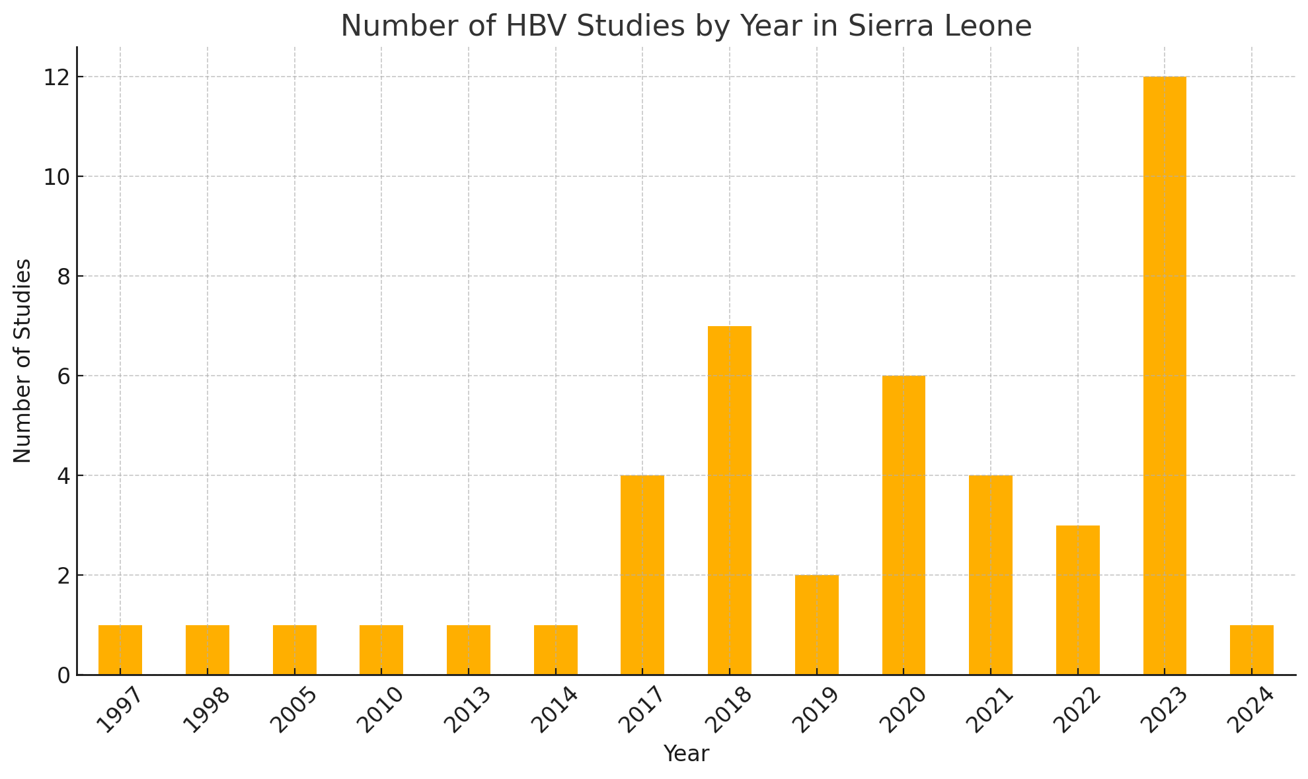
Figure 1: Publication trends of HBV-related studies in Sierra Leone

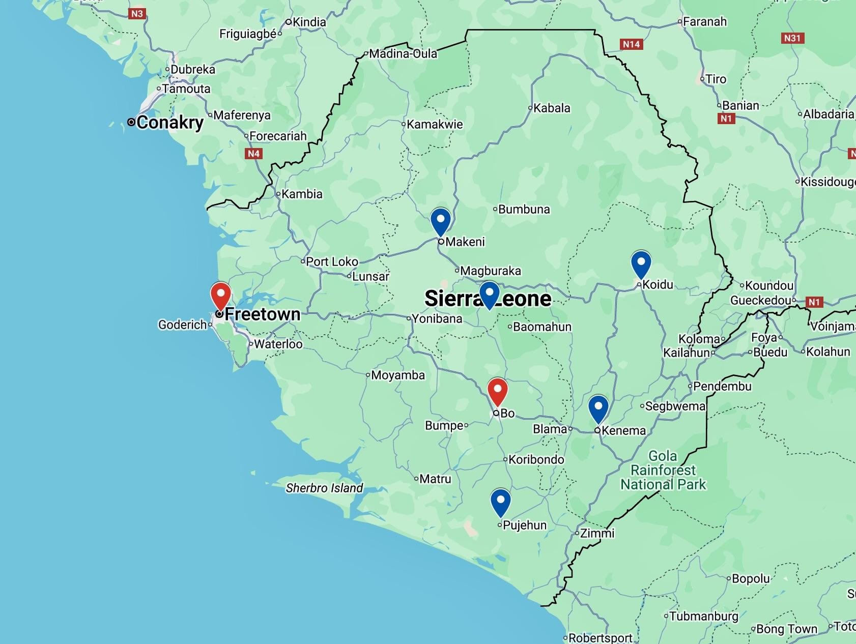
Figure 2: Map of Sierra Leone showing the major urban cities included in the geographical analysis. Cities with the highest number of HBV-related studies are highlighted in red.

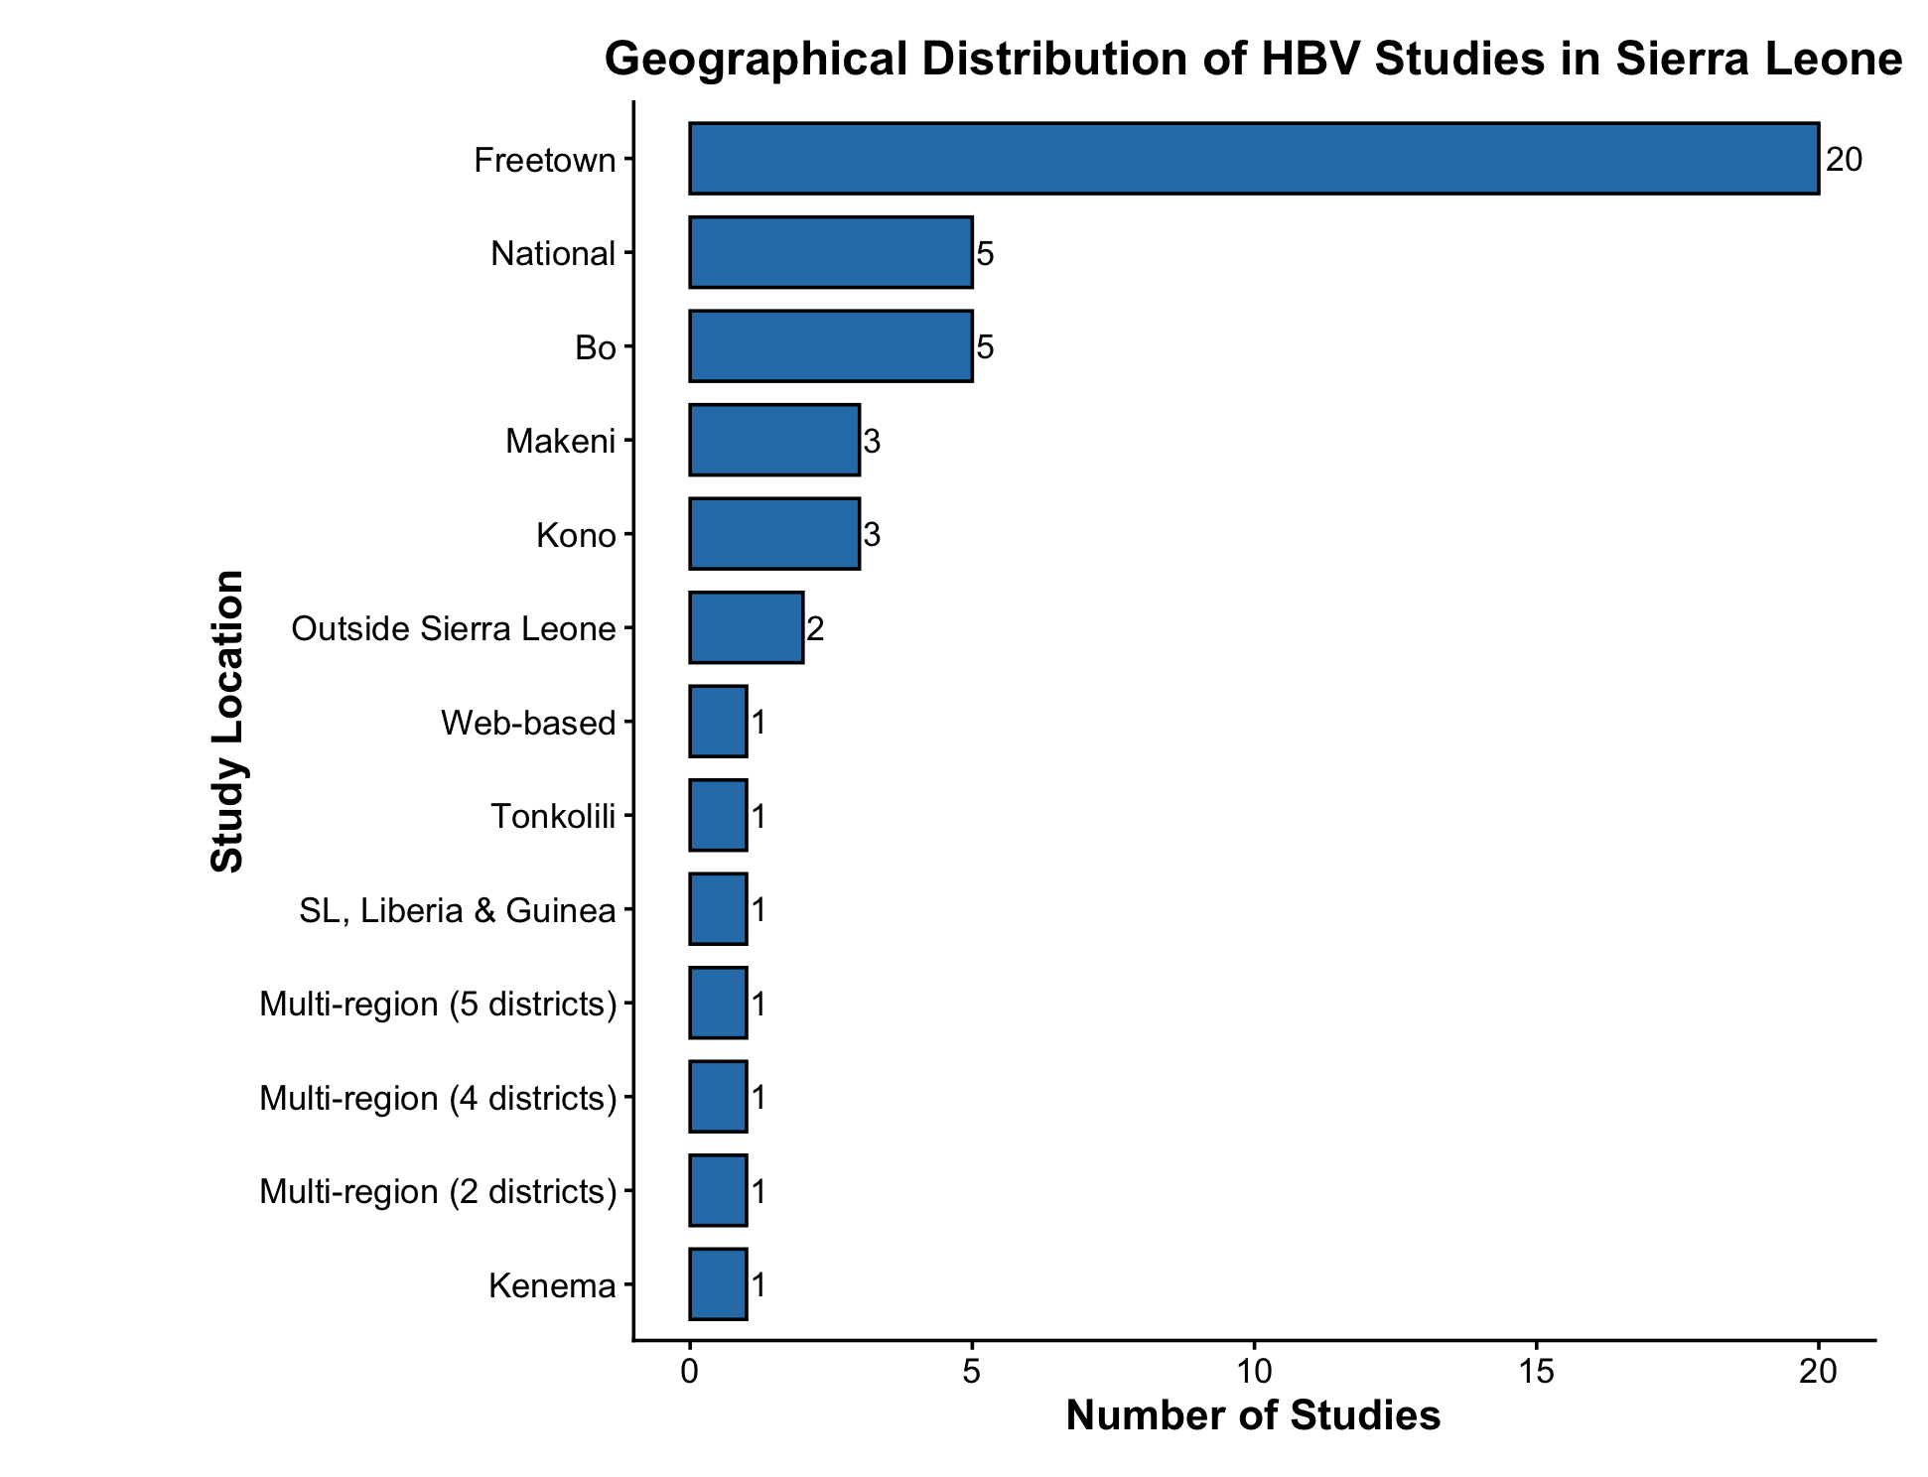
Figure 3: Geographical distribution of HBV-related studies conducted in Sierra Leone between 1997-2024. Distribution of the 45 studies included in the scoping review according to the geographical location(s) reported in the original publication.

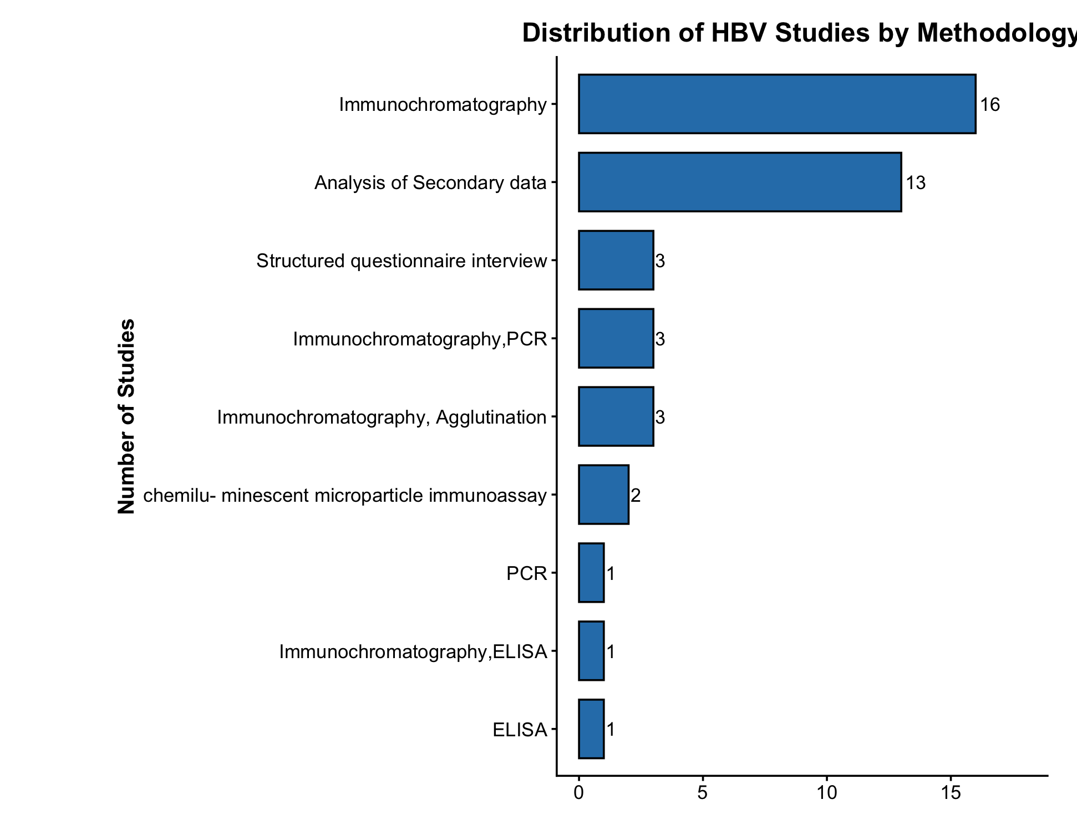
Figure 4: Distribution of HBV-related studies by Methodology in Sierra Leone(1997-2024)
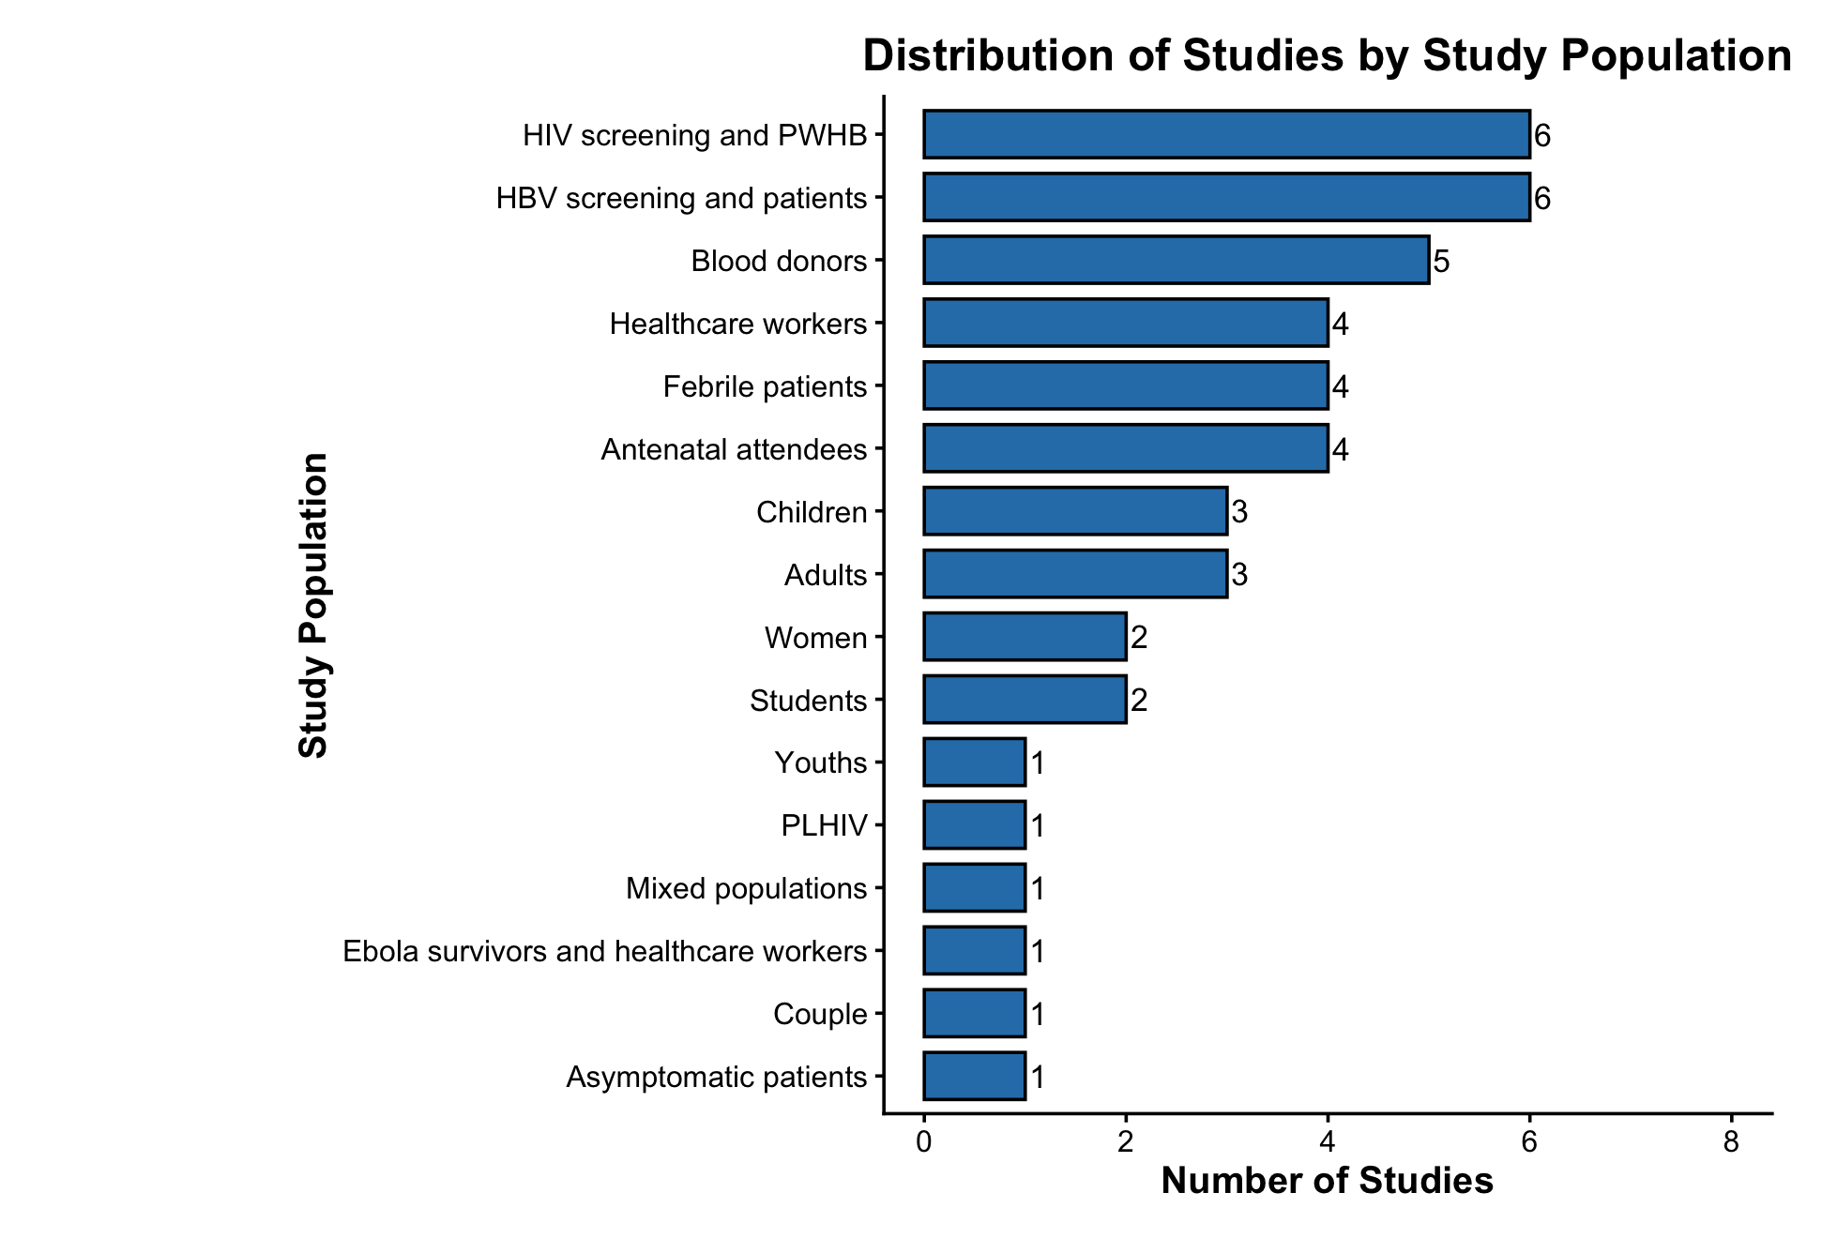
Figure 5: Distribution of HBV-related studies by Study Population in Sierra Leone(1997-2024)

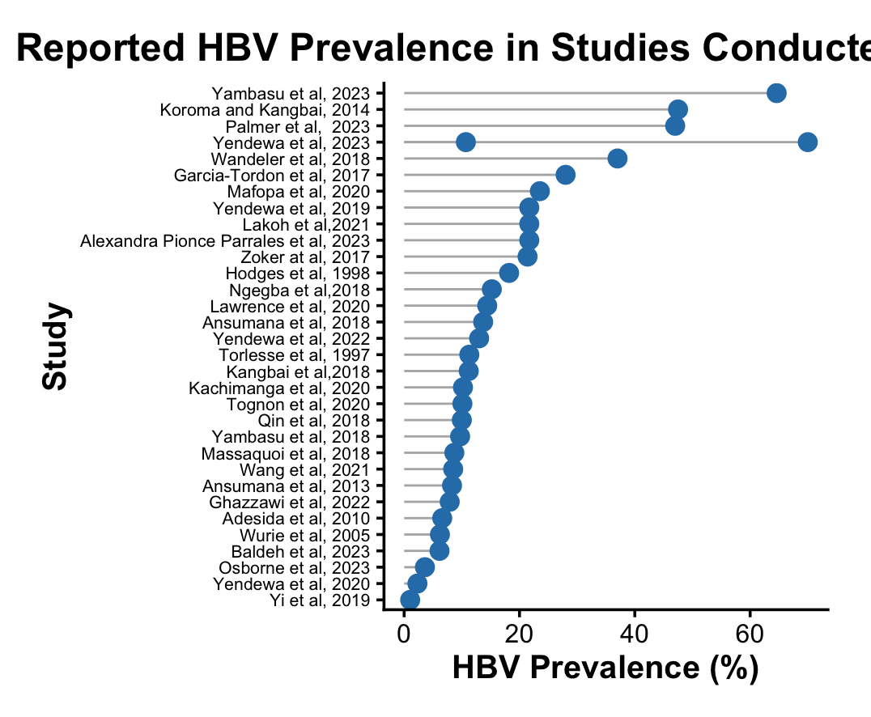
Figure 6: Reported HBV prevalence across the studies included in the scoping review
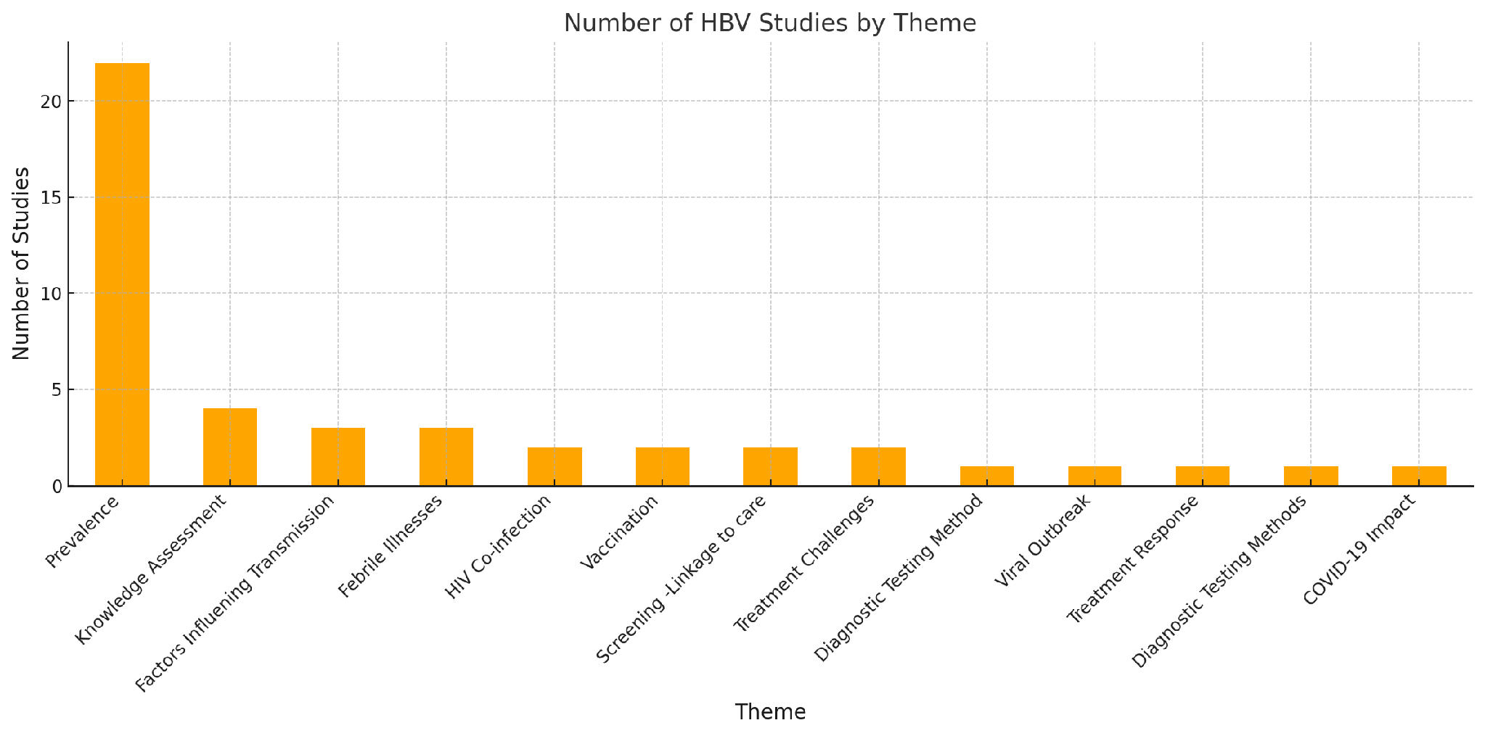
Figure 7:The Distribution of study themes
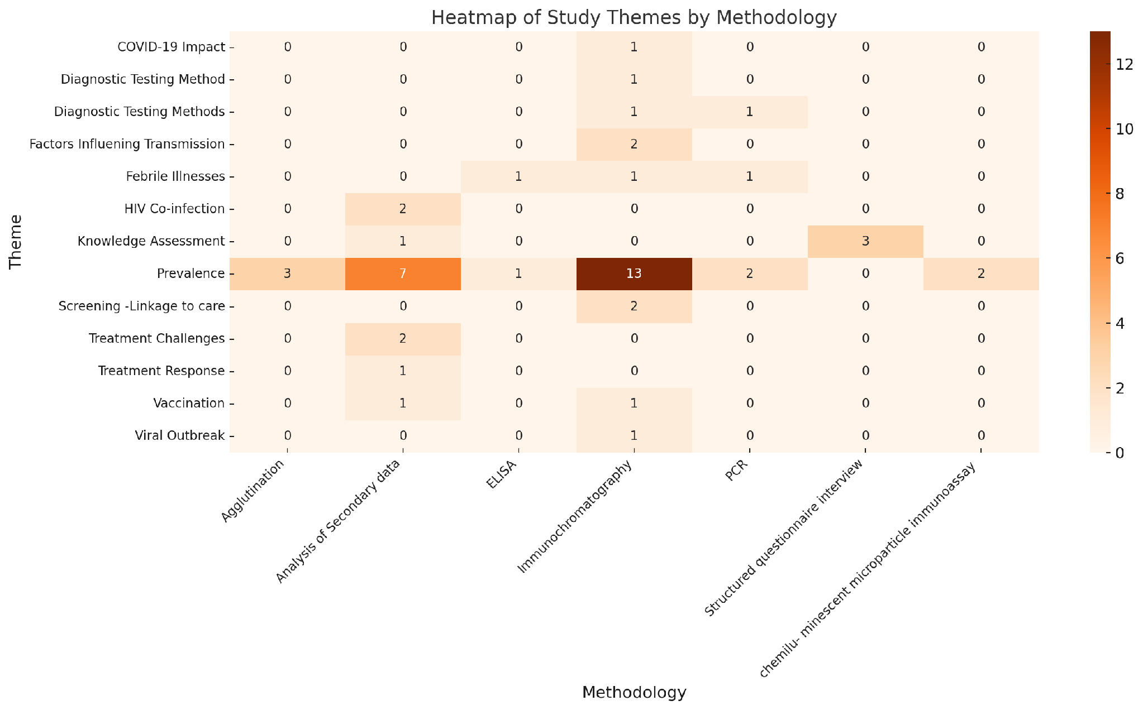
Figure 8: A heatmap showing the relationship between the Study themes and Study Methodologies

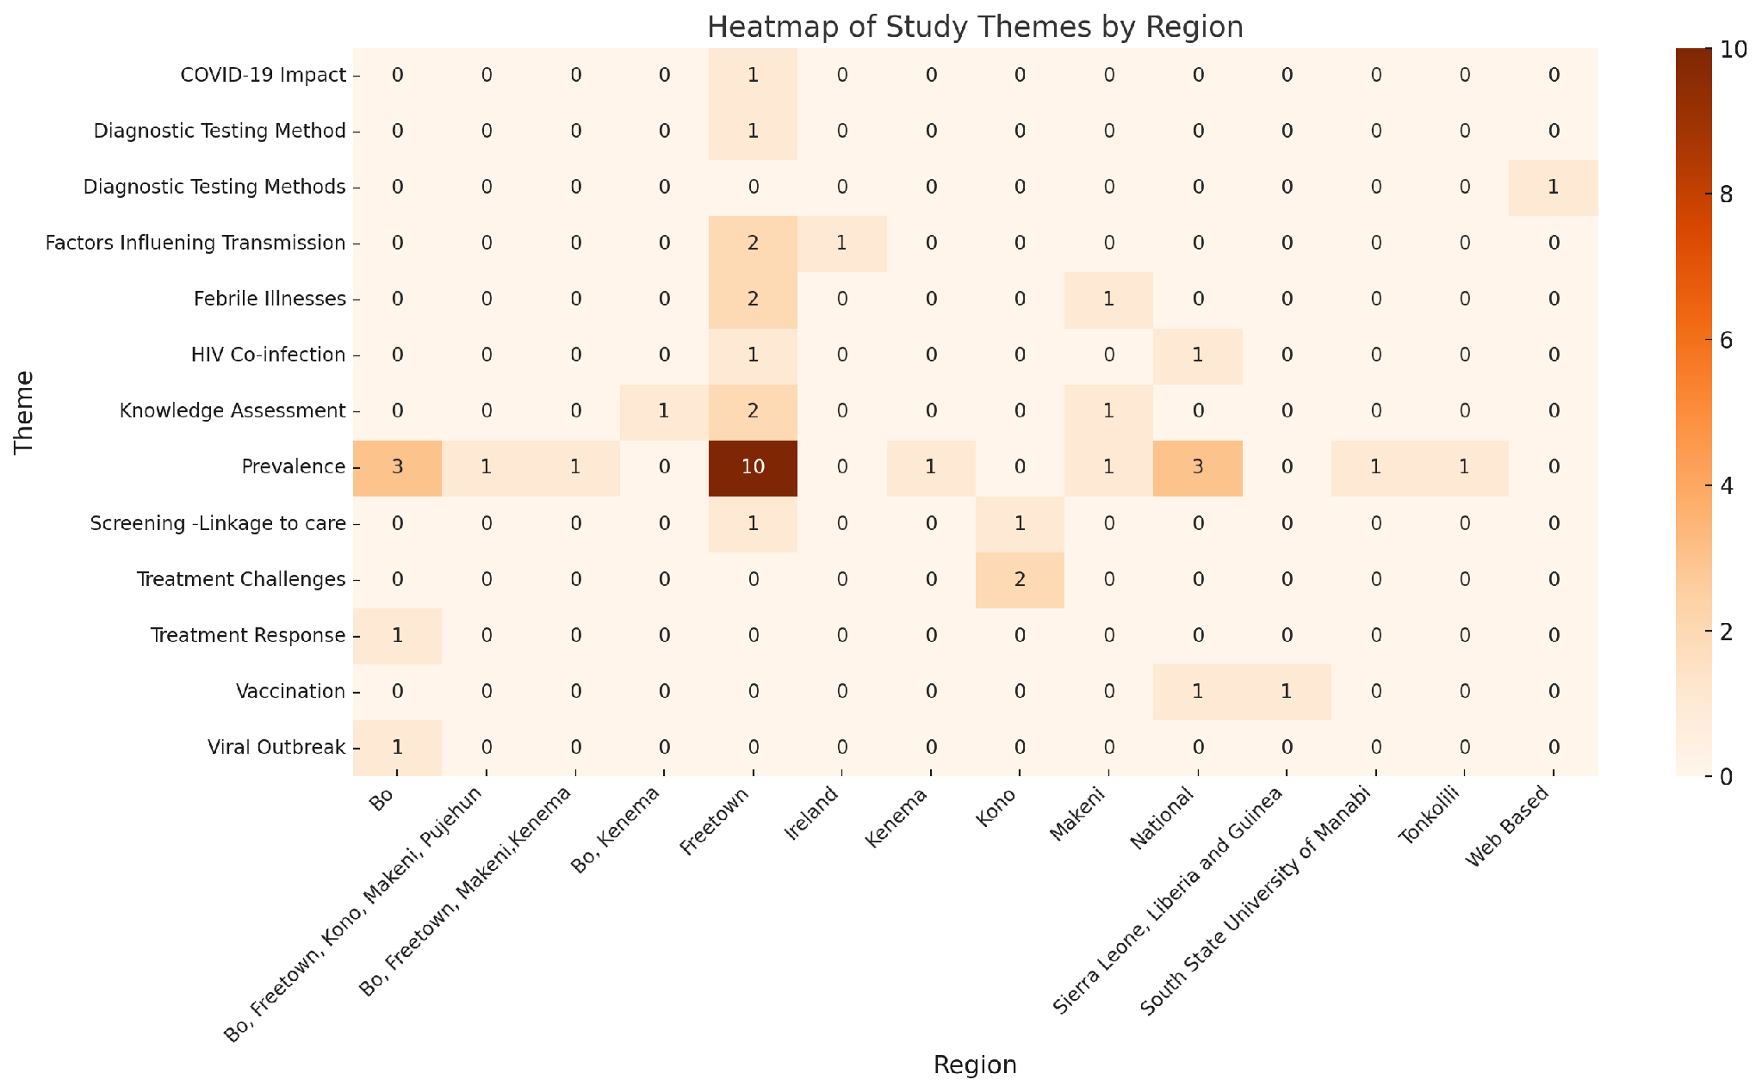
Figure 9: The Distribution of study themes across the different study regions

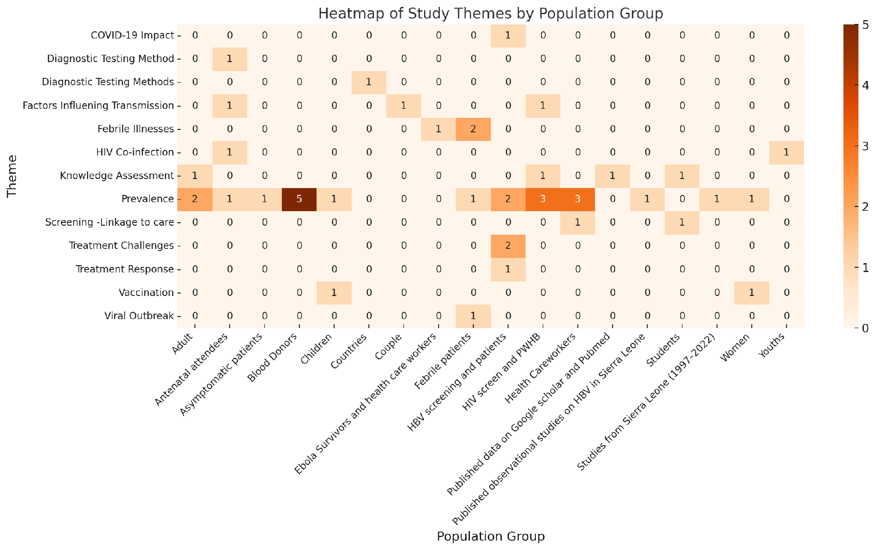
Figure 10: A heatmap showing the relationship between the Study themes and Study Population groups

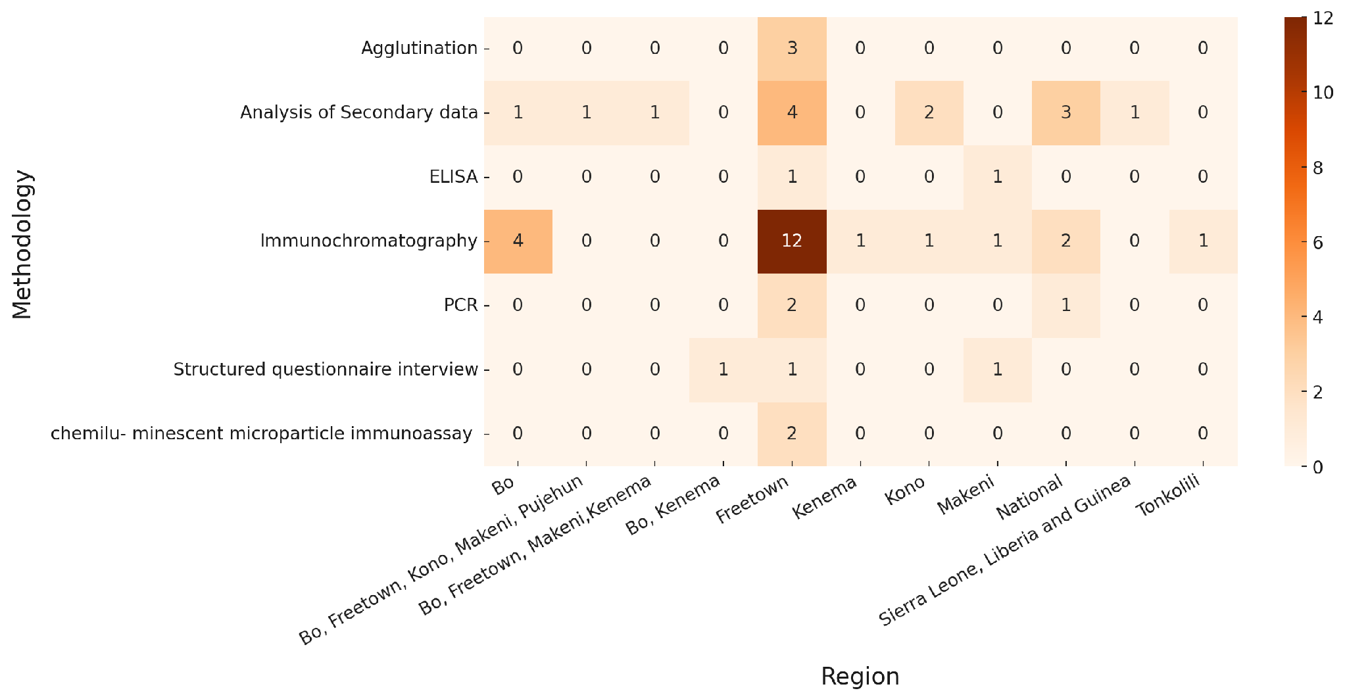 Figure 11: Heat map showing the frequency of methodology in the studies reviewed across locations

