Transforming Maternal and Child Health through Skilled Birth Attendance in Pastoral Ethiopia: Evidence from South Omo Zone

Author: H.E. Roman Tesfaye Abneh
teshetafesse@gmail.com
May 2025

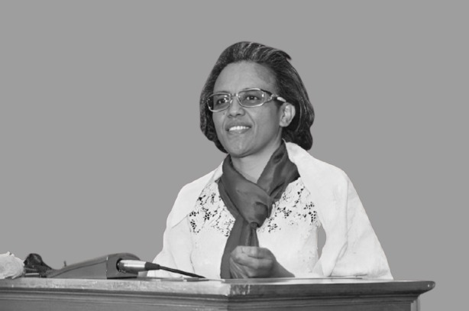
H.E. Roman Tesfaye, former First Lady of Ethiopia and CEO of the Hailemariam & Roman Foundation (HRF), has been a transformative leader in advancing maternal and child health (MCH) in Ethiopia, particularly in underserved pastoral regions like South Omo. Her strategic vision combines grassroots engagement, high-level advocacy, and systemic health reforms, positioning her as a pivotal figure in Ethiopia's public health landscape.

Abstract
This article presents empirical evidence on the impact of the Hailemariam & Roman Foundation (HRF)’s Reproductive, Maternal, Newborn, and Child Health (RMNCH) interventions implemented between 2021 and 2024 in the Hamar and Bena Tsemay districts of South Omo Zone, Ethiopia. The initiative achieved a 53.8% increase in skilled birth attendance in Hamar Woreda (from 34% to 52.3%) and an 8.6% increase in Bena Tsemay (from 86% to 94.6%), surpassing Ethiopia’s national target of 90% (FMoH, 2020). Over 140 health professionals, 20 health managers, and 23 community leaders were trained, while 64 Traditional Birth Attendants (TBAs) were integrated into the formal referral system —a strategy aligned with WHO recommendations for engaging informal providers to expand maternal health service coverage (WHO, 2015). Additionally, antenatal care (ANC) coverage increased, with over 80% of women attending at least one ANC visit, and 60% completing four or more—a significant improvement from baseline levels. Postnatal care (PNC) within 48 hours rose from under 20% to over 50%, and ambulance referrals quadrupled, enhancing emergency obstetric response. The findings demonstrate the effectiveness of combining health system strengthening, community-based engagement, strategic advocacy, and culturally tailored solutions to significantly improve maternal and neonatal health outcomes in underserved and remote regions, offering a compelling case for scaling up context-specific RMNCH strategies across pastoralist settings in sub-Saharan Africa.

- Introduction
Skilled birth attendance is widely recognized as a critical intervention for reducing maternal and neonatal mortality (United Nations Population Fund [UNFPA], 2018). Despite global efforts to improve maternal health outcomes, low- and middle-income countries continue to bear a disproportionate burden, accounting for 99% of all maternal deaths—over half of which occur in sub-Saharan Africa (World Health Organization [WHO], 2015). These deaths are largely preventable with timely access to skilled health professionals during pregnancy, childbirth, and the postnatal period. The World Health Organization emphasizes the need to strengthen health systems and expand access to trained personnel to reduce avoidable maternal and neonatal deaths (Kassie, Tadele, & Tessema, 2022).

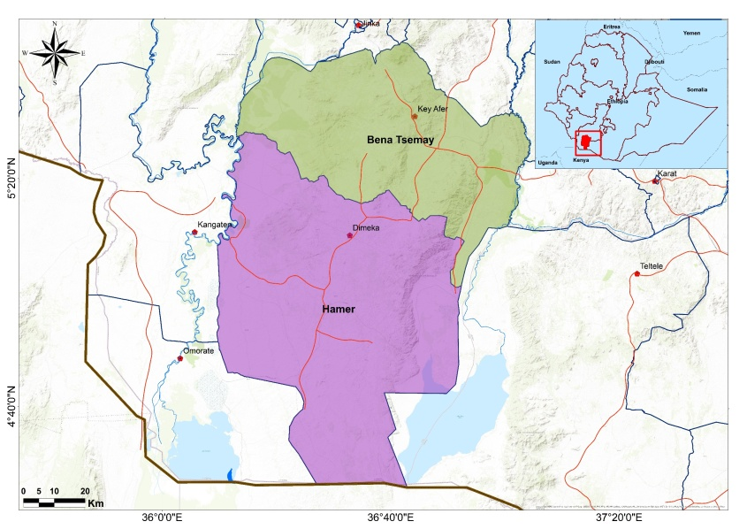
In Ethiopia, national efforts to improve maternal health indicators have yielded notable gains; however, disparities persist across regions. Remote and pastoralist areas such as South Omo, Afar, and Somali face persistent challenges, including a shortage of skilled health professionals, limited infrastructure, and barriers related to geography, culture, and mobility (Mesganaw, 2010). These systemic challenges have resulted in significantly lower utilization of maternal health services and poorer health outcomes in these regions compared to the national average.

The 2020 Baseline Assessment by the Hailemariam & Roman Foundation (HRF) revealed substantial gaps in maternal healthcare across South Omo Zone. These include limited community awareness, a shortage of skilled health personnel, inadequate infrastructure and medical supplies, and significant transportation barriers (HRF, 2020). Cultural norms that promote harmful practices often result in home births attended by untrained individuals (Worku et al., 2019), while the region’s challenging geography, susceptibility to flooding, and the mobility of pastoralist communities severely constrain emergency access to health facilities(UNICEF, 2020; Tsegaye et al., 2022). Such barriers are consistent with broader findings across remote and underserved areas in Ethiopia, where inequities in maternal health outcomes remain a major public health concern (Federal Ministry of Health [FMoH], 2020; UNICEF, 2019).

These baseline assessment findings highlight the urgent need for context-specific, equity-driven interventions to improve access to skilled maternal health services and reduce preventable deaths (HRF, 2020).The WHO also emphasizes the importance of culturally appropriate strategies and the integration of informal health providers into the formal system as critical measures to expanding maternal care coverage in resource-limited settings (WHO, 2015).

In response to these disparities, the Hailemariam & Roman Foundation (HRF), in collaboration with the Center for International Reproductive Health Training (CIRHT), implemented the Reproductive, Maternal, Newborn, and Child Health (RMNCH) interventions from 2021 to 2024 in the Hamar and Bena Tsemay woredas of South Omo Zone.

- Methodological Approach and Impact Assessment
Data for this article were gathered through a combination of methods to ensure a comprehensive understanding of the interventions’ impact. These included an analysis of health facility records, which provided quantitative data on health outcomes and service delivery metrics. Field observations were conducted to gain insights into the real-time challenges and successes observed during the intervention’s implementation. Furthermore, a joint monitoring visit, carried out in April 2024 by program implementers and key stakeholders, allowed for direct engagement with community members and local health workers, offering qualitative insights into the interventions’ effectiveness and areas for improvement. The combination of these data sources enabled a robust evaluation of the interventions’ impact on both the health system and the communities it aimed to serve.

- Interventions and Strategies
Pastoralist health systems are characterized by interdependent social, cultural, economic, and environmental factors, and the interventions must go beyond traditional, linear models, and adopt holistic strategies that address both demand-side barriers (such as cultural beliefs and social norms) and supply-side constraints (such as infrastructure and provider competencies) (Jebena et al., 2022).

From 2021 to 2024, the Hailemariam & Roman Foundation (HRF) implemented a comprehensive package of interventions to strengthen maternal health systems in the Hamar and Bena Tsemay woredas of South Omo Zone, Ethiopia. The interventions employed a comprehensive, multi-faceted approach aimed at addressing the key determinants of maternal and child health in the targeted pastoralist communities. This approach focused on three primary strategies: health system strengthening, community mobilization, and high-level advocacy. Health system strengthening efforts were directed at improving the capacity of local health facilities by enhancing infrastructure, increasing the availability of skilled health professionals, and ensuring the availability of essential medical supplies. Community mobilization aimed to raise awareness about maternal and child health issues, challenge harmful traditional practices, and foster community-led health initiatives. Additionally, high-level advocacy efforts targeted policymakers, government officials, community leaders and stakeholders to create an enabling environment for sustainable health reforms.

Central to the comprehensive package was the training of over 140 health professionals, 20 health managers, and 23 community leaders, complemented by the integration of 64 trained Traditional Birth Attendants (TBAs) into the formal referral system. By leveraging the cultural trust TBAs hold within communities, the project effectively promoted skilled birth attendance—an approach consistent with global recommendations for improving service uptake in rural settings (HRF Report, 2024; Sibley et al., 2007).

To address geographic and cultural barriers to institutional delivery, HRF constructed and equipped new Maternity Waiting Homes (MWHs) that provided culturally tailored services, including traditional meals, coffee ceremonies, and health education. These facilities helped mitigate challenges related to distance, transport, and social norms, thereby increasing utilization of maternal health services, as evidenced by studies on the effectiveness of culturally sensitive maternal care (Sullivan et al., 2016; Gabrysch & Campbell, 2009). The project also enhanced the referral system by donating and maintaining two ambulances, improving emergency obstetric care access and reducing delays in reaching skilled care—a critical factor in maternal survival (Thaddeus & Maine, 1994; Barros et al., 2012).

At the policy level, high-level advocacy led by HRF CEO and former First Lady H.E. Roman Tesfaye was pivotal in mobilizing key stakeholders and shaping public perceptions about institutional delivery. These advocacy efforts were essential in strengthening political commitment, thereby driving an increased demand for maternal health services. This aligns with findings in studies that emphasize the importance of political will in boosting health service utilization (Freedman et al., 2007; Richey et al., 2011). Additionally, community mobilization was bolstered by the establishment of effective grassroots networks, such as women’s one-to-five groups and the Women Development Army. Health Extension Workers (HEWs) played a key role in maintaining ongoing community engagement, promoting positive health behaviors, and encouraging the use of institutional care—an approach supported by research on the effectiveness of community-based health worker programs (FMOH, 2015; WHO, 2014).

To enhance diagnostic capacity, the project deployed four portable Doppler ultrasound machines to local health centers, leading to improved prenatal monitoring and a notable increase in facility-based service utilization—an outcome consistent with evidence linking ultrasound availability to higher antenatal care attendance and institutional delivery rates (Kawakatsu et al., 2014). Simultaneously, the renovation of four health posts and two health centers helped upgrade infrastructure and enhance the quality and reliability of maternity services. These facility-level investments were complemented by strong community engagement strategies. Local communities contributed to the sustainability of Maternity Waiting Homes (MWHs) by establishing nutrition gardens and making regular monthly contributions (10–30 birr per household), demonstrating the effectiveness of community-driven support mechanisms in sustaining maternal health interventions (UNFPA, 2018).

- Outcomes and Impact
  - Increase in Skilled Birth Attendance
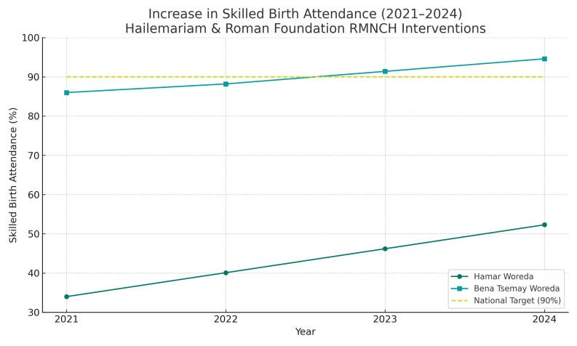
Between 2021 and 2024, skilled birth attendance in Hamar Woreda increased from 34% to 52.3%, while Bena Tsemay saw a rise from 86% to 94.6%, exceeding Ethiopia’s national target of 90% (FMOH, 2020). This improvement reflects the cumulative impact of workforce training, strengthened referral systems, and culturally tailored maternity waiting homes. These results are consistent with global evidence that access to skilled care during childbirth significantly reduces maternal and neonatal mortality (Campbell & Graham, 2006; WHO, 2015). Moreover, integrating TBAs into the referral chain proved effective in building trust and transitioning communities toward institutional deliveries—an approach endorsed in low-resource settings (Sibley et al., 2007).

  - Rise in Antenatal and Postnatal Care
Antenatal care (ANC) attendance improved markedly, with over 80% of pregnant women receiving at least one ANC visit and approximately 60% completing four or more visits—up from significantly lower baseline levels. Similarly, postnatal care (PNC) within 48 hours increased from below 20% to over 50%. These trends are in line with findings that sustained community outreach, health worker training, and availability of diagnostic services contribute to greater ANC and PNC utilization (Carroli et al., 2001; Pell et al., 2013). The introduction of portable Doppler ultrasounds served as a key motivator, improving risk detection and strengthening maternal-facility connections early in pregnancy.

  - Improved Emergency Response
Emergency obstetric care response improved substantially, with ambulance referrals quadrupling over the project period. This was accompanied by earlier identification of high-risk pregnancies, made possible through better-equipped health centers and the use of ultrasound technology. According to Thaddeus and Maine’s (1994) “three delays” model, reducing the delay in reaching care—especially through transport solutions—is critical in improving maternal outcomes. The integration of emergency transport with diagnostic capacity represents a model for comprehensive maternal risk management.

  - Health System Strengthening
The project significantly enhanced the capacity of local health systems. Health posts and centers were upgraded to offer 24/7 delivery services, improved diagnostics, and more robust staffing. Training for health workers and supportive supervision contributed to improved service quality and staff retention. These systemic improvements align with WHO’s framework for strengthening health systems to achieve universal health coverage (WHO, 2007). Additionally, functional community structures such as the Women Development Army ensured continuity in service delivery through grassroots-level mobilization (FMOH, 2015).

  - Enhanced Community Engagement
Community engagement deepened over the project’s duration, driven by inclusive strategies such as the integration of TBAs, culturally attuned MWHs, and high-level advocacy. Community members contributed monthly financial support and maintained nutrition gardens to sustain the MWHs—an approach that fostered ownership and reduced dependency. Literature underscores that community-driven models enhance program sustainability and reinforce the demand for maternal health services (UNFPA, 2018; Bhutta et al., 2010). Positive feedback from women who accessed MWHs further reinforced a virtuous cycle of trust and utilization.

- Conclusion
HRF’s integrated RMNCH interventions demonstrate that targeted investments, collaborative partnerships, and community-centered approaches can substantially improve skilled birth attendance and maternal health outcomes in remote pastoralist regions. The model presents scalable solutions applicable to other underserved areas in Ethiopia and across sub-Saharan Africa.

References
Barros, A. J. D., Ronsmans, C., Axelson, H., Loaiza, E., Bertoldi, A. D., França, G. V. A., ... & Victora, C. G. (2012). Equity in maternal, newborn, and child health interventions in Countdown to 2015: a retrospective review of survey data from 54 countries. The Lancet, 379(9822), 1225–1233.
Bhutta, Z. A., Lassi, Z. S., Blanc, A., & Donnay, F. (2010). Linkages among reproductive health, maternal health, and perinatal outcomes. Seminars in Perinatology, 34(6), 434–445.
Campbell, O. M. R., & Graham, W. J. (2006). Strategies for reducing maternal mortality: getting on with what works. The Lancet, 368(9543), 1284–1299.
Carroli, G., Rooney, C., & Villar, J. (2001). How effective is antenatal care in preventing maternal mortality and serious morbidity? An overview of the evidence. Paediatric and Perinatal Epidemiology, 15(s1), 1–42.
Federal Ministry of Health (FMOH). (2015). Health Sector Transformation Plan (HSTP) 2015/16–2019/20. Addis Ababa, Ethiopia.
Federal Ministry of Health (FMOH). (2020). Ethiopia Health Sector Performance Report 2019/20. Addis Ababa, Ethiopia.
Freedman, L. P., Waldman, R. J., de Pinho, H., Wirth, M. E., Chowdhury, M. E., & Rosenfield, A. (2007). Transforming health systems to improve the lives of women and children. The Lancet, 370(9595), 1287–1295.
Gabrysch, S., & Campbell, O. M. R. (2009). Still too far to walk: literature review of the determinants of delivery service use. BMC Pregnancy and Childbirth, 9, 34.
Hailemariam & Roman Foundation (HRF). (2020). Baseline Assessment Report: Maternal Health in South Omo Zone. Addis Ababa, Ethiopia.
Hailemariam & Roman Foundation (HRF). (2024). Project Completion Report: RMNCH Interventions in South Omo Zone. Addis Ababa, Ethiopia.
Jebena, M. G., Tadesse, T., & Eba, A. (2022). Health systems in pastoralist settings: a review of the interlinkages between contextual factors and service delivery in Ethiopia. Pastoralism: Research, Policy and Practice, 12(1), 1–13.
Kassie, G. M., Tadele, M. K., & Tessema, Z. T. (2022). Trends and determinants of skilled birth attendant utilization in Ethiopia: evidence from EDHS 2000–2016. BMC Public Health, 22, 142.
Kawakatsu, Y., Sugishita, T., Oruenjo, K., Wakhule, S., Kibosia, K., Were, E., & Honda, S. (2014). Determinants of health facility utilization for childbirth in rural western Kenya: cross-sectional study. BMC Pregnancy and Childbirth, 14, 265.
Mesganaw, F. (2010). Maternal health in Ethiopia: achievements and challenges. Ethiopian Medical Journal, 48(3), 25–29.
Pell, C., Meñaca, A., Were, F., Afrah, N. A., Chatio, S., Manda-Taylor, L., ... & Pool, R. (2013). Factors affecting antenatal care attendance: results from qualitative studies in Ghana, Kenya and Malawi. PLOS ONE, 8(1), e53747.
Richey, L. A., Mandarano, L., & Yamin, A. E. (2011). Political commitment, human rights, and maternal health: Understanding the gaps between policy and practice in Nigeria. Health and Human Rights, 13(2), 123–137.
Sibley, L. M., Sipe, T. A., Brown, C. M., Diallo, M. M., McNatt, K., & Habarta, N. (2007). Traditional birth attendant training for improving health behaviours and pregnancy outcomes. Cochrane Database of Systematic Reviews, (3), CD005460.
Sullivan, T. M., Suchdev, D. B., Ruth, L. J., & al Ayed, A. K. (2016). Cultural sensitivity in maternal health: understanding and responding to the unique needs of women in pastoral communities. Global Health: Science and Practice, 4(3), 447–457.
Thaddeus, S., & Maine, D. (1994). Too far to walk: maternal mortality in context. Social Science & Medicine, 38(8), 1091–1110.
Tsegaye, M., Bekele, D., & Gebre, A. (2022). Challenges and opportunities in maternal health service delivery in pastoralist communities: A case study from South Omo Zone, Ethiopia. Ethiopian Journal of Health Development, 36(1), 34–40.
United Nations Children’s Fund (UNICEF). (2019). The State of the World’s Children 2019: Children, Food and Nutrition. New York: UNICEF.
United Nations Children’s Fund (UNICEF). (2020). Maternal and Newborn Health Disparities in Ethiopia. New York: UNICEF.
United Nations Population Fund (UNFPA). (2018). State of the World’s Midwifery 2018: Investing in Midwives and Others with Midwifery Skills. New York: UNFPA.
Worku, A. G., Yalew, A. W., & Afework, M. F. (2019). Factors affecting utilization of skilled maternal care in Northwest Ethiopia: a multilevel analysis. BMC International Health and Human Rights, 19, 15.
World Health Organization (WHO). (2007). Everybody's Business: Strengthening Health Systems to Improve Health Outcomes: WHO’s Framework for Action. Geneva: WHO.
World Health Organization (WHO). (2014). Community Health Worker Programmes: A Review of Recent Evidence. Geneva: WHO.
World Health Organization (WHO). (2015). Trends in Maternal Mortality: 1990 to 2015. Geneva: WHO.

