FACTORS ASSOCIATED WITH RECURRENT URINARY TRACT INFECTIONS AMONG FEMALES OF REPRODUCTIVE AGE AT KISUGU HEALTH CENTRE III, UGANDA

KAVUMA SHARIF
REG NO.2018DPHARFT-A01

A RESEARCH DISSERTATION SUBMITTED TO THE INSTITUTE OF ALLIED HEALTH SCIENCES FOR THE PARTIAL FULFILLMENT OF THE REQUIREMENTS FOR THE AWARD OF DIPLOMA IN PHARMACY

CLARKE INTERNATIONAL UNIVERSITY
JANUARY 2022.

Declaration
I Kavuma Sharif declare that this dissertation document is my own work and has never been submitted to any higher institution of learning.
Name Kavuma Sharif
Signature

Date 05th /Jan/2022

Approval
I hereby declare that this research dissertation has been developed and submitted for examination under my supervision.

Sign
 Date: 05TH/Jan/2022.
Mrs. MARTHA NAKAYE (BMLS, MSc)
Institute of Allied Health Sciences,
Clarke International University

Dedication
I dedicate this research to my father Mr. Segirinya Haruna for his advocacy for my education and his provisions to ensure it is a successful path of education. I also dedicate this work to my mum Nabweteme Hanifah for her efforts.

Acknowledgement
I thank Allah for enabling me to complete this level and for the success I have achieved; I also thank Clarke International University, basically my supervisor Mrs. Marthae Nakaye, for the endless support given to me through this difficult road.
Special thanks to my father Mr. Segirinya Haruna for his endless provisions to me throughout my education and my mum Ms. Nabweteme Hanifah for the support.

Table of contents
Declaration 2
Approval 3
Dedication 4
Acknowledgement 5
List of acronyms 9
Definition of Terms 10
Abstract 11
Chapter One 12
Background 12
Problem statement 13
1.3 Objectives of the Study 13
1.3.1 Broad Objective 13
1.3.2 Specific Objectives 13
1.4 Research Questions 14
1.5 Significance of the study. 14
1.6 Conceptual frame work 15
1.6.1 Conceptual Framework. 15
1.7 Scope of study 16
1.7.1 Geographical scope 16
1.7.2 Content scope 16
Chapter Two 17
Literature review 17
2.0 Introduction 17
2.1 Female Recurrent UTIs Knowledge. 17
2.2 Recurrent UTIs Attitude among Females. 19
2.3 Female Recurrent UTIs Practices. 19
Chapter Three 23
Methodology 23
3.0 Introduction 23
3.1 Study Design 23
3.2 Study Area 23
3.3 Study Population 23
3.4 Selection Criteria 23
3.4.1 Inclusion Criteria 23
3.4.2 Exclusion Criteria 24
3.5 Sample Size Estimation 24
3.6 Sampling Procedure 24
3.7 Study Variables 24
Dependent Variable 24
Independent Variables 25
3.8 Data Collection Methods 25
3.8.1 Data Collection Tool 25
3.8.2 Data Collection Procedure 25
3.9 Interpretation of Results 26
3.10 Quality Control 26
3.11 Data Analysis 26
3.12 Data Presentation 27
3.13 Limitations of the Study 27
3.14 Ethical Considerations 27
Chapter Four 28
Results 28
4.0 Introduction 28
4.1 Prevalence of Recurrent UTIs 28
4.2 Knowledge on Recurrent UTIs 29
4.3 Attitudes on recurrent UTIs. 32
4.4 Recurrent UTIs Practices. 33
Chapter Five 37
Discussion 37
5.0 Introduction 37
5.1 Recurrent UTIs Prevalence. 37
5.2 Knowledge on Recurrent UTIs 37
5.3 Attitudes of recurrent UTIs. 38
5.4 Recurrent UTIs Practices. 39
5.4.1 Hygiene Practices 39
5.4.2 Sex and Reproductive Practices. 39
5.4.3 Medical and Treatment related Practices. 39
5.5. Integration of With the Conceptual Framework. 40
Conclusion 40
Recommendations 41
References 43
APPENDIX 1 ESTIMATED BUDGET 49
APPENDIX II: WORK PLAN 50
APPENDIX III: INFORMED CONSENT 51
APPENDIX V: INTRODUCTORY LETTER 58
APPENDIX VI: RISK MANAGEMENT PLAN 59
APPENDIX VII: MAP OF KISUGU 60

List of acronyms
AMR: Antimicrobial Resistance
AST: Antimicrobial Susceptibility Testing.
CTX: Cotrimoxazole
CDC: Centre for Disease Control
CA-UTI: Community Acquired Urinary Tract Infections
E. coli: Escherichia coli
ESBL: Extended spectrum Beta Lactamase
HA-UTI: Hospital Acquired Urinary Tract Infection.
MHA: Muller Hinton Agar
MIC: Minimum Inhibitory Concentration
S. Aureus: Staphylococcus aureus
UTI: Urinary tract infections
WHO: World Health Organization
XDR: Extensively Drug-resistant

Definition of Terms
Antimicrobial
Drug used against the micro-organism that can either kill or prevent growth of the microbe.
Antimicrobial resistance
Ability of an organism to resist the effect of a drug used against it
Bacteria
These are unicellular organisms that are microscopic in size that cause infections.
Community Acquired-Urinary tract infections (CA-UTI)
These are urinary tract infections acquired from the community.
Culture media
This is the medium where microbes are grown.
Culturing
This is the process of growing microbes on different media.
Incidence
This is the occurrence of the new infections
Hospital Acquired-Urinary tract infection (HA-UTI)
These are infections that are acquired from the hospital i.e. occur among the admitted patients.
Microbes
These are organisms that are microscopic in size that can cause diseases to human.
Pathogen These are disease causing organisms.
Prevalence: The proportion of a population who have a certain condition, disease or infection at a given period of time
Recurrence: The fact of the urinary tract infection occurring again
Recurrent Urinary tract infections
This is when UTI (Urinary tract infection) reoccurs i.e. the threshold of 3 UTIs in a year or 2 UTIs in 6 months.

Urinary tract infections (UTIs): These are infections of the urinary tract caused mainly by bacteria.

Abstract
Women of reproductive age in Uganda still suffer from recurrent urinary tract infections (UTIs), a major public health problem. The assessment of factors associated with recurrent UTIs among females aged 15 – 49 years attending Kisugu Health Centre III, Kampala.
A cross-sectional study conducted on 144 randomly selected samples with the help of an interviewer-administered questionnaire to assess knowledge, attitudes and practices of recurrent UTI. The analysis of data was done in SPSS version 21. For the association, chi-square was applied at p<0.05. Of participants 36.8% had recurrent UTIs.
Most of the respondents admitted that UTIs can recur, but only 53.5% showed good overall knowledge which was significantly associated with recurrence (p=0.049). The improper technique of wiping, high level of coitus, poor medication adherence and co-existing disease conditions like diabetes.
Although individuals generally opted to seek health care, difficulty in getting the support they needed was a barrier they faced due to embarrassment. According to this study, strengthening preventive measures and providing enhanced counselling and targeted health education will help reduce recurrent UTIs in females.

Chapter One

Background
Globally, the impact of urinary tract infections (UTIs) remains to be significant, and current estimates put the prevalence of 150-160 million people in the country every year (Gupta et al., 2001). Lifetime incidence rates in women are also significantly high (50 to 60 percent) , a figure that intensifies the high vulnerability of female sex to such infections. Depending on the geographical area, prevalence rates stand at 19.6 -20% in Europe and 24 -20% in developing nations (Medina and Castillo‑Pino, 2019). Empirical data also reports an increased risk of UTIs in women; almost every 3rd woman has had an experience of UTI by 24 years old (Besty Foxman and Brown, 2003). In Asia, the rates were observed to be 9.8 percent in the studies carried out in 17 countries involved (Lee et al., 2018). Additional variability is found in the African data that show an incidence of 4.5 percent by Algeria and 0.7 percent by Senegal using regional surveillance.

Centers of disease control and prevention (CDC) divides UTIs into bladder and kidney infections and always finds bladder infection as the most common form of UTIs. UTIs have been commonly diagnosed in community practices where empirical treatment is started on the foundation of traditional clinical characteristics. There is strong evidence to prove that Escherichia coli which is a commensal of the intestinal flora is the most common etiologic agent (Payam Behzabi, 2010). Other pathogens such as Klebsiella, Proteus and Pseudomonas aeruginosa have also been seen as important contributors (Yilmaz et al., 2016). UTIs are bacterial infections that spread out of the rectal or cutaneous microbiota and extend to the urinary system through the urethra, the organ most frequently affected being the bladder. UTIs recurring are three or more of the same episodes within 12 months. A cohort study in Spain reported 27 percent of women getting recurrence within six months, 2.7 percent getting a second recurrence in the same period (Alos, 2005).

UTIs are a topical health problem within the Kisugu Parish, Kampala. However, the exact predictors of repeat among the reproductive age females are yet to be clearly understood. The current research, therefore, will be carried out at Kisugu Health Centre III in an effort to clarify the issues related to frequent UTIs in women living at Kisugu, Kampala, Uganda.

Problem statement
UTIs in females have been noted to be 14.6% in Uganda (Kabugo et al., 2016). This number differs depending on districts, but always reflects a greater number of females being burdened as compared to males. Bushenyi District had a prevalence of 32.2% with most of the cases being among females of reproductive age (Odoki et al., 2019). Similar studies in Mulago National Referral Hospital also revealed that the rates of UTIs in females were higher than in males (Kabugo et al., 2016; Odongo, 2020).

Although the Ministry of Health today undertakes a variety of interventions, such as health education, reproductive health services and primary health-care strategies, the UTI rates are still high throughout the district-level, implying that the existing interventions might be insufficient to tackle the burden of the infection. Moreover, there are no peer-reviewed articles that directly look into the factors behind the frequent UTIs in females in the Kisugu Parish or the entire Uganda.

As a result, this study aims at establishing factors that cause repeated UTIs in reproductive-age females accessing Kisugu Health Centre III, Kampala, Uganda.

1.3 Objectives of the Study

1.3.1 Broad Objective
To determine the factors associated with recurrent urinary tract infections among females of reproductive age attending Kisugu Health Centre III, Kampala, Uganda.

1.3.2 Specific Objectives
- To assess the knowledge on recurrent urinary tract infections among females of reproductive age at Kisugu Health Centre III, Kampala, Uganda.
- To determine the attitudes towards recurrent urinary tract infections among females of reproductive age at Kisugu Health Centre III, Kampala, Uganda.
- To determine the practices related to recurrent urinary tract infections among females of reproductive age at Kisugu Health Centre III, Kampala, Uganda.

1.4 Research Questions
- What is the level of knowledge on recurrent urinary tract infections among females of reproductive age at Kisugu Health Centre III, Kampala, Uganda?
- What are the attitudes towards recurrent urinary tract infections among females of reproductive age at Kisugu Health Centre III, Kampala, Uganda?
- What are the practices related to recurrent urinary tract infections among females of reproductive age at Kisugu Health Centre III, Kampala, Uganda?

1.5 Significance of the study.
The proposed study aims at generating evidence that is empirically based with regard to the predictors of recurrent UTI among women of reproductive age in Kisugu Parish. The findings of the results are expected to be beneficial to the local community, health staff at Kisugu Health Centre III, and other peripheral stakeholders since they address the understanding of behavioral, knowledge-based, and practice-related factors that contribute to the frequent UTIs. These insights can be used to inform specific educational interventions, promote timely behavior to seek health, and also inform the design of more effective preventive measures.

In addition, the study can provide useful advice to the policy-makers and those engaged in primary health-care programs and services, which could guide improvement of the recurrent UTI burden mitigation methods. Academically, the project will complement the available academic material and will be made as the completion of part of the requirements to award a Diploma in Pharmacy.

1.6 Conceptual frame work

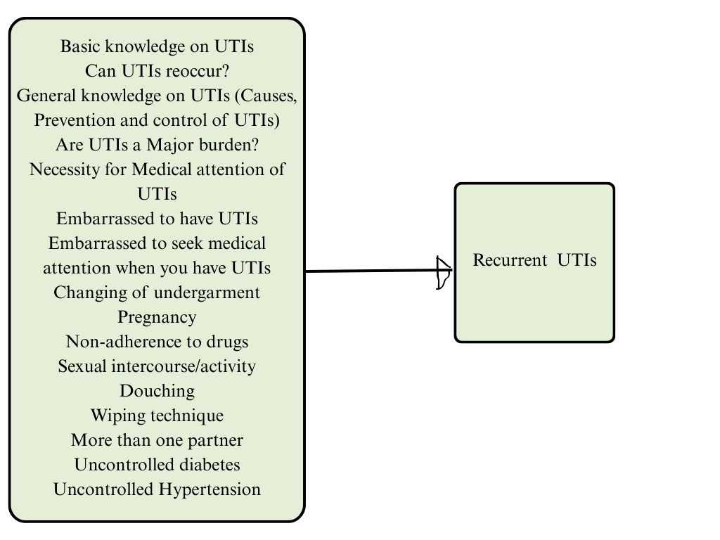

1.6.1 Conceptual Framework.
The study conceptualizes that several factors may be associated with recurrent urinary tract infections among females of reproductive age. These include:
- Knowledge-based variables: understanding of UTIs, the understanding of the mechanisms of recurrence, and the awareness of risk factors;
- Attitudinal factors: embarrassment about UTIs, attitude towards medical consultation, attitude to treatment options;
- Practice-related determinants: Adherence to medications, personal hygiene behaviors, sexual behaviors (e.g. frequency of intercourse, multiple partner), undergarments, wiping behaviors, body mass index, socioeconomic status and co-morbid conditions (e.g. diabetes, hypertension, etc.).
These variables are independent predictors postulated to influence the dependent variable- reoccurrence of UTI.

1.7 Scope of study

1.7.1 Geographical scope
The research will be done within Kisugu Health Centre III, which is located in Kampala, Uganda.

1.7.2 Content scope
The inquiry will be based on establishing determinants related to recurrent urinary tract infections among reproductive-age women in Kisugu Health Centre III, by evaluating the knowledge, attitudes, and practices of the participants on recurrent UTI.

Chapter Two

Literature review

2.0 Introduction
The chapter provides a detailed literature review on available studies regarding the causes of recurrent urinary tract infections (UTIs) in women. It integrates the body of knowledge, attitudes, and practice regarding the recurrent UTIs, with special focus on those studies that would be relevant to the Ugandan context and other similar circumstances.

2.1 Female Recurrent UTIs Knowledge.
Infection of the urinary tract among women is widespread: 50-60 percent of the women in the United States are estimated to get one UTI in their life (Foxman et al., 2000). Recurrent UTIs are always operationalized in terms of two or three positive urine cultures in 1 year or six months respectively (Foster, 2008; Mohsin and Siddiqui, 2010). In a cohort study of women of reproductive age at Washington University, the incidence of 0.7 UTIs per year was reported (Scholes, 2000).

The information about UTIs varies significantly through populations. As an example, in a study of primigravida expectant mothers in Nepal, aged 24-25 years, 24.39 per cent of the respondents had poor knowledge, 65.05 per cent of respondents had average knowledge, and 10.56 per cent had good knowledge on UTIs (Adhikari & Dhakal, 2015). The same group was the least educated on the etiological factors and incidence of UTIs and had a higher level of understanding of treatment modalities. A Dutch study also found that women with a lower degree of education were less aware of the causes, prevention, and treatment of UTIs, which was especially severe in women with repeated incidences (Geerlings, 2008).

Patients with underlying medical conditions are at high risk of developing UTI. As an illustration, diabetic patients have a significantly increased susceptibility to UTIs than non-diabetics do (De Lastours & Foxman, 2014). This relationship is explained by the fact that neuropathy caused by diabetes may lead to the inability to empty the bladder completely, and, therefore, to promote the increase of bacteria and their infection (Funfstuck et al., 2012). This has also been demonstrated in Canadian studies (Nicolle, 2005), and a retrospective, Dutch study of women of 30 and older years, which also reported that diabetic women were more likely to have recurrent UTIs (Gorter et al., 2010), a result supported by another study in the Netherlands (Schneeberger et al., 2008).

The literature also highlights the key role that education plays in the development of UTI knowledge. One of the studies conducted in Southern Ethiopia has shown that patients with less education had a poor knowledge of UTI, its causes, and prevention (Tadesse et al., 2014). Similar results were found in a Kenyan study of pregnant women, with only low levels of knowledge: 37.6 per cent of the participants were unable to list any causes of UTIs, and only a minority of them mentioned poor urogenital hygiene (9 per cent), sexual intercourse (17.6 per cent), or wearing damp underwear (10 per cent) (Onyango et al., 2018). This lack of knowledge was linked to the poor use of hygiene and late access to medical services, which led to poor health outcomes, but the same research study did not report statistically significant differences between the level of education and the occurrence of UTI (Onyango et al., 2018). Similar results were obtained in Tanzania (Masinde et al., 2009).

Tanzanian researches also outline the most vulnerable populations such as women living with HIV into which the UTI prevalence reached 14.2% as opposed to 6% in men infected with HIV (Ngowi et al., 2021). This difference can be partially explained by anatomical reasons, a shorter female urethra and the closeness to the anus that makes it easier to ascend with bacteria. According to another research conducted in Tanzania, the risk of UTIs was higher among pregnant women aged 1825 years, which implies that age and the risk of infections are related (Mwabete & M. Msigwa, 2017).

A study conducted in Uganda cited a prevalence of UTI of 13.3 9 (Andabati and Byamugisha, 2010). The variables related to sporadic UTIs are similar to the variables related to recurrent UTIs; gender, age, and marital status were also found to significantly correlate with the involvement of UTI in a study conducted at Mulago Hospital (Kabugo et al., 2016). However, there are no published researchers who specifically investigate the knowledge about recurrent UTIs in Uganda, including Kisugu, which creates an evidence gap that the research aims to address.

2.2 Recurrent UTIs Attitude among Females.

The studies prove that the attitudes toward urinary tract infections (UTIs) may significantly affect care-seeking behavior and preventive measures. (Minejima et al., 2019) have found that one-fourth of patients claimed to be embarrassed by the presence of UTI and one-eighth of patients did not seek medical care due to the fear of stigma. Seyeded (2014) determined that in Iran, the moderate or average attitude toward UTIs existed among pregnant women and that organized educational meetings and workshops would improve the attitude, practices, and knowledge of women.

Navarro et al. (2019) also found in the Philippines that despite a lack of optimality in the knowledge about UTIs, a significant number of pregnant women had a positive attitude to prevent the disease. On the same note, (Santoso et al., 2017) indicated that the high, or good, attitudes towards UTIs among pregnant Indonesian women are associated with understanding the preventive importance of UTIs. According to an African study by Hazwell and Matafwali Sichilima, (2020), in Zambia, a knowledge-enhancement initiative among mothers who used the antenatal care unit might be beneficial to change the attitudes and awareness of UTI.

2.3 Female Recurrent UTIs Practices.

Various researches have attributed frequent UTIs in females to certain behavioral habits. In the United States, K et al. (1999) documented that sexual activity and spermicide use were some of the most common practices that led to recurrence of UTI. These findings were confirmed by Cai T (2021), once again, these behaviors were recognized as risk factors. According to Griebling (2005), women who use cotton absorbent garments have the possibility of incident of recurrent UTIs being reduced and that the undergarment material was one of the contributing factors. Alos (2005) conducted a study in Spain that found that 50-60 per cent of adult females had one UTI in their lifetime and that about10 per cent of postmenopausal females had one UTI in the last year. She noted also that Escherichia coli infections were more recurrent, perhaps because of such practices like wiping back to front after toileting, which allows fecal flora to settle on the periurethral region.

Other studies also focus on other behavioral and physiological predictors. An example is Epp (2010) in Canada, Foster (2008) in the United States and Mohsin and Siddiqui (2010) in Pakistan, which all found a relationship between one sexual partner, age at first UTI and voiding dysfunction and recurrent UTIs. Nicolle (2005) conducted a prospective Canadian research, which reported 15-19 episodes of bacteriuria over the period of 24 hours following sexual intercourse, which showed the strong impact of sexual behavior on the recurrence of infection. Additional risk factors have been highlighted by other studies: in Australia, Jones-Freeman et al. (2021) highlighted repeated infections can be followed back to bladder colonization, bacterial persistence and reinfection-facilitating practices; in Washington, USA, Thanert et al. (2019) did the same, and in the study of Rosen et al. (2007) as well.

A number of behavioral and physiological practices have been noted to increase susceptibility of recurrent UTIs in women. UTIs have been found to be recurrent among premenopausal women due to poor wiping technique that is characterized by back-to-front wiping, vaginal douching, deferred voiding, restrictive underwear use, and late voiding before or after sex (Scholes, 2000).

Pregnant women in a cohort study carried out in England were identified as having a significant relationship between pregnancy, diabetes mellitus, and immunosuppression and recurrent UTIs. High blood glucose level was observed to facilitate growth of bacteria in the urine (Franco, 2005). The same results were obtained in China (Wang et al., 2013), Brazil (Truzzi et al., 2008), and Israeli studies (Nitzan et al., 2015) where hyperglycemia and impaired immunity were confirmed as key factors in the recurrence of UTIs.

Two studies of diabetic patients in Kuwait showed that 35 percent of diabetic urine cultures were positive to UTIs with most of the infections being among women who had uncontrolled blood sugar levels (Sewify et al., 2016; Benwan, 2010). The findings of another Israeli study confirmed the prevalence of UTIs in women with uncontrolled diabetes and poor glycemic control as a major risk factor (Nitzan et al., 2015).

Repeat UTIs are costly in terms of economic cost. UTIs in diabetic patients were also estimated to cost over 2.3million USD per year in the United States and UTIs in young women were reported to be a significant cause of morbidity and spending on health care (Simersing et al., 2017).

A study at Assiut University in Egypt discovered that uncontrolled diabetic women had a high chance of getting UTIs due to the high levels of urine glucose, which acts as a good growing medium to microbes (Aly, 2016). The other Egyptian study found that there were links between undergarment material, the number of undergarment changes per month and the frequent UTIs with a higher likelihood of recurrence with the increase in sexual intercourse (Dimetry et al., 2007).

A case study in southeastern Nigeria noted that the incidence of UTI increased with age with the highest rates being recorded in middle-aged and sexually active women and pregnant women (Oli et al., 2017). Ethiopian studies also highlighted that pregnancy causes hormonal and mechanical alterations predisposing women to the vesicoureteral reflux hence increasing the risk of infections (Debalke et al., 2014). Since the vagina and anus are anatomically close, gastrointestinal bacteria, especially E. coli, can easily find their way into the vagina during improper wiping or intercourse, and can increase the chances of infection (Subramaniam, 2016).

In a Kenyan study, UTI was found prevalent at 15.7% in pregnant women, and was more prevalent in multiparous women (72.7%). The correlation between parity and UTI was however not significant. The same study established that women who had multiple sexual partners were more likely to develop UTI and use of non-cotton underwear aggravated the risk. Moreover, undergarments were rarely changed, and it increased cases of UTI (Onyango et al. and Nedi, 2018).

In Uganda, there is a consistent finding of the leading cause of UTIs being caused by E. coli and the practice of wiping the perineum back to front is a factor that has been identified to contribute immensely to the prevalence of UTIs as well as their recurrence of the disease among women (Andabati and Byamugisha, 2010). A Ugandan research of Mulago Hospital also found that UTIs are closely related to diabetes and explained this by the altered immunity, uncontrolled blood glucose, and diabetic neuropathy resulting in incomplete bladder emptying (Odoki et al., 2019). Although UTIs are a problem in Uganda, no published reports have studied the attitude or practice of women contributing to recurrent UTIs especially in women who are of reproductive age. This literature gap is the reason why the current study is necessary.

The analyzed literature proves that the complex of knowledge gaps, attitudes, and everyday practices is a complex determinant of recurrent urinary tract infection among females of reproductive age. The results of the various settings have always indicated that inadequate knowledge on the causes, prevention and recurrence of UTI has been contributing to delayed healthcare-seeking and treatment failure. The attitudinal issues that include shame and stigma anxiety also contribute to delayed care. Furthermore, the recurrence of UTIs has been strongly associated with a number of behavioural practices, such as low perineal hygiene, high level of sexual activity, use of non-cotton undergarments, delayed voiding and uncontrolled diabetes.

Although the well-established risk factors are already identified according to the international and regional studies, there is still a great gap in Uganda in terms of knowledge, attitudes and practices related to recurrent UTIs among women. No literature has investigated these factors in reproductive women in Kisugu or any other urban context. Such deficiency highlights the significance of the current research, which aims to produce context-specific information that will help inform the target health education, enhance prevention measures, and eventually decrease the morbidity of frequent UTIs in the group.

Chapter Three

Methodology

3.0 Introduction
The chapter states the methodology used to conduct the study to examine the factors related to frequent urinary tract infections in females of reproductive age at Kisugu Health Centre III. It describes the design of the study, the geographical area, the population, the estimation of sample size, the sampling technique to be applied in the study, the study variables and data collection methods used in the study.

3.1 Study Design
In the study, the cross-sectional design was adopted, which is suitable in estimating the prevalence rates of recurrent UTIs and analyzing related variables at one point in time among the study population.

3.2 Study Area
The research was conducted in Kisugu Health Centre 3, located in the Kisugu Parish, Makindye Division, Kampala, District, Uganda. The health facility offers a variety of services such as outpatient care, maternal and reproductive health services and is available to the various urban populations (See Map: Appendix V).

3.3 Study Population
The population used in the study comprised females between the age of 15 and 49 years who visited Kisugu Health Centre III between the study period.

3.4 Selection Criteria

3.4.1 Inclusion Criteria
The females aged 15‑49 years who gave informed consent to take part in the study in writing.

3.4.2 Exclusion Criteria
Women who were either unconscious or they could not answer the questions.
Females actively in labor during the period of data collection.

3.5 Sample Size Estimation
To calculate the estimated sample size, the formula was used.
Sample size was estimated using the formula
N= 4P (1-P)/d²
N= 144
Where N= required sample size, 4 is a standard value, P= estimated proportion of women (15-49) years with recurrent UTIs is 10%, error at 5% (0.05), Q= 1-P
A number of 144 participants was found as a result of the calculation.

3.6 Sampling Procedure
The study used simple random sampling to select the study participants. The sampling frame was all females of reproductive age (15 -49 years), who visited Kisugu Health Centre III within the study period and had to respond to the inclusion criteria. All the relevant participants were allowed equal opportunities in selection; therefore, the sample was representative of the target population. A lottery was used to select the participants until the required sample size of 144 was reached. The process of recruiting was done to the various departments of the health facility to reduce selection bias. The questionnaire was refined by analyzing preliminary answers to make it easier to understand and minimizing ambiguous answers.

3.7 Study Variables

Dependent Variable
Recurrent urinary tract infection (UTI) was defined as 2 or more UTI episodes in six months with 3 or more episodes in one year based on self-report of history gathered by means of questionnaire.

Independent Variables
The information about frequent UTIs.
UTIs-related attitudes and healthcare-seeking.
Hygiene, sexual behavior, voiding habits, and lifestyle factors are practices that lead to recurrence.

The association between the independent variables and the recurrent UTIs have been evaluated to come up with variables that are significantly connected to the recurrence.

3.8 Data Collection Methods

3.8.1 Data Collection Tool
The structured interviewer-administered questionnaire (Appendix IV) was used to gather data. The questionnaire was created to include the detailed data on the socio-demographic features of the participants and their history of urinary tract infection as well as the knowledge, attitudes, and practices concerning the recurring UTIs. Pre-test was made to refine the tool in order to make it clear, appropriate, and relevant to the study objectives.

3.8.2 Data Collection Procedure
The questionnaire was administered to the respondents privately by the principal researcher in the presence of the trained research assistants within the health facility to achieve confidentiality and reduce the chances of bias in the responses. The participants were interviewed in isolation and questions were clarified using a language that the participant found comfortable to ensure the appropriate way of understanding and responding to the questions. The responses of the participants were taken down in a systematic way and any clarifications that were required during the interview process were made and this facilitated accuracy of the data.

Data collection process was based on acquiring sound information about:
UTI history Number of episodes in the past six months and one year.
Knowledge -Awareness of causes, symptoms, prevention and recurrence of UTI.

Attitudes -Perceptions, stigma, and health seeking behavior towards UTIs.

Practices- Sexual behavior, hygiene practices, voiding habits, and other lifestyle factors that may contribute to UTI recurrence.

The approach was used to capture complete and quality data to respond to the study objectives successfully.

3.9 Interpretation of Results
Recurrent urinary tract infection (UTI) was determined to be three or more episodes of UTI in the last twelve months or two or more episodes of UTI in the last six months. Those participants who qualified this condition at the time of data collection were also characterized as having recurrent UTIs that occurred recently, which implied the probability of further recurrence. Those who had a history similar within a period of more than twelve months earlier were placed under the past recurrent UTIs. Participants had their knowledge, attitudes, and practices compared on the cases in the past and recent to determine the patterns and factors that relate to UTI recurrence.

3.10 Quality Control
To ensure clarity and relevancy, the questionnaire underwent pre-testing on a representative sample of the population not a part of the research and subsequent modifications were made on the questionnaire. Standardized data-collection procedures, ethical considerations and study objectives were taught to research assistants so that they could be consistent and accurate. The quality of data was on the basis of two data entry and checking by the principal researcher. Completeness, consistency, and accuracy checks were done in the course of routine checking in order to uphold data integrity.

3.11 Data Analysis
The data gathered were verified to be complete, were cleaned and inputted in a computer to be analyzed. The SPSS version 21 was used to conduct statistical analysis. The chi-square test was used to evaluate the relationship between the independent variables (knowledge, attitudes and practices) and the dependent variable (recurrent UTIs). In all inferential analyses, p -values below 0.05 were considered statistically significant and a 95 percent confidence level was used.

3.12 Data Presentation
Tables, graphs, and pie charts were used to show the results in a clear and comprehensive way to give the findings of the study. The descriptive statistics identified the quantitative data and the inferential statistics were used to depict associations between variables.

3.13 Limitations of the Study
The study was carried out over a short period, which could have impacted on the sample size and the data collection area. Secondly, the history of UTI relied on self-report, and this could have caused recall bias.

3.14 Ethical Considerations
The ethics permission was granted by the concerned authorities before the data was collected. The study was done voluntarily, and all the participants have been given comprehensive information on the objectives and procedures of the study. Each participant signed an informed consent in writing and was well explained and understood. The privacy and confidentiality were achieved through code assignment rather than names to questionnaires. Questionnaires filled were safely placed under lock and key and only accessed by the main researcher. The interviews were done privately thus avoiding the violation of confidentiality. A study approval was granted by Kisugu Health Centre III to do the work to have access to the participants and the facility. Ethical aspects included educating participants about preventative aspects, as well as risk factors of recurring UTIs as a direct benefit of the study.

Chapter Four

Results

4.0 Introduction
The chapter provides the results of the study on 144 females of reproductive age who visited Kisugu Health Centre III. Findings will be presented in a manner that is based on the study objectives, including prevalence of recurrent urinary tract infections (UTIs), knowledge, attitudes and practices that relate to recurrence. Data are either provided in narrative format and with the support of corresponding tables and figures.

4.1 Prevalence of Recurrent UTIs
The frequency of recurrent UTIs was identified by determining the number of UTI incidences in 1 year. The respondents that reported three or more episodes were considered to experience recurrent UTIs. The findings include that 36.8% of the respondents had recurrent UTIs and 63.2% had less than three incidences. This proves that over a third of the women visiting the facility had experienced recurrent UTIs, which indicates that there was a high burden among this group of people.
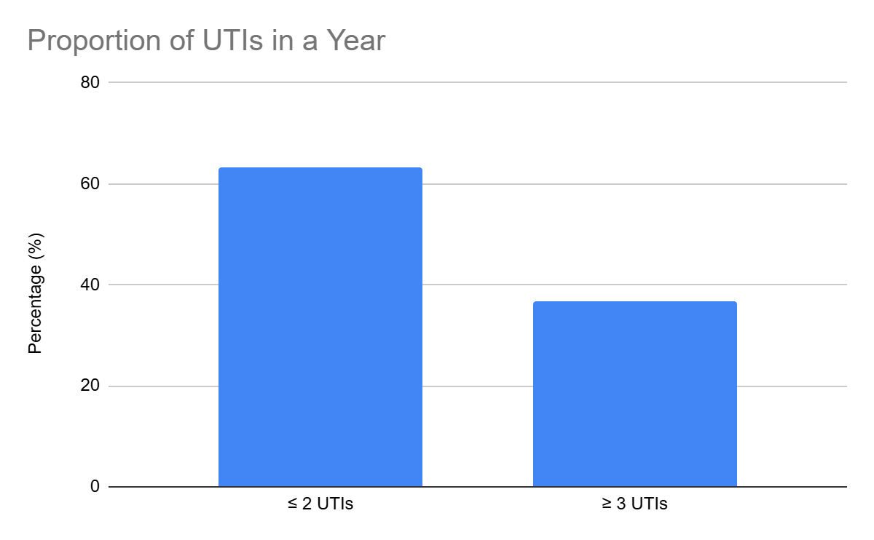

Figure 1: Proportion of UTIs in a year (%)

4.2 Knowledge on Recurrent UTIs
The first knowledge was measured by asking the respondents to answer whether they were aware of the possibility of recurrence of UTIs. Basic awareness was high as most participants (88.9) indicated they were aware of UTI recurrence.
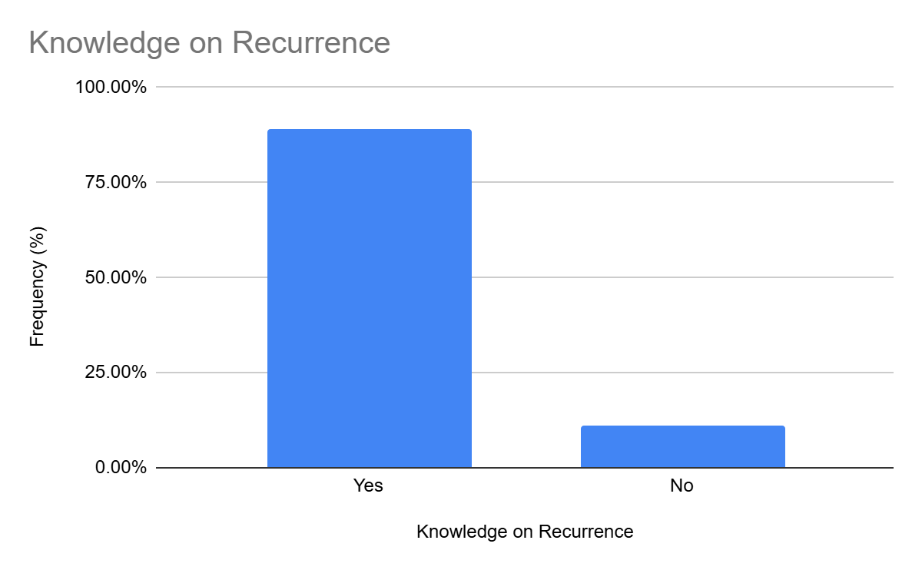

Figure 2: Knowledge on Recurrent UTIs in proportions

In addition to mere awareness, general knowledge of respondents was measured and divided into poor, average or good. More than 53.5% of the respondents represented good knowledge, whereas 31.3% represented poor knowledge and 15.3% represented average knowledge.
Table 1: General Knowledge on UTIs in it.

Knowledge Level | Frequency (n) | Percentage (%)
Poor | 45 | 31.3
Average | 22 | 15.3
Good | 77 | 53.5
Total | 144 | 100

(Insert Figure 3: General Knowledge Levels on UTI)

The correlation between the general knowledge and the UTI recurrence was studied using a cross- tabulation. The results revealed that frequent UTIs were more prevalent among poorly knowledgeable respondents than good knowledge ones.
Table 2: Cross-tabulation of Knowledge Level and UTI Recurrence

Knowledge Level | Recurrent UTIs (≥3 episodes) | Non-recurrent UTIs (<3 episodes) | Total
Poor | 10 | 35 | 45
Average | 10 | 12 | 22
Good | 33 | 44 | 77
Total | 53 | 91 | 144

Interpretation: The relationship between knowledge level and the frequency of UTI was observed to vary between the initial and subsequent UTIs. Interpretation: It was found that the association between the level of knowledge and the frequency of the UTI differed between the first and the second UTI.
A cross-tabulation was conducted to examine the relationship between general knowledge and UTI recurrence. The findings indicated that recurrent UTIs were more common among respondents with poor knowledge compared to those with good knowledge.
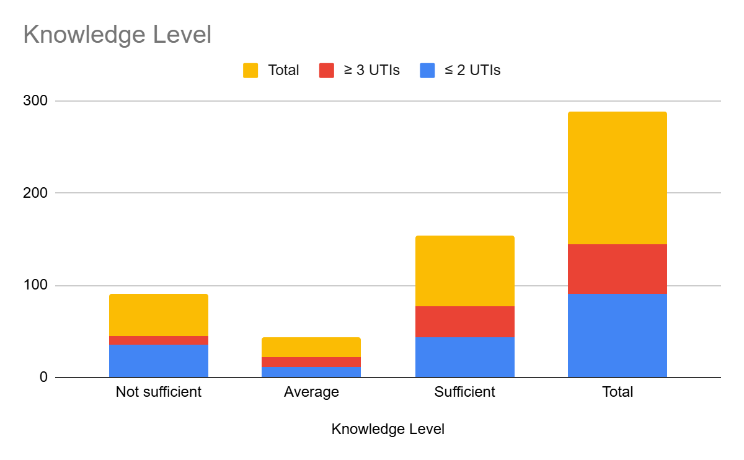

A chi-square test was used to reveal the statistically significant relationship between the level of knowledge and recurrent UTIs (p = 0.049). This implies that women who have low knowledge levels will have higher chances of developing recurrent UTI cases and thus proper health education on UTI prevention is significant.
Table 3: Chi-square Test of Knowledge and Recurrent UTIs

Variable Tested | Chi-square Value (χ²) | df | p-value
Knowledge level vs UTI recurrence | 6.035 | 2 | 0.049*

4.3 Attitudes on recurrent UTIs.
The attitude of the respondents towards UTIs was measured to determine how perceptions and emotional attitudes might affect the health-seeking behavior. Almost half of the respondents said that they were embarrassed to have a UTI and 41% said they felt embarrassed to consult a doctor. Nevertheless, most (93.8 %) of them reported that they would consult a doctor in case they experienced the symptoms of UTI, and 97.9% of them would clearly describe their symptoms to a specialist.
Table 4: Attitudes Towards Recurrent UTIs

Attitude Statement | Response Category | Frequency (n) | Percentage (%)
Embarrassed to have a UTI | Yes | 68 | 47.2
 | No | 76 | 52.8
Embarrassed to seek medical attention | Yes | 59 | 41.0
 | No | 85 | 59.0
Would seek medical attention when experiencing UTI symptoms | Yes | 135 | 93.8
 | No | 9 | 6.3
Would clearly explain symptoms to the doctor | Yes | 141 | 97.9
 | No | 3 | 2.1

Indeed, the majority of nurses exhibit a moderate level of disinterest in their work. As a matter of fact, most nurses are moderately disinterested in their work.

These results show a general positive health-seeking attitude in spite of a feeling of embarrassment that can delay the accessibility of timely care among some individuals.

4.4 Recurrent UTIs Practices.
The hygiene, sexual, medical, and obstetric practices were looked into in order to determine the behavioral determinants of recurrent urinary tract infections (UTIs). Hygiene data showed that 51.4% of the respondents used a back-to-front wiping method and this is a factor that trans locates perianal bacteria into the urethral canal. Only 38.9% of the participants followed the suggested front-to-back method.
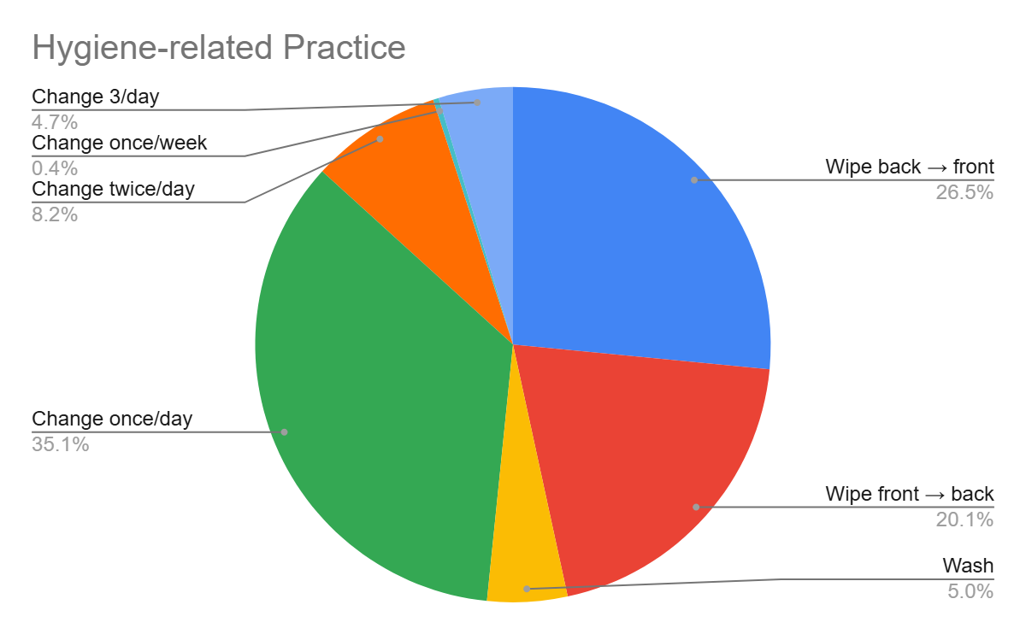
Sexual habits were also exhibiting tendencies that were relevant to UTI recurrence. A large proportion of respondents (88.2%) reported a sexual activity with most of them reporting a sexual experience with a husband and 29.3% with a boyfriend. Sexual activity is a documented risk factor of UTIs, and this trend can be one of the reasons for the recurrence rates.

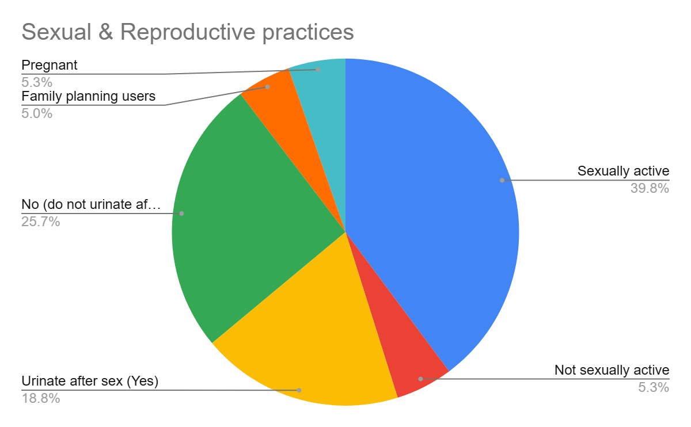

It can be contended that the target audience consists of older adults who are sexually active and who might face certain challenges or difficulties in fulfilling their sexual desires and needs. One can argue that the target audience is that of the older adult population that is sexually active and may experience some challenges or problems in their sexual needs and desires.

Medical related practices: The adherence rate to prescribed antimicrobials was at (79.9%), showing a high level of association with the recurrent UTIs. In addition, although a small proportion of the study population had uncontrolled diabetes (0.7) and hypertension (2.8), the conditions were relatively highly associated with recurrence as it has been reported that metabolic mismanagement (poorly controlled diabetes) increases predisposition to infection. Mode of delivery also showed a very strong relationship, and women who had vaginal delivery were more likely to report recurrent UTIs.
Other steps that were undertaken during the last UTI episode showed that a number of respondents self-medicated, used herbal remedies, or used analgesics without consulting a professional medical care- behaviors that are linked to high recurrence risks.
Table5: Practices Related to Recurrent UTIs

Practice Variable | Response Category | Frequency (n) | Percentage (%)
Wiping method | Back to front | 74 | 51.4
 | Front to back | 56 | 38.9
 | Wash with water | 14 | 9.7
Sexual intercourse | Yes | 127 | 88.2
 | No | 17 | 11.8
Sex partner | Husband | 85 | 59.0
 | Boyfriend | 42 | 29.3
 | Not sexually active | 17 | 11.8
Drug adherence | Non-adherence | 115 | 79.9
 | Adhered | 29 | 20.1
Comorbidities | Uncontrolled diabetes | 1 | 0.7
 | Uncontrolled pressure | 4 | 2.8
Mode of Delivery | Vaginal delivery | 88 | 61.1
 | C-section | 12 | 8.3
 | No delivery history | 44 | 30.6
Action during last UTI episode | Self-medication | 9 | 6.3
 | Used herbs | 3 | 2.1
 | Took painkillers only | 5 | 3.5
 | Went to health facility | 127 | 88.2

Chapter Five

Discussion

5.0 Introduction
The current chapter has explicated the results on the determinants of recurrent UTIs in reproductive age women who attended Kisugu Health Centre III. The presentation is based on the objectives of the study and summarizes the findings with the literature, biological plausibility, and the idea of the conceptual framework on which the study was conducted. The most important findings are discussed to clarify the impact of knowledge, attitudes, and practices on the prevalence of recurrent UTIs among this group of people.

5.1 Recurrent UTIs Prevalence.
It was found that 36.8% of the respondents had recurrent UTIs, defined as three or more episodes in one year. It is significantly higher than the national rate of 14.6% reported by Kabugo et al. (2016), and other African settings (Algeria at 4.5% and Senegal at 0.7%). The high prevalence rate in Kisugu implies that repeated infections are perpetuated by local behavioral, environmental and health-seeking factors.

The prevalence is consistent with the literature in Spain where the recurrent UTI rate was 27% in six months (Alos, 2005). This congruency shows that frequent UTIs are an international issue among women who are of reproductive age. The possible factors are the increased exposure to bacterial exposure due to anatomical vulnerability, sexual activity, and hygiene behavior- all of which are observed among the subjects in this study.

5.2 Knowledge on Recurrent UTIs
Even though 88.9% of the respondents were aware that UTIs can be recurrent, in-depth evaluation revealed that 53.5% of them had sufficient understanding of it, and 31.3% had limited comprehension. The level of knowledge was linked to frequent UTI occurrence (p = 0.049) which highlights the fact that simple knowledge of the influences is not enough but in-depth knowledge is central to the prevention of UTI.

The trend is similar to other countries such as Nepal (Adhikari and Dhakal, 2015) and Kenya (Onyango et al., 2018), where women had high awareness but had little knowledge on causes, prevention and risk factors. Geerings (2008) further mentioned that lower educated women tend to have less knowledge as regards to UTIs.

Poor knowledge in this regard is a probable cause of maladaptive behaviors, including improper wiping method, improper use of medication, or delayed care-seeking, which are likely to escalate the likelihood of recurrence. The conceptual framework places knowledge in the position of a determinant that influences the attitude as well as practices and the findings affirm this relationship.

5.3 Attitudes of recurrent UTIs.
The analysis identified complex attitudes: even though almost half of the participants expressed embarrassment about having UTI, a significant proportion of potential users (93.8%) said that they would seek medical care when the symptoms appeared. Embarrassment is a psychosocial obstacle which is widely mentioned in the literature. Similar outcomes were reported by Minejima et al. (2019), as nearly a quarter of women were embarrassed and this factor led to the delayed shame into care.

However, the attitudes of this study were more positive in terms of health seeking behavior, which is in line with the studies carried out in Indonesia (Santoso et al., 2017) and the Philippines (Navarro et al., 2019), where pregnant women reported willingness to undertake preventive measures despite knowledge deficiencies.

The interplay between embarrassment and good intent indicates that, though women realize that treatment is needed, they are affected by stigma and social discomforts when it comes to the promptness of seeking health services. Such a delay may lead to inappropriate treatment, partial clearance of bacteria and recurrence.

5.4 Recurrent UTIs Practices.
Practices became the most powerful type of factors that were associated with repeated UTIs. Several behavioral patterns proved significantly statistically relevant and high biological plausibility, which are consistent with the existing literature.

5.4.1 Hygiene Practices
51.4% of the respondents said they wiped back to front, a behavior that has been known to inoculate perianal bacteria, most specifically with Escherichia coli, into the urethra. This result is in line with the results of other studies in the United States, Egypt, and Uganda where poor wiping practices significantly enhanced recurrence of UTI (Alos, 2005; Dimetry et al., 2007; Andabati and Byamugisha, 2010). The process behind this risk is explained by the anatomical position of the anus and the urethra in the female body.

5.4.2 Sex and Reproductive Practices.
Sexual activity was not low (88.2%), and some of the respondents had more than one partner. Sexual intercourse is always mentioned in the literature as one of the most significant risk factors of UTIs and relapse, as it is mechanically introduced into the urethra and causes the introduction of bacteria (K et al., 1999; Foster, 2008). Similar relationships were found in Spanish, Australian, and North American research, which supports the result on the Kisugu population.

Mode of delivery showed a high correlation with recurrence and vaginal delivery was more likely to cause higher risks. Such biological plausibility lies in the fact that obstetric trauma can result in a change in the structure of the pelvic floor or urethral positioning thus predisposing women to incomplete bladder emptying, an identified risk factor (Franco, 2005).

5.4.3 Medical and Treatment related Practices.
There was a startling level of non-compliance with prescription of 79.9% of the respondents. It is a severe factor in constant infection, where untreated treatment will result in bacterial survival and resistance. The same result has been reported in Canadian research (Nicolle, 2005) and in diabetic patients of Kuwait (Sewify et al., 2016).
Moreover, although a small number of respondents indicated that they had uncontrolled diabetes or hypertension, they had a strong relationship with recurrence. This agrees with the various researches (Gorter et al., 2010; Nitzan et al., 2015) that revealed that immunity is impaired by poor glycemic control and favors bacterial growth.
Self-medication, use of herbs and dependency on painkillers-mentioned by a percentage of the participants towards their last UTI episode- also lead to poor management and recurrence. Such behaviors indicate knowledge and accessibility lapses to adequate care.

5.5. Integration of With the Conceptual Framework.
The conceptual framework presented that knowledge, attitudes, and practices interact to determine UTIs recurrence. The results of the study are very much in favor of this model:
The knowledge gaps were factors in the low practices like wrong wiping, non-adherence, and absence of preventive behaviors.
Health-seeking behavior was mediated by attitudes, especially embarrassment, which might delay treatment.
The practices had a direct influence on the biological risk pathways and were the best predictors of recurrence.
Therefore, the frequent cases of UTIs among this population are caused by a set of behavioral, cognitive, and psychosocial factors, which is in line with the interactional model described in the initial part of the paper.

Conclusion
The paper has looked at the factors related with recurrent urinary tract infection in women of reproductive age who visit Kisugu Health Centre III. The results indicate that an occurrence of UTIs is a major health issue among the population, with more than a third of the respondents having three or more incidents per year. High prevalence is an indication of a complex of behavioral, cognitive and clinical vulnerabilities that make women susceptible to recurrent infections.

The paper concludes that knowledge, attitudes, and practices are correlated towards the impact on recurrent UTIs. Whereas the rudimentary knowledge of UTI recurrence was significant, there still existed an enormous void in in-depth knowledge of causes, risk factors, and prevention. Such knowledge gaps had major links to recurrence, and were also manifested in inappropriate practices including wrong wiping methods, inadequate medication compliance, and self-medication in times of UTI. There were also attitudinal barriers like embarrassment where most respondents noted that they would seek medical attention when they would be symptomatic.

Recurrence was also linked to clinical factors like uncontrolled diabetes, hypertension and a history of vaginal birth which confirms biological evidence showing that comorbidities and obstetric history can contribute to failure of urinary tract health. Sexual activity, especially multiple partners, also adds risk and this is much in line with established epidemiological trends. In general, the paper points out that frequent UTIs in women are not only single cases of clinical manifestations but rather a compound interaction of knowledge, behavior, attitudes and physiological states.

The results highlight the importance of increased specific health education, enhanced counselling on facility level, and organized screening of modifiable risk factors. To minimize the rates of recurrence and enhance the quality of life of women in this society, these determinants should be tackled as a whole.

Recommendations
Empower Health Education and Awareness: Kisugu Health Centre III needs to initiate organized health education that concentrates on prevention of UTI, proper hygiene practices and need to take full medication compliance seriously. There should be focus on the risk factors like wiping technique, sexual hygiene and early symptom recognition. This must be included in the normal outpatient services, maternal health clinics and the community outreach programs.

Enhance Clinical Management and Counselling: Individual counselling to women should be offered by healthcare workers so that women can be aware of prescribed treatment and the effects of not pursuing treatment. The mechanism of follow-ups, like reminder phone calls or brief return-visit plans, needs to be implemented to ensure compliance, as well as to prevent self-medication.
Discuss Psychosocial Challenges to Care: A program of interventions based on the minimization of embarrassment related to the symptoms of UTI should be developed. This can incorporate sensitization efforts that encourage free discussion on reproductive health of women and provision of non-judgmental clinical settings.

Improve Pre-testing of Comorbidities: Outpatient services should also include routine screening of diabetes and hypertension as they play a big role in the occurrence of UTIs. Women with such diagnoses are to be provided with special counselling on the risk of infection and a strict control of blood glucose and blood pressure.

Spread Safer Sexual and Reproductive Health Practices: Sexual risk factors should be discussed during health education, and the practices which decrease the risk of UTI should be promoted. In preventing UTI in sexually active women, and particularly, the ones who experience frequent infections, clinicians should consider preventive measures, including post-coital voiding and irritant product avoidance.

Create Community-based Interventions: CHWs have the potential to be critical performers with regards to the spread of the prevention messages, the identification of the women at high risk, and the connection of the women to prompt care. The problem of household, partner, and mother sensitization at the community level has the potential to establish a favorable environment that supports the adoption of healthy practices.

Strengthening of Policy at the level of the facility: Kisugu Health Centre III should be assisted by the Ministry of Health and Kampala City Council Authority (KCCA) to enhance diagnostic capacity, provision of drugs, and the provision of staff with continuous professional training in infection management.
Future Research Recommendation: Future research ought to investigate the patterns of microbial resistance of women with recurring UTIs in this context because recurrence of antimicrobial resistance may be a cause of the recurrence. It is also suggested that qualitative research should be undertaken to determine more behavioral and socio-cultural issues affecting hygiene and health-seeking behavior.

References
Adhikari, S. and Dhakal, R. (2015) ‘Knowledge on Urinary Tract Infection among Primigravida Women.’, undefined.
Alós (2005) ‘[Epidemiology and etiology of urinary tract infections in the community. Antimicrobial susceptibility of the main pathogens and clinical significance of resistance]’, Enfermedades infecciosas y microbiologia clinica, 23 Suppl 4(SUPPL.4), pp. 3–8. doi: 10.1157/13091442.
Aly, T. (2016) ‘Bacterial catheter-associated urinary tract infection in the Intensive Care Unit of Assiut University Hospital’, Al-Azhar Assiut Medical Journal, 14(2), p. 52. doi: 10.4103/1687-1693.192652.
Andabati, G. and Byamugisha, J. (2010) ‘Microbial aetiology and Sensitivity of asymptomatic bacteriuria among ante-natal mothers in Mulago hospital, Uganda’, African Health Sciences, 10(4), pp. 349–352. doi: 10.4314/ahs.v10i4.63842.
Benwan, A. (2010) ‘Etiology and antibiotic susceptibility patterns of community-and hospital-acquired urinary tract infections in a general hospital in Kuwait’, Medical Principles and Practice, 19(6), pp. 440–446. doi: 10.1159/000320301.
Besty Foxman and Brown (2003) ‘Epidemiology of urinary tract infections: transmission and risk factors, incidence, and costs’, Infectious disease clinics of North America, 17(2), pp. 227–241. doi: 10.1016/S0891-5520(03)00005-9.
Cai T, W. (2021) ‘A non-pharmacological approach to the treatment of urinary tract infections: case reports with Utipro ® Plus’, Drugs in context, 10. doi: 10.7573/DIC.2021-2-2.
Debalke, S. et al. (2014) ‘Urinary tract infection among antiretroviral therapy users and nonusers in jimma university specialized hospital, Jimma, Ethiopia’, International Journal of Microbiology, 2014. doi: 10.1155/2014/968716.
Dimetry et al. (2007) ‘Urinary tract infection and adverse outcome of pregnancy’, The Journal of the Egyptian Public Health Association, 82(3–4), pp. 203–218. Available at: https://pubmed.ncbi.nlm.nih.gov/18410708/ (Accessed: 9 September 2021).
Epp, A. et al. (2010) ‘Recurrent Urinary Tract Infection’, Journal of Obstetrics and Gynaecology Canada, 32(11), pp. 1082–1090. doi: 10.1016/S1701-2163(16)34717-X.
Flores-Mireles, A. L. et al. (2015) ‘Urinary tract infections: Epidemiology, mechanisms of infection and treatment options’, Nature Reviews Microbiology, 13(5), pp. 269–284. doi: 10.1038/nrmicro3432.
Foster, R. T. (2008) ‘Uncomplicated Urinary Tract Infections in Women’, Obstetrics and Gynecology Clinics of North America, 35(2), pp. 235–248. doi: 10.1016/J.OGC.2008.03.003.
Foxman, B. (1990) ‘Recurring urinary tract infection: Incidence and risk factors’, American Journal of Public Health, 80(3), pp. 331–333. doi: 10.2105/AJPH.80.3.331.
Foxman, B. et al. (2000) ‘Urinary tract infection: Self-reported incidence and associated costs’, Annals of Epidemiology, 10(8), pp. 509–515. doi: 10.1016/S1047-2797(00)00072-7.
Franco (2005) ‘Recurrent urinary tract infections’, Best practice & research. Clinical obstetrics & gynaecology, 19(6), pp. 861–873. doi: 10.1016/J.BPOBGYN.2005.08.003.
Fünfstück et al. (2012) ‘Urinary tract infection in patients with diabetes mellitus’, Clinical nephrology, 77(1), pp. 40–48. doi: 10.5414/CN107216.
Geerlings, S. (2008) ‘Knowledge about Urinary Tract Infections and Prevention in Women with Recurrent Urinary Tract Infections’. Idsa.
Gorter et al. (2010) ‘Risk of recurrent acute lower urinary tract infections and prescription pattern of antibiotics in women with and without diabetes in primary care’, Family practice, 27(4), pp. 379–385. doi: 10.1093/FAMPRA/CMQ026.
Griebling (2005) ‘Urologic diseases in America project: trends in resource use for urinary tract infections in women’, The Journal of urology, 173(4), pp. 1281–1287. doi: 10.1097/01.JU.0000155596.98780.82.
Gupta, K. et al. (2001) Antimicrobial Resistance Among Uropathogens that Cause Community-Acquired Urinary Tract Infections in Women: A Nationwide Analysis, Resistance in Community-Acquired UTI • CID. Available at: https://academic.oup.com/cid/article/33/1/89/317836.
Hazwell, G. and Matafwali Sichilima, A. (2020) ‘Knowledge and Attitude Regarding Urinary Tract Infections and Its Prevention Among Mothers Attending Antenatal Sessions at Chipokota Mayamba Clinic in Ndola Zambia’, International Journal of Science, Technology and Society, 8(3), p. 53. doi: 10.11648/j.ijsts.20200803.13.
Jones-Freeman et al. (2021) ‘The microbiome and host mucosal interactions in urinary tract diseases’, Mucosal immunology, 14(4), pp. 779–792. doi: 10.1038/S41385-020-00372-5.
K, G. et al. (1999) ‘The prevalence of antimicrobial resistance among uropathogens causing acute uncomplicated cystitis in young women’, International journal of antimicrobial agents, 11(3–4), pp. 305–308. doi: 10.1016/S0924-8579(99)00035-7.
Kabugo, D. et al. (2016) ‘Factors associated with community-acquired urinary tract infections among adults attending assessment centre, Mulago Hospital Uganda.’, African Health Sciences, 16(4), pp. 1131–1142. doi: 10.4314/ahs.v16i4.31.
De Lastours, V. and Foxman, B. (2014) ‘Urinary tract infection in diabetes: Epidemiologic considerations topical collection on genitourinary infections’, Current Infectious Disease Reports, 16(1). doi: 10.1007/s11908-013-0389-2.
Lee, D. S. et al. (2018) ‘Community-Acquired Urinary Tract Infection by Escherichia coli in the Era of Antibiotic Resistance’. doi: 10.1155/2018/7656752.
Masinde et al. (2009) ‘Prevalence of urinary tract infection among pregnant women at Bugando Medical Centre, Mwanza, Tanzania’, Tanzania journal of health research, 11(3), pp. 154–159. doi: 10.4314/THRB.V11I3.47704.
Medina, M. and Castillo-pino, E. (2019) ‘An introduction to the epidemiology and burden of urinary tract infections’, pp. 3–7. doi: 10.1177/https.
Minejima, E. et al. (2019) ‘Understanding patient perceptions and attitudes toward urinary tract infections and treatment in a medically underserved population’, JACCP Journal of the American College of Clinical Pharmacy, 2(6), pp. 616–622. doi: 10.1002/JAC5.1071.
Mohsin, R. and Siddiqui, K. M. (2010) ‘Review Article Recurrent urinary tract infections in females Definition : Risk Factors : Diagnosis : Pathogenesis ’:, J Pak Med Assoc, 60.
Mwabete and M. Msigwa (2017) ‘prevalence of asymptomatic urinary tract infection among pregnant women residing rural and urban areas in Tanzania’, East and Central Journal of Pharmaceutical Sciences, 20(February), pp. 27–32. Available at: file:///F:/ali/payanname/Article/و هﺮﯿﻐﺘﻣ ﺪﻨﭼ ﯽﻄﺧ نﻮﯿﺳﺮﮔر يﺎﻫ شور ﺞﯾﺎﺘﻧ ﻪﺴﯾﺎﻘﻣ ؛ ﻞﻧﻮﺗ ﺮﻔﺣ ﻦﯿﺷﺎﻣ ذﻮﻔﻧ خﺮﻧ ﯽﻨﯿﺑ ﺶﯿﭘ ﯽﺒﺼﻋ يزﺎﻓ ﯽﻘﯿﺒﻄﺗ جﺎﺘﻨﺘﺳا ﻢﺘﺴﯿﺳ يﺮﯿﺼﺑ ﻦﯿﺴﺣ ﺪﻤﺤﻣ ، 2 يﺰﯾر.pdf.
Navarro et al. (2019) ‘Knowledge, attitude, practices, and health beliefs of pregnant women about urinary tract infection and its associated risk factors: A local filipino community experience’, Kesmas, 14(2), pp. 82–87. doi: 10.21109/kesmas.v14i2.3111.
Ngowi et al. (2021) ‘Prevalence of Multidrug Resistant UTI Among People Living with HIV in Northern Tanzania’, Infection and drug resistance, 14, pp. 1623–1633. doi: 10.2147/IDR.S299776.
Nicolle (2005) ‘Complicated urinary tract infection in adults’, The Canadian journal of infectious diseases & medical microbiology = Journal canadien des maladies infectieuses et de la microbiologie medicale, 16(6), pp. 349–360. doi: 10.1155/2005/385768.
Nitzan, O. et al. (2015) ‘Urinary tract infections in patients with type 2 diabetes mellitus: review of prevalence, diagnosis, and management’, Diabetes, Metabolic Syndrome and Obesity: Targets and Therapy, 8, p. 129. doi: 10.2147/DMSO.S51792.
Odoki, M. et al. (2019) ‘Prevalence of Bacterial Urinary Tract Infections and Associated Factors among Patients Attending Hospitals in Bushenyi District, Uganda’, International Journal of Microbiology, 2019. doi: 10.1155/2019/4246780.
Oli, A. N. et al. (2017) ‘Bacteriology and Antibiogram of Urinary Tract Infection Among Female Patients in a Tertiary Health Facility in South Eastern Nigeria’, The Open Microbiology Journal, 11(1), p. 292. doi: 10.2174/1874285801711010292.
Onyango, H. A. et al. (2018) ‘Urinary Tract Infection among Pregnant Women at Pumwani Maternity Hospital, Nairobi, Kenya: Bacterial Etiologic Agents, Antimicrobial Susceptibility Profiles and Associated Risk Factors’, Advances in Microbiology, 08(03), pp. 175–187. doi: 10.4236/aim.2018.83012.
Payam Behzadi (2010) ‘A survey on urinary tract infection associated with two most common uropathogenic bacteria’, A Journal of clinical Medicine, 5(2). doi: 10.4314/ajcem.v19i3.3.
Rosen, D. A. et al. (2007) ‘Detection of Intracellular Bacterial Communities in Human Urinary Tract Infection’, PLOS Medicine, 4(12), p. e329. doi: 10.1371/JOURNAL.PMED.0040329.
Santoso, B. I. et al. (2017) ‘The awareness of urinary tract infection management in pregnant women. A qualitative study’, Majalah Obstetri & Ginekologi, 25(3), pp. 92–96. doi: 10.20473/MOG.V25I32017.92-96.
Schneeberger, C. et al. (2008) ‘Differences in the Pattern of Antibiotic Prescription Profile and Recurrence Rate for Possible Urinary Tract Infections in Women With and Without Diabetes’, Diabetes Care, 31(7), p. 1380. doi: 10.2337/DC07-2188.
Scholes, D. (2000) ‘Risk factors for recurrent urinary tract infection in young women’, Journal of Infectious Diseases, 182(4), pp. 1177–1182. doi: 10.1086/315827.
Sewify, M. et al. (2016) ‘Prevalence of Urinary Tract Infection and Antimicrobial Susceptibility among Diabetic Patients with Controlled and Uncontrolled Glycemia in Kuwait’, Journal of Diabetes Research, 2016. doi: 10.1155/2016/6573215.
Seyeded (2014) ‘Evaluation of Knowledge, Attitude and Behavior in the Field of Urinary Tract Infection among the Pregnant Women Consulted in Health Centers Zahedan City, Iran, Based on the Health Belief Model (HBM)’, Journal of Health System Research, 12(1), pp. 114–118.
Simmering, J. E. et al. (2017) ‘The Increase in Hospitalizations for Urinary Tract Infections and the Associated Costs in the United States, 1998–2011’, Open Forum Infectious Diseases, 4(1). doi: 10.1093/OFID/OFW281.
Subramaniam (2016) ‘Association of urinary tract infection in married women presenting with urinary incontinence in a hospital based popuClinicallation’, Journal of and Diagnostic Research, 10(3), pp. DC10–DC13. doi: 10.7860/JCDR/2016/16547.7390.
Tadesse et al. (2014) ‘Asymptomatic urinary tract infection among pregnant women attending the antenatal clinic of Hawassa Referral Hospital, Southern Ethiopia.’, BMC research notes, 7, p. 155. Available at: http://www.embase.com/search/results?subaction=viewrecord&from=export&id=L373978494%5Cnhttp://dx.doi.org/10.1186/1756-0500-7-155%5Cnhttp://sfx.hul.harvard.edu/sfx_local?sid=EMBASE&issn=17560500&id=doi:10.1186%2F1756-0500-7-155&atitle=Asymptomatic+urinary+.
Thänert, R. et al. (2019) ‘Comparative genomics of antibiotic-resistant uropathogens implicates three routes for recurrence of urinary tract infections’, mBio, 10(4). doi: 10.1128/mBio.01977-19.
Truzzi et al. (2008) ‘Residual urinary volume and urinary tract infection--when are they linked?’, The Journal of urology, 180(1), pp. 182–185. doi: 10.1016/J.JURO.2008.03.044.
Wang et al. (2013) ‘Bacterial characteristics and glycemic control in diabetic patients with Escherichia coli urinary tract infection’, Journal of microbiology, immunology, and infection = Wei mian yu gan ran za zhi, 46(1), pp. 24–29. doi: 10.1016/J.JMII.2011.12.024.
Yilmaz, Y. et al. (2016) ‘Bacterial uropathogens causing urinary tract infection and their resistance patterns among children in Turkey’, Iranian Red Crescent Medical Journal, 18(6), pp. 4–7. doi: 10.5812/ircmj.26610.

APPENDIX 1 ESTIMATED BUDGET
ITEM | QUANTITY | COST PRICE | AMOUNT
Stationary |  |  | 60000
Typing |  | 10000 | 10000
Research assistant |  | 60000 | 60000
Photocopying |  |  | 30000
Binding |  | 40000 | 40000
Miscellaneous |  |  | 50,000
TOTAL |  |  | 250000/=

APPENDIX II: WORK PLAN
Month | Feb  2021 | Mar  2021 | April  2021 | May  2021 | June  2021 | July  2021 | August  2021 | Sept  2021 | Oct  2021 | Nov  2021
Task
Concept development
Proposal writing
Proposal approval
Data collection
Data analysis
Report writing
Submission of dissertation

APPENDIX III: INFORMED CONSENT

Clarke International University Institute of allied health sciences, school of pharmacy I am asking you to take part in my study called Factors associated with recurrent UTIs among females of reproductive age at Kisugu health Center III.
The person who is in charge of this research study is called Kavuma sharif. The research will be conducted in Kampala District of Uganda.
Purpose of the study
To determine the knowledge on recurrent UTIs among females of reproductive age at Kisugu health center III, Uganda
To determine the attitude and practices on recurrent UTIs among females of reproductive age at Kisugu health center III, Uganda
Study Procedures
You are being asked to participate in this study, as you are a Ugandan woman of reproductive age who can help us to better understand the factors associated with recurrent Urinary tract infections among women of your age. If you take part in this study, you will be asked to:
- Take part in a one-time, one-on-one interview.
- The interview will take approximately thirty minutes.
- The interview will take place at a location most convenient to you as the participant.
- The interview will be transcribed, in the form of field notes, to ensure accuracy in reporting your statements.
Benefits
You will be educated on the various ways of preventing recurrent UTIs and about the predisposing factors to the recurrent UTIs; this will enable you to prevent future recurrence. The study will also use the information you provide to enable future planning and organizing of health awareness campaigns on recurrent UTIs.

Risk or discomfort
This research is considered to be minimal risk. That means that the risks associated with this study are the same as what you face every day. There are no known additional risks to those who take part in this study.
Compensation
No research participant will be compensated.
Privacy and Confidentiality
We will keep your study records private and confidential. Certain people may need to see your study records. By law, anyone who looks at your records must keep them completely confidential. The only people who will be allowed to see these records are: The research team, including the Principal Investigator and those involved with the study. I may publish what I have learnt from this study. If i do, i will not include your name. I will not publish anything that would let people know who you are.
Voluntary Participation / Withdrawal
You should only take part in this study if you want to volunteer. You should not feel that there is any pressure to take part in the study. You are free to participate in this research or withdraw at any time. There will be no penalty or loss of benefits you are entitled to receive if you stop taking part in this study.
You can get the answers to your questions, concerns, or complaints
If you have any questions, concerns or complaints about this study, or experience an adverse event or unanticipated problem, contact the researcher on 0705725405. If you have questions about your rights as a participant in this study, general questions, or have complaints, concerns or issues you want to discuss with someone outside the research, call the CIUREC Chairperson Dr. Samuel Kabwigu on (0312307400) & the executive secretary of UNCST on (0414-705500) respectively.

Assessment of understanding
Please check which box best describes your assessment of understanding of the above informed consent document:
□ I have read the above informed consent document and understand the information provided to me regarding participation in the study and benefits and risks. I give consent to take part in the study and will sign the following page.
□ I have read the above informed consent document, but still have questions about the study; therefore, I do not give yet give my full consent to take part in the study.
_____________________________________________ ____________
Signature of Person Taking Part in Study Date

Printed Name of Person Taking Part in Study

Thumb print of Person Taking Part in Study
Note: Leave this space for the CIUREC

_____________________________________________ ____________
Signature of Person Obtaining Informed Consent / Research Authorization Date

Printed Name of Person Obtaining Informed Consent / Research Authorization

APPENDIX IV: QUESTIONNARE
I am Kavuma Sharif a student of Clarke international University doing a diploma of pharmacy. I am conducting a study about the factors associated with recurrent UTIs among females of reproductive age at Kisugu health Center III. I am kindly requesting you to take part in this study by offering information to the questions below. All the information you give will be taken confidential.
QUESTIONS
- Age …………….
- What is your marital status
- Married
- Single
- Divorced
- Widow
- What is your level of education
- O-level
- A-Level
- Primary level
- Institute
- University
- Never studied

- Do you know Urinary tract Infections?
- Yes
- No
If yes what do understand by it.
- Have you ever suffered from UTIs?
- Yes
- No
If yes which month was your last infection?
- Do you that Urinary tract Infections can reoccur
- Yes
- No
- How many times have you had UTIs this year
- Once
- Twice
- Thrice
- More than 3
- Never
- The last time you had a Urinary tract infection what did you do.
- I visited the doctor
- I took antibiotics from my friend
- I used herbs
- I took my antibiotics which were left

- Did you get better after?
- Yes
- No
If yes what do you think made you to get better
- What have you ever taken antibiotics for UTI prescribed from the doctor
- Yes
- No
10a). If yes which antibiotics exactly……………
10b). did you swallow all the antibiotics as they were prescribed?
- Yes
- No
10c). did you get better
- Yes
- No
- Do you have any antibiotic or herb that you think whenever you have UTI and you use you always get better?
- Yes
- No
If yes which one exactly………

- When was the last time you had sex?
- This week
- Last week
- Last month
- Months back
- Last year
- Years back
- Never
If time is picked then was it with your husband
- Yes
- No
- After you have sex do you go and urinate.
- Yes
- No
- How often do you change your inner ware?
- Once a day
- Twice a day
- Once/twice a day
- Once in a week
- After you defecate in the toilet how do you clean your self
- I clean from behind to front
- I clean from front to behind
- I just rinse using water.
- Are you pregnant
Yes
No
- Are you on any contraceptives?
- Yes
- No
If yes which type are u on…….
- Are you having any other disease
- Diabetes
- Hypertension
- What is your religion? ..............
- What is your occupation………….
- Do you use any sprays for cleansing your private areas…?
- Yes
- No
If yes how often……
- Are you having any of the following diseases
- Diabetes
- Hypertension
- None
- How many children do you have….?
If none have you ever gotten pregnant?
- Have been giving birth normally
- Yes
- No
- Have you ever had a still birth …...?
- Would you seek medical attention once you have another episode of UTI.
  - Yes
  - No
- Do you feel embarrassed once you have a UTI?
  - Yes
  - No
- Can embarrassment prevent you from seeking medical attention when you have a UTI
  - Yes
  - No
- Would you tell the doctor the exact symptoms you have cause of a UTI in order to get proper diagnosis?
  - Yes
  - No



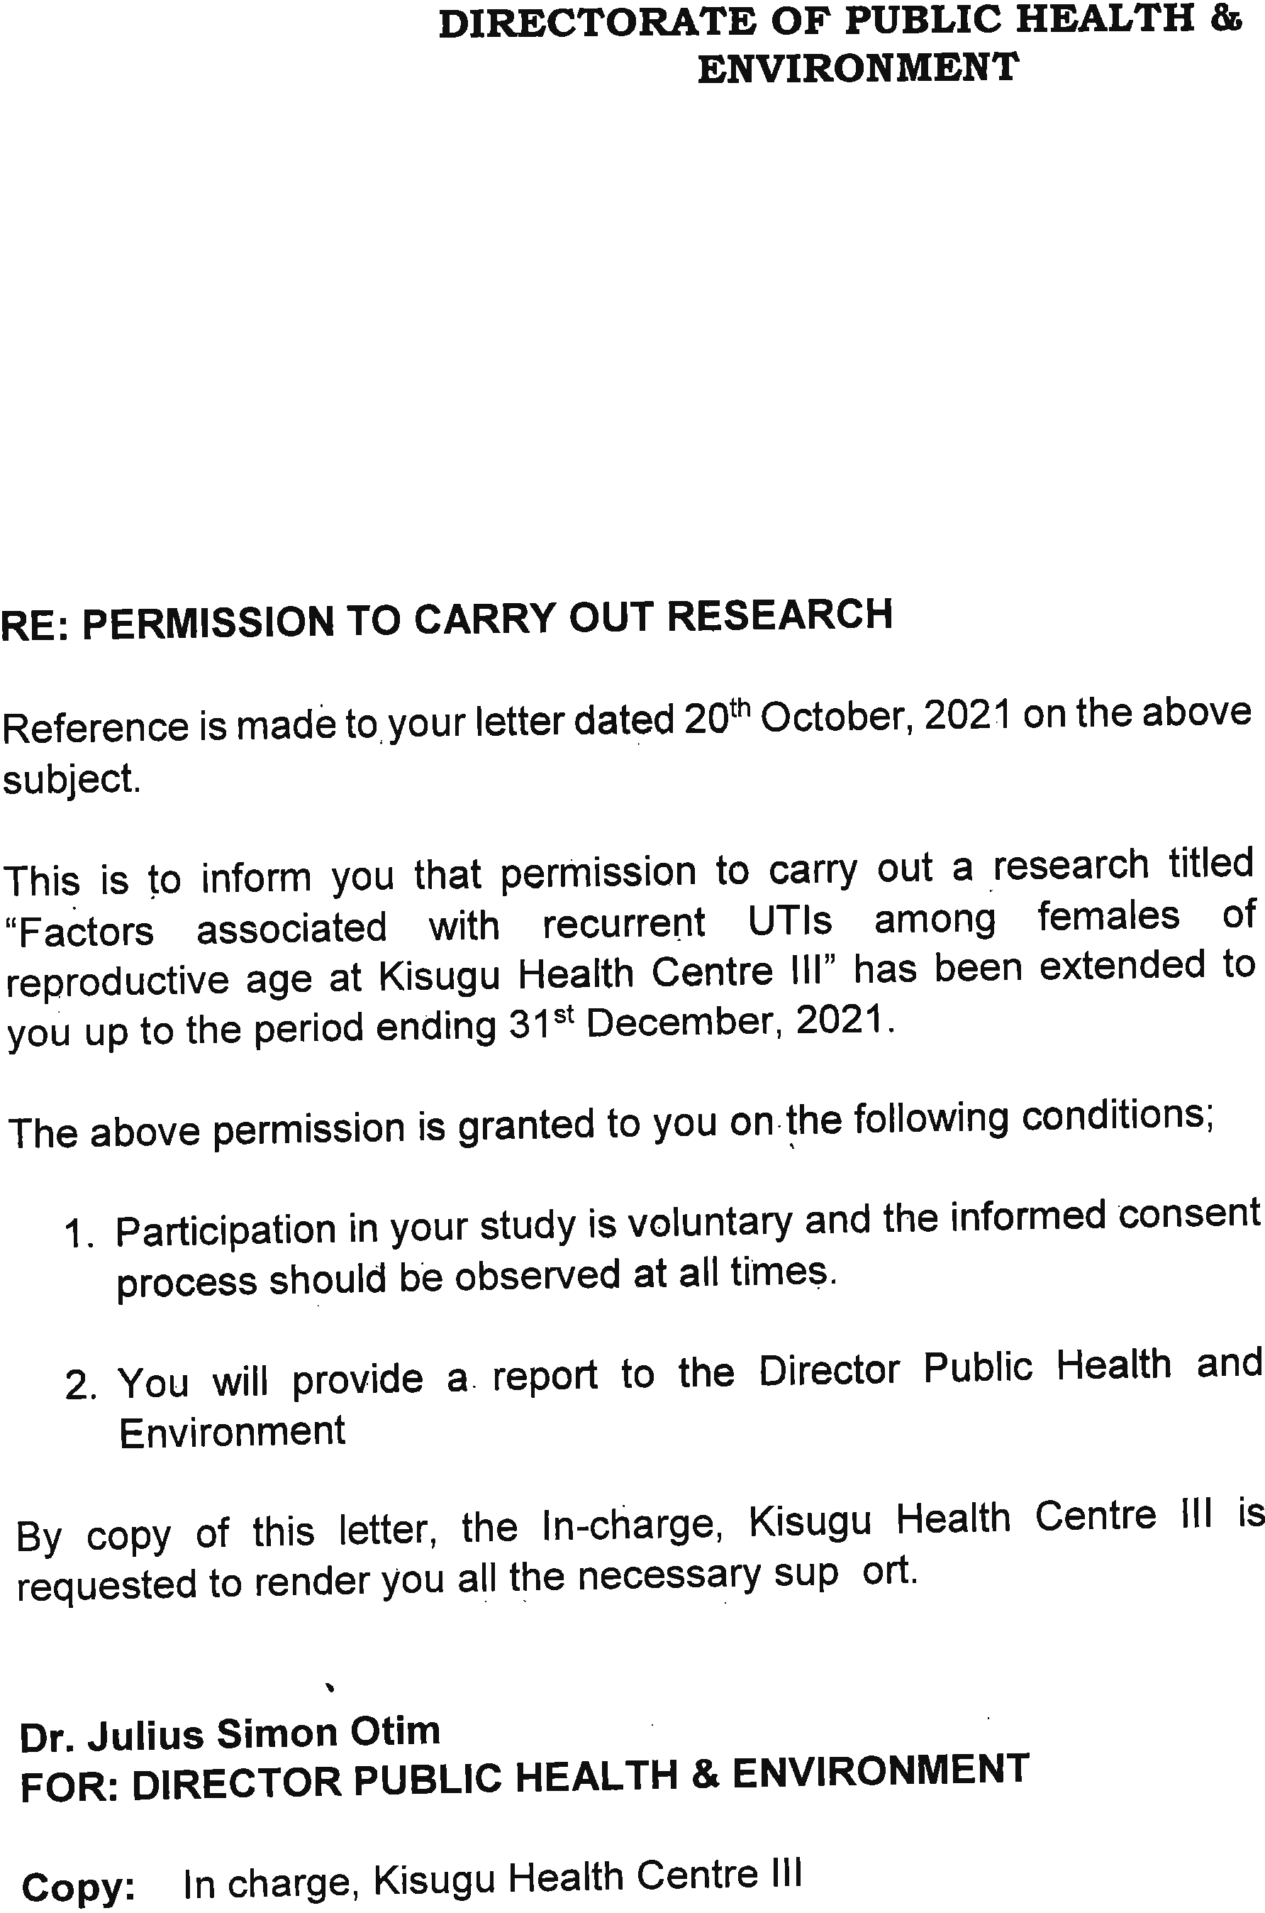


APPENDIX V: INTRODUCTORY LETTER

APPENDIX VI: RISK MANAGEMENT PLAN

Researcher: Kavuma Sharif
Research Topic: Factors associated with recurrent UTIs among females of reproductive age at Kisugu health Center III.
Introduction
The COVID-19 is a disease that is transmitted by people carrying the virus. The disease can be spread by person to person trough respiratory droplets expelled from the nose and mouth when a person coughs or sneezes. It can also be transmitted when humans have contact with hands or surfaces that contain the virus and touch their face, mouth or nose with the contaminated hands. There is currently no vaccine or treatment for COVID-19. Due to the rapidly increasing number of cases in the country, there is a great danger posed among communities to have cross infection from either symptomatic or asymptomatic individuals if mitigation or prevention measures are not well observed. The research team engaging study participants using face to face approach to collect data may be at high risk of infection which may potentially increase the risk of transmitting COVID-19 between study participants, their household members, participant to study staff and vice versa. This Plan is designed to ensure the health and safety of research teams, support staff, participants and community members against COVID-19. To ensure the protection of study participants and the research team, the following protocol will be observed;
- All persons involved in the study (principal investigator and research assistants) will put on masks and covering the mouth and the nose properly and consistently.
- All research assistant/s will be given alcohol-based sanitizer to be used during training and collection of data.
- Social distance of two meters will be maintained at all times during training of research assistants and during data collection.
- Study participants without masks will not be recruited in the study.
- No exchanging hands/sharing of pens, books and other items during data collection with the study participants.
- The research team will be trained on risk prevention and identification of COVID-19 disease symptoms prior to data collection.
- The study team will on a daily basis conduct reviews of risk prevention and management procedures based on need of risk awareness, identification, documentation and communication.

APPENDIX VII: MAP OF KISUGU


