Hepatitis B Vaccination Status and KAP towards Hepatitis B Virus among Medical Students at Green Hope University Branch of Beledweyne
*author: Abdirahman Jibril. Warsame, co-authors; Mohamed Farah Sabrie, Abdullahi Mohamed Ibrahim

Abstract
Background: Hepatitis B infection is a disease of the liver caused by the hepatitis B virus (HBV), which has a partially double stranded circular DNA and belongs to the family Hepadnaviridae [1, 2,3].
Study design: This was a descriptive cross-sectional study conducted on 270 medical students at green hope branch of beledweyne in Beledwein District, Somalia. A pretested structured questionnaire were adapted for data collection among medical students.
Result: Results indicate that there are 176 total responses, with 10 unique age groups and 2 unique genders of male and female. Out of the respondents, 65 have received at least one dose of the hepatitis B vaccine, while 111 have not been vaccinated. The mean value for "heard of HBV" is high (88.00%), indicating a general awareness of HBV among respondents. Knowledge of Transmission: There is a moderate understanding that HBV can be transmitted by blood and blood products, with a mean of 58.67 were aware of hepatitis.
Conclusion: High Awareness: Most respondents have heard of HBV (mean = 0.93) and know it can be transmitted by blood and blood products (mean = 0.91). Knowledge Gaps: There is a significant gap in understanding that HBV can affect organs other than the liver (mean = 0.48) and that it can be transmitted by contaminated water/food (mean = 0.44). Misconceptions: A low percentage correctly identified that HBV cannot be transmitted through skin contact (mean = 0.29).
Key words: knowledge attitude and practice, and vaccine status medical students.
Introduction
Hepatitis B virus (HBV) is a global health challenge, with an estimated 257 million chronic cases worldwide as of 2015. (5) Africa has the highest prevalence (6.1%) compared to less than 2% in developed countries.(6) In Somalia, the prevalence among children under five reached 11.06% in 2019. HBV is responsible for 80% of liver cancer cases and remains a significant cause of mortality, claiming 1.34 million lives in 2015 alone. (4, 4, 5)
Medical students and healthcare workers are at high risk for HBV due to occupational exposure. The risk of infection is heightened during clinical training, especially for less experienced medical students who may not strictly adhere to universal safety protocols. (7) Although safe and effective vaccines have been available since 1982, (8) Somalia has no mandatory vaccination or immunity checks for students entering medical programs.
This study aimed to assess the hepatitis B vaccination status and the knowledge, attitudes, and practices (KAP) regarding HBV among medical students at Green Hope University’s Beledweyne branch. The findings will help identify areas for improvement in student awareness, vaccination efforts, and preventive measures.
Materials and Methods
Study Design and Setting
A cross-sectional study was conducted in October 2024 at the Green Hope University branch in Beledweyne, targeting all medical students in the School of Health Science and Medicine. Green Hope University is a private institution with campuses across Somalia, including Beledweyne, the capital of the Hiran region. Beledweyne, located 340 km from Mogadishu and near the Ethiopian border, is a strategic city along the Shabelle River, with the Hiran region hosting Somalia’s largest livestock population (estimated at 5 million in 2018). According to the National Development Plan 9.
Data collection
Data were collected using a self-administered questionnaire in English, consisting of 30 questions across five sections: (1) Demographics, (2) HBV perception and vaccination status, (3) HBV knowledge, (4) Attitudes toward HBV, and (5) Practices regarding HBV. Participants were briefed on the study’s purpose and assured of anonymity and voluntary participation. To ensure clarity, questions were explained and translated as necessary.
Data analysis
The data were coded, entered, and analyzed using SPSS version 20.0 and Python. Ethical approval was obtained from the Institutional Ethical Review Board of the Faculty of Health Science and Medicine, Green Hope University, Beledweyne branch.
Data Collection
Data were collected using a self-administered questionnaire in English, consisting of 30 questions across five sections: (1) Demographics, (2) HBV perception and vaccination status, (3) HBV knowledge, (4) Attitudes toward HBV, and (5) Practices regarding HBV. Participants were briefed on the study’s purpose and assured of anonymity and voluntary participation. To ensure clarity, questions were explained and translated as necessary.
Data Analysis
The data were coded, entered, and analyzed using SPSS version 20.0 and Python. Ethical approval was obtained from the Institutional Ethical Review Board of the Faculty of Health Science and Medicine, Green Hope University, Beledweyne branch.
Results
HB Infection Perception and Hepatitis B Vaccination Status
The majority of respondents have heard of HBV, as indicated by the high count of "Yes" responses. There are significant gaps in understanding specific aspects of HBV, such as its transmission and effects on organs other than the liver.

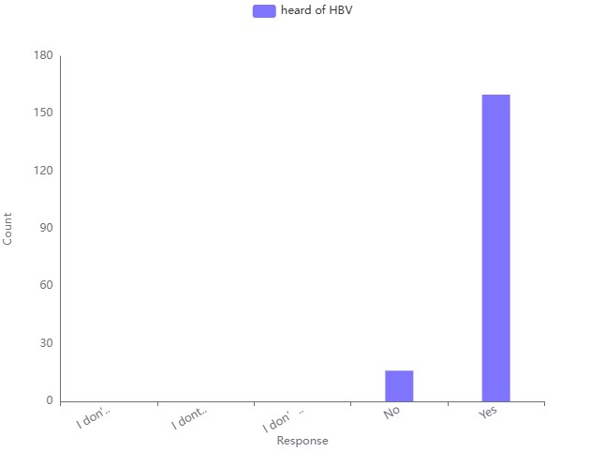
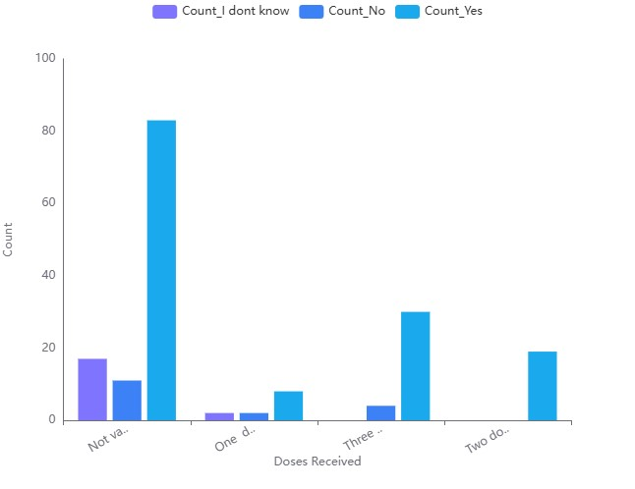
(a)
(b)
Figure 1 HB Infection Perception and Hepatitis B Vaccination Status

.

Figure 1: (a) shows a strong awareness of HBV, with most respondents acknowledging its existence. However, there are still some who are unsure or unaware. (b) Highlights the disparity in vaccination status, with a significant number of individuals not receiving any doses. Those who are vaccinated mostly receive three doses, indicating partial compliance with vaccination protocols.

Correlation of Demographic Factors with Vaccination Status

Age Correlation: The age group 20-22 shows a significant correlation with HB vaccine protection. Gender and Department Correlation: No significant gender differences, but departments like Medicine and Public Health show higher vaccination-related counts.

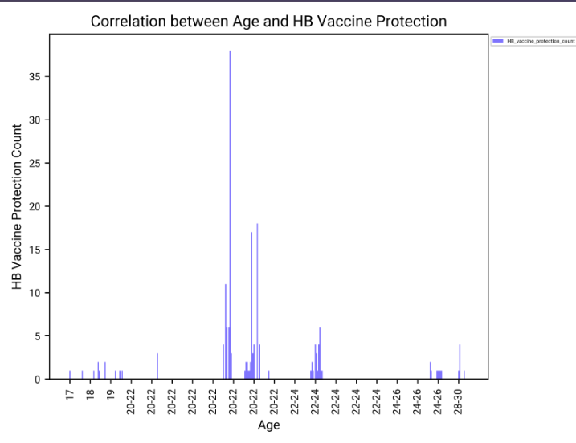
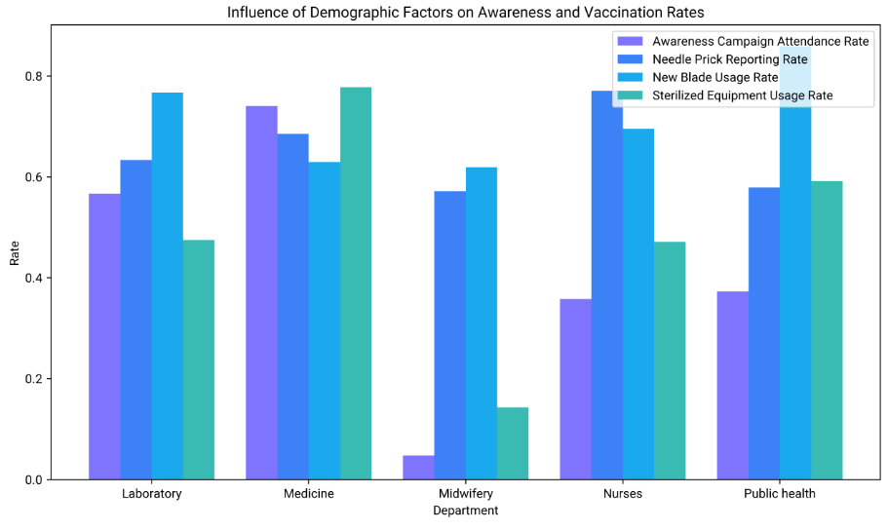
a
b

Figure 2 Correlation of Demographic Factors with Vaccination Status

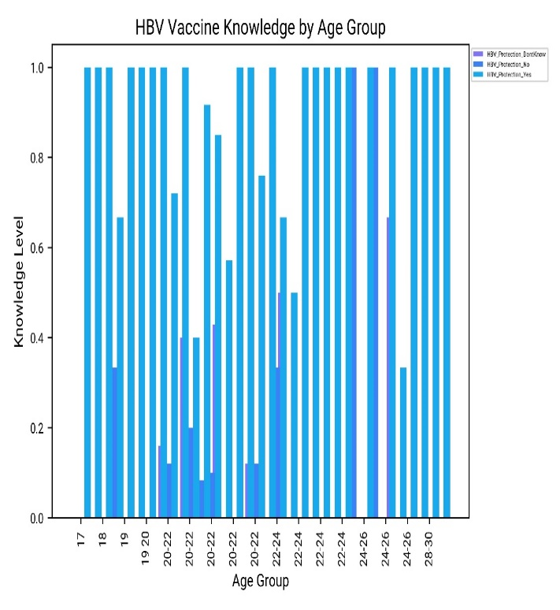
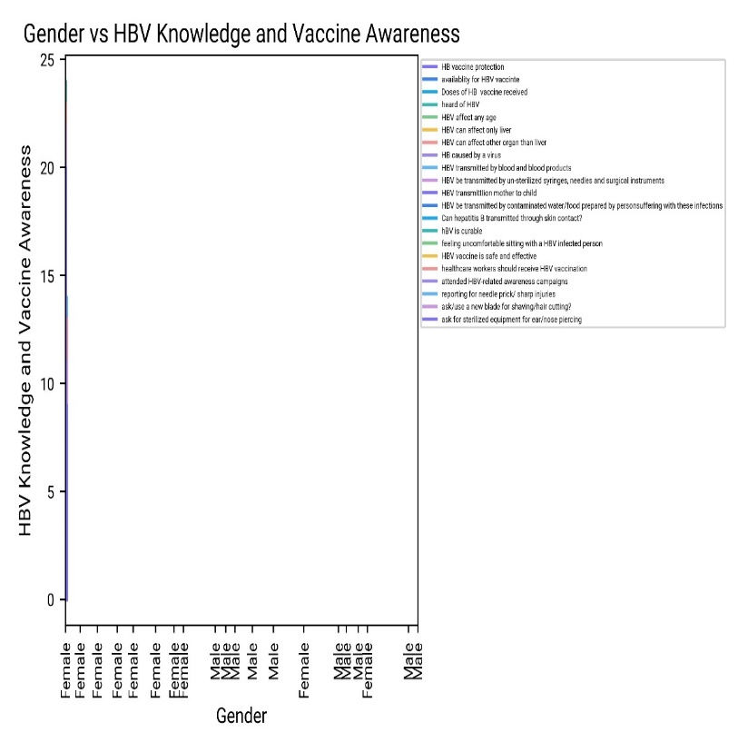
Figure 2: (a) Grouped Bar Chart Insights: Shows varying rates of awareness and vaccination practices across different departments, with Nurses and Public Health departments leading in most categories. (b) The bar chart highlights the age group 20-22 as having the highest HB vaccine protection count, indicating a focus on this age group for vaccination effort.
b
a

Figure 3: (a) This chart shows HBV Vaccine Knowledge by Age Group, with knowledge levels represented for different age ranges. The bars are categorized into three levels :(( 1) HBV Protection “Don’t Know” (dark blue): Represents those who are uncertain about the HBV vaccine’s protection. (2) HBV-Protection-No (light purple): Indicates respondents who believe the HBV vaccine does not provide protection. (3) HBV-Protection-Yes (light blue): Shows respondents who are aware that the HBV vaccine offers protection.
Figure 3 shows HBV Vaccine Knowledge by Age Group

(b) Gender Differences: The visualization shows minimal variation between genders in terms of HBV knowledge and vaccine awareness, indicating a general lack of awareness across both group
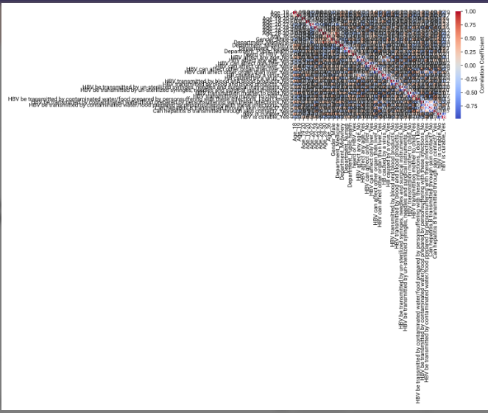
Figure 4 the heatmap shows a complex correlation pattern between demographic factors and perception-related
Figure 4: This heatmap displays a complex correlation matrix that visualizes the relationships between demographic factors and perception-related variables (such as knowledge, attitudes, and beliefs). Correlation values range between -1 and +1, indicating the strength and direction of the relationships between pairs of variables. Correlation Coefficients: Positive Correlation (+1 to 0): Indicates that as one variable increases, the other variable also tends to
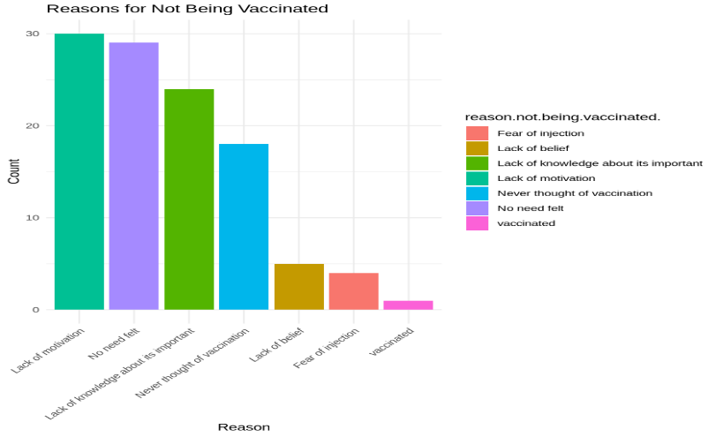
Increase. Example: If age positively correlates with vaccination knowledge, older individuals are more likely to have higher knowledge. Negative Correlation (0 to -1): Indicates that as one variable increases, the other variable tends to decrease. Example: If gender negatively correlates with fear of vaccination, one gender may have less fear than the other. Near Zero (0): Suggests little to no linear relationship between the variables.
Figure 5 the chart illustrates various reasons why individuals did not get vaccinated

Figure 5: Lack of motivation" (24%) and "No need felt" (22.4%) together account for nearly half of the reasons. Knowledge Gaps: Around 20% of individuals cited a lack of knowledge, which points to the need for educational campaigns. Minor Barriers: "Fear of injection" and "Lack of belief" are less common but still significant barriers for 14.4% of the population combined. Vaccination Coverage: Only 3.2% of the individuals surveyed reported being vaccinated, which indicates low uptake. These percentages provide a clearer view of where to prioritize public health efforts, such as addressing motivation and knowledge barriers to improve vaccination rates.
Discussion
Vaccination Rates by Age and Gender
A significant portion of unvaccinated individuals were in the younger age group (17–22). This suggests that vaccination efforts should focus on this demographic, which may face barriers such as insufficient knowledge or motivation.
Reasons for not being vaccinated
Key reasons for non-vaccination included: Lack of awareness about the importance of vaccination. Low motivation to seek vaccination. Never considering vaccination.
Educational campaigns should target these barriers by raising awareness, boosting motivation, and addressing common misconceptions.
Correction patterns
The study highlighted strong correlations between demographic factors and perceptions. For example:
Older respondents tended to have better vaccination knowledge and more positive attitudes toward vaccination. Gender differences influenced perceptions such as fear of injections.
Efforts to increase vaccination rates should be data-driven, addressing these correlations by tailoring educational strategies to specific demographics.
KAP (Knowledge, Attitude, and Practice) Differences
Clear differences were observed in KAP responses between vaccinated and unvaccinated individuals. Higher knowledge and positive attitudes were linked to better vaccination practices. Programs should aim to: Improve knowledge by addressing misinformation. Promote positive attitudes by emphasizing vaccine safety and importance. This approach could lead to better vaccination uptake and reduced vaccine hesitancy among medical students.

Key Findings from the Study
- High Awareness but Significant Knowledge Gaps
  - Awareness: The study found that 88.6% of respondents had heard of HBV, indicating a strong general awareness of the virus.
  - Knowledge Gaps: However, there were significant misconceptions about HBV transmission and its effects. For example, only 48% of respondents knew that HBV could affect organs other than the liver, and 44% incorrectly believed it could be transmitted through contaminated food or water.
- Low Vaccination Rates
  - Out of 176 respondents, only 65 (37%) had received at least one dose of the hepatitis B vaccine.
  - The primary reasons for not getting vaccinated included a lack of motivation (24%), feeling no need for vaccination (22.4%), and insufficient knowledge about the vaccine (20%).
- Demographic Insights
  - Younger students (aged 17–22) were less likely to be vaccinated, highlighting the need for targeted vaccination campaigns for this age group.
  - Gender differences in vaccination rates were minimal, but fear of injections was a slightly more common barrier among female students.
- Correlation Between Knowledge and Vaccination
  - Students with higher knowledge levels and positive attitudes toward HBV were more likely to be vaccinated. This underscores the importance of educational campaigns to address misinformation and promote vaccine uptake.
Conclusion
This study revealed a concerning number of unvaccinated medical students and highlighted gaps in their knowledge about HBV. There is a critical need to improve education on the risks of HBV and the importance of vaccination. It is recommended that the Green Hope University branch of Beledweyne revise its curriculum to enhance awareness among medical students about HBV and vaccination.
Education plays a vital role as students contribute to community awareness about viral hepatitis. Therefore, greater efforts should be made to educate students on HBV prevention and how to seek care when exposed to the virus. Green Hope University should also participate in national and international discussions on hepatitis prevention to contribute to broader public health initiatives.
Providing free HBV vaccines to all unvaccinated students could encourage universal vaccination among medical students. Future research should focus on measuring anti-HBs levels and evaluating vaccine efficacy to further improve vaccination programs.
This study highlights the critical need to address HBV awareness and vaccination among medical students. By taking proactive steps, we can reduce the burden of HBV and protect the health of future healthcare professionals.
Medical students are on the frontlines of healthcare delivery, and their exposure to HBV during clinical training poses a significant risk. The low vaccination rates and knowledge gaps identified in this study highlight the urgent need for:
- Enhanced Education: Integrating comprehensive HBV education into medical curricula to address misconceptions and improve awareness.
- Vaccination Programs: Providing free or subsidized HBV vaccines to all medical students to ensure universal coverage.
- Public Health Campaigns: Raising awareness about the importance of vaccination and addressing barriers such as fear of injections and lack of motivation.
Confect of interests
The authors declare no conflicts of interest regarding the publication of this paper.
Acknowledgments
The authors extend their gratitude to the students who participated in the study and assisted with data collection.
References
- Carman, W. F., & Thomas, H. C. (1992). Genetic variation in hepatitis B virus. Gastroenterology, 102(2), 711–719.
- Gitlin, N. (1997). Hepatitis B: diagnosis, prevention, and treatment. Clinical Chemistry, 43(8), 1500–1506.
- Zuckerman, A. J. (1999). More than a third of the world’s population has been infected with hepatitis B virus. British Medical Journal, 318(7192), 1213.
- World Health Organization. (1996). The world health report 1996: Fighting disease, fostering development. Executive Summary, Geneva, Switzerland.
- Alter, M. J. (2003). Epidemiology and prevention of hepatitis B. Seminars in Liver Disease, 23(1), 39–46.
- Lavanchy, D. (2004). Hepatitis B virus epidemiology, disease burden, treatment, and current and emerging prevention measures. Journal of Viral Hepatitis, 11(2), 97–107.
- Sun, Z., Ming, L., Zhu, X., & Lu, J. (2002). Prevention and control of hepatitis B in China. Journal of Medical Virology, 67(3), 447–450.
- Alter, M. J., Ahtone, J., Weisfuse, I., et al. (1986). Hepatitis B virus transmission between heterosexuals. The Journal of the American Medical Association, 256(10), 1307–1310.
- Kingsley, L. A., Rinaldo, C. R. Jr., Lyter, D. W., et al. (1990). Sexual transmission efficiency of hepatitis B virus and HIV among homosexual men. The Journal of the American Medical Association, 264(2), 230–234.
- Beasley, R. P., Trepo, C., Stevens, C. E., & Szmuness, W. (1977). The e antigen and vertical transmission of hepatitis B surface antigen. The American Journal of Epidemiology, 105(2), 94–98.
- Kane, A., Lloyd, J., Zaffran, M., Simonsen, L., & Kane, M. (1999). Transmission of hepatitis B, hepatitis C, and HIV through unsafe injections in developing regions: Model-based regional estimates. Bulletin of the World Health Organization, 77(10), 801–807.
- Broers, B., Junet, C., Bourquin, M., et al. (1998). Prevalence and incidence rates of HIV, hepatitis B, and hepatitis C among drug users on methadone maintenance in Geneva (1988–1995). AIDS, 12(15), 2059–2066.
- Vegnente, A., Iorio, R., Guida, S., & Cimmino, L. (1992). Chronic hepatitis B infection in families of hepatitis B surface antigen-positive chronic carriers. European Journal of Pediatrics, 151(3), 188–191.
- Lauer, J. L., Van Drunen, N. A., Washburn, J. W., & Balfour, H. H. Jr. (1979). Transmission of hepatitis B virus in clinical laboratory settings. Journal of Infectious Diseases, 140(4), 513–516.
- Hu, D. J., Kane, M. A., & Heymann, D. L. (1991). Transmission of HIV, hepatitis B, and bloodborne pathogens in healthcare settings: Review of risk factors and prevention guidelines. Bulletin of the World Health Organization, 69(5), 623–630.
- Fernandes, J. F., Braz, R. F. S., Neto, F. A. V., et al. (1999). Serologic markers of hepatitis B virus prevalence among hospital personnel. Revista de Saúde Pública, 33(2), 122–128.
- Colombo, M., Oldani, S., Donato, M. F., et al. (1987). A multicenter study of post-transfusion hepatitis in Milan. Hepatology, 7(4), 709–712.
- Saxena, R., Thakur, V., Sood, B., et al. (1999). Transfusion-associated hepatitis in a tertiary hospital in India: A prospective study. Vox Sanguinis, 77(1), 6–10.
- Williams, S. V., Huff, J. C., Feinglass, E. J., et al. (1974). Epidemic hepatitis B among hospital personnel. The American Journal of Medicine, 57(6), 904–911.
- Mioli, V. A., Balestra, E., Bibiano, L., et al. (1992). Viral hepatitis epidemiology in dialysis centers: A national survey. Nephron, 61(3), 278–283.
- Prüss-Üstün, A., Rapiti, E., & Hutin, Y. (2005). Estimation of the global burden of disease due to contaminated sharps injuries among healthcare workers. The American Journal of Industrial Medicine, 48(6), 482–490.
- Gerberding, J. L. (1994). Incidence and prevalence of HIV, hepatitis B, hepatitis C, and cytomegalovirus among healthcare personnel at risk for blood exposure: Final report from a longitudinal study. Journal of Infectious Diseases, 170(6), 1410–1417.
- World Health Organization. (2013). Global policy report on the prevention and control of viral hepatitis in WHO Member States. Geneva, Switzerland.
- McMahon, B. J., Alward, W. L. M., Hall, D. B., et al. (1985). Acute hepatitis B infection: Relation of age to clinical disease expression and subsequent carrier state development. Journal of Infectious Diseases, 151(4), 599–603.
- Hyams, K. C. (1995). Risks of chronicity following acute hepatitis B infection: A review. Clinical Infectious Diseases, 20(4), 992–1000.
- Ikeda, K., Saitoh, S., Suzuki, Y., et al. (1998). Disease progression and hepatocellular carcinoma in patients with chronic viral hepatitis: Prospective observation of 2,215 patients. Journal of Hepatology, 28(6), 930–938.
- Beasley, R. P., & Hwang, L. Y. (1991). Overview of hepatocellular carcinoma epidemiology. In Hollinger, F. B., Lemon, S. M., & Margolis, H. S. (Eds.), Viral Hepatitis and Liver Disease: Proceedings of the International Symposium on Viral Hepatitis and Liver Disease: Contemporary Issues and Future Prospects (pp. 532–535). Baltimore, MD: Williams & Wilkins.
- Perz, J. F., Armstrong, G. L., Farrington, L. A., Hutin, Y. J. F., & Bell, B. P. (2006). The contributions of hepatitis B and C infections to cirrhosis and primary liver cancer worldwide. Journal of Hepatology, 45(4), 529–538.
- Hepatitis B Vaccine. (2009). Hepatitis B Foundation. Doylestown, PA, USA.
- Al Ghamdi, S. S., Fallatah, H. I., Fetyani, D. M., Al-Mughales, J. A., & Gelaidan, A. T. (2013). Long-term efficacy of hepatitis B vaccine in high-risk groups. Journal of Medical Virology, 85(9), 1518–1522.
- Gong Y, Brok J, Boxall EH, Gluud C. A Cochrane review from 2006 evaluated the effectiveness of hepatitis B vaccination for newborns born to mothers who are hepatitis B surface antigen-positive. Published in the Cochrane Database of Systematic Reviews (Issue 2), Art. No.: CD004790, DOI:10.1002/14651858.CD004790.pub2.
- Koria B, Lala MK. A study in 2012 examined knowledge, attitudes, and practices regarding hepatitis B infection among laboratory technicians at Civil Hospital, Ahmedabad, Gujarat. Published in Healthline, 3(1):63-65.
- Asadpour M, Arabbaniassad F, Bidaki R, Moazzeni V, Shabani Z, Sayadi A. A 2011 study assessed knowledge, attitudes, and practices about hepatitis B among patient porters in Rafsanjan's hospitals. Published in GMJ, 1(2):60-65.
- Haq NU, Hassali MA, Shafie AA, Saleem F, Farooqui M, Aljadhey H. In 2012, a cross-sectional study evaluated knowledge, attitudes, and practices about hepatitis B among the population of Quetta, Pakistan. Published in BMC Public Health, 12:692.
- Othman SM, Saleh MA, Shabila NP. A 2013 study assessed hepatitis B infection knowledge among medical students in Erbil City, Iraq. Published in ESJ, 3:299-305.
- Saravanan S, Velu V, Nandakumar S, Madhavan V, Shanmugasundaram U, Murugavel KG, et al. A 2009 study investigated dual hepatitis B and C virus infections in chronic liver disease patients. Published in J Microbiol Immunol Infect, 42(2):122-128.
- Mesfin YM, Kibret KT. A 2013 study assessed knowledge and practices related to hepatitis B among medical and health science students at Haramaya University, Ethiopia. Published in PLoS ONE, 8(11):e79642, DOI:10.1371/journal.pone.0079642.
- Mohamed R, Ng CJ, Tong WT, Abidin SJ, Wong LP, Low WY. A 2012 study investigated knowledge, attitudes, and practices of individuals with chronic hepatitis B attending a hepatology clinic in Malaysia. Published in BMC Public Health, 12:601.

