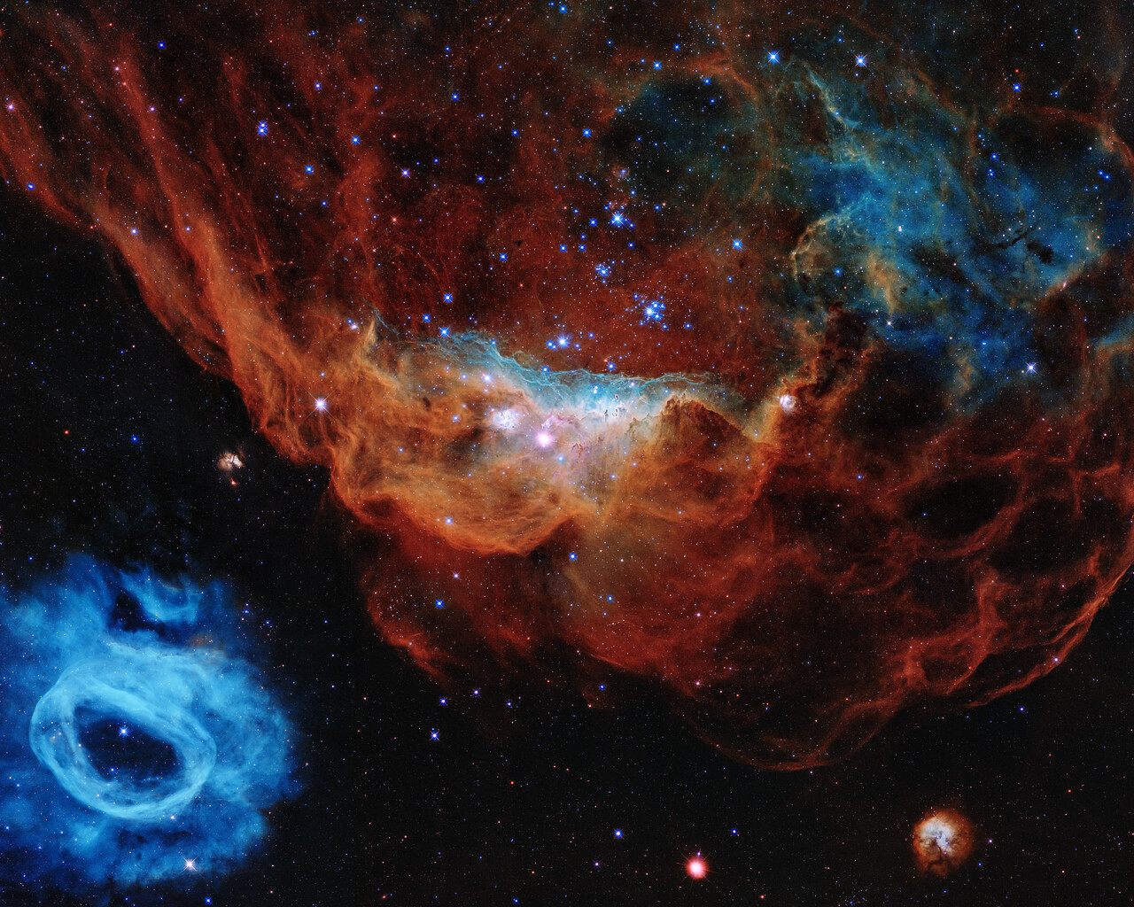

This image is one of the most photogenic examples of the many turbulent stellar nurseries the NASA/ESA Hubble Space Telescope has observed during its 30-year lifetime. The portrait features the giant nebula NGC 2014 and its neighbour NGC 2020 which together form part of a vast star-forming region in the Large Magellanic Cloud, a satellite galaxy of the Milky Way, approximately 163 000 light-years away.
Credit:
NASA, ESA, and STScI
Empirical Observation: In the Tapestry of Blazing Star birth, anarchy=0 is empirically and observationally true. As you can, no supreme physical authority or supreme physical force is observed. It is important to distinguish between constancy and supremacy. Unlike constancy, supremacy is simply omnipotence. As you can see, omnipotence is not observed in the picture. That is how anarchy=0 has been concluded. Anarchy=0 is not only the ordering principle of the tapestry, but its coded origin. You will understand through the other 100 pictures why I consider it the code of everything that is physical, measurable, and observable, and experimental. The physical axiom is falsifiable as long as someone finds a system where omnipotence is observable. Authority is simply defined here as force. Anarchy is defined as the absence of an absolute authority with absolute power or the absence of an omni-force, a force which is physically supreme; a force that we physically experience and see.
My aim in this paper is only to prove the physical observable, the simple, and the coherent. Anarchy=0 is my sole aim in this paper. To observe it, to test it, to measure it, and certainly to see how beautiful, simple, and consistent it is throughout this adventure of telescopic observations and listings.

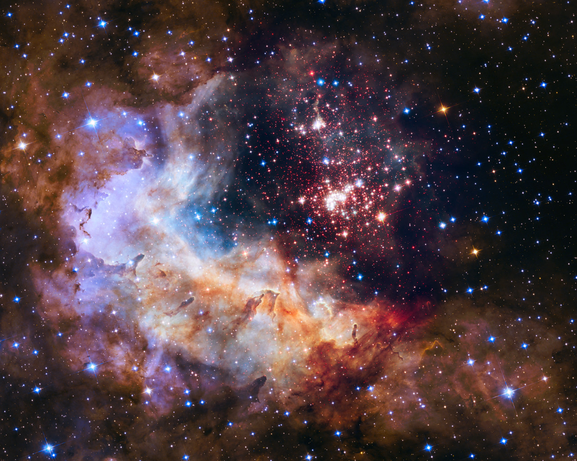

As all images are credited by NASA, it is important to credit them for taking the images. In the Westernlund 2 image, the same pattern of experimental and observational thought can be perceived. Anarchy is not metaphorical, metaphysical, or existential, it is simply real.

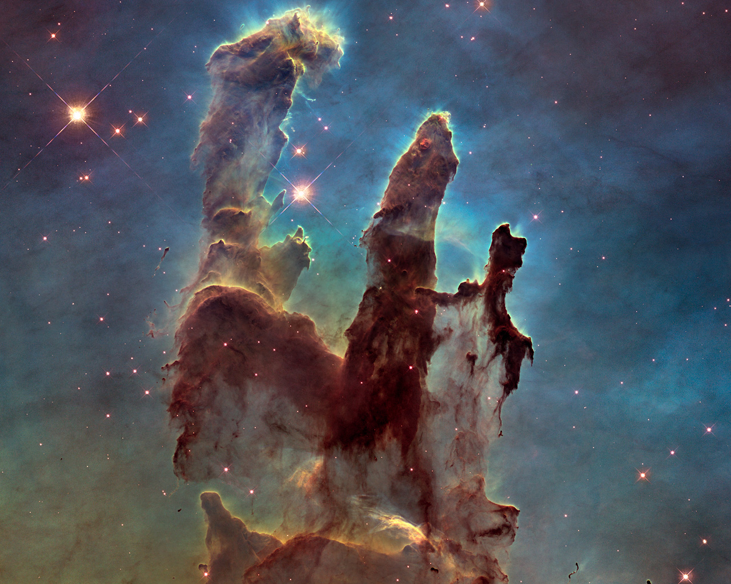

Amidst the pillars as seen in visible light, capturing the multi-coloured glow of gas clouds, wispy tendrils of dark cosmic dust, and the rust-coloured elephants’ trunks of the nebula’s famous pillars, we can see why anarchy=0.

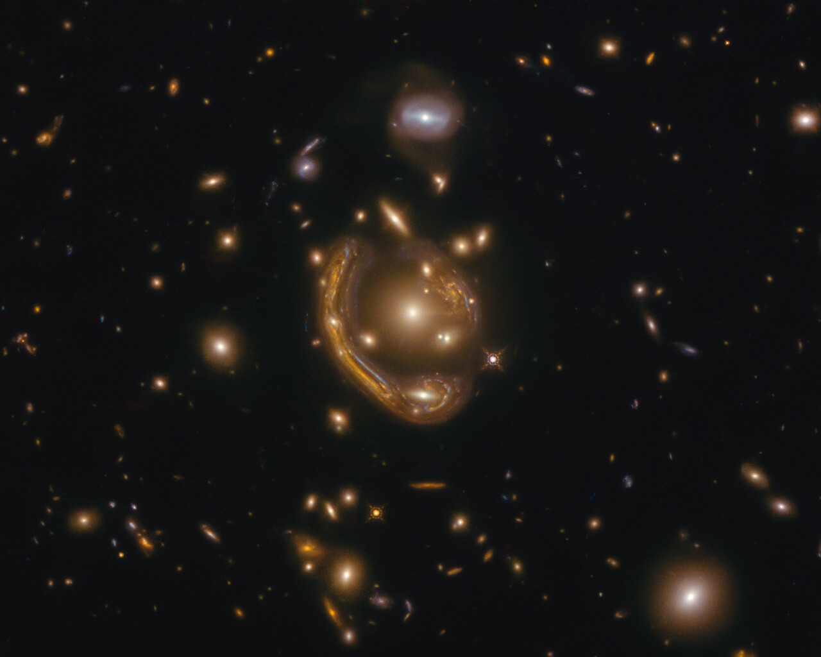

In the picture of general relativity and gravitational lensing, anarchy=0 is also observed. As no omni-force or authority is seen by the eye, we can confirm anarchy=0. Authority is simply defined here.

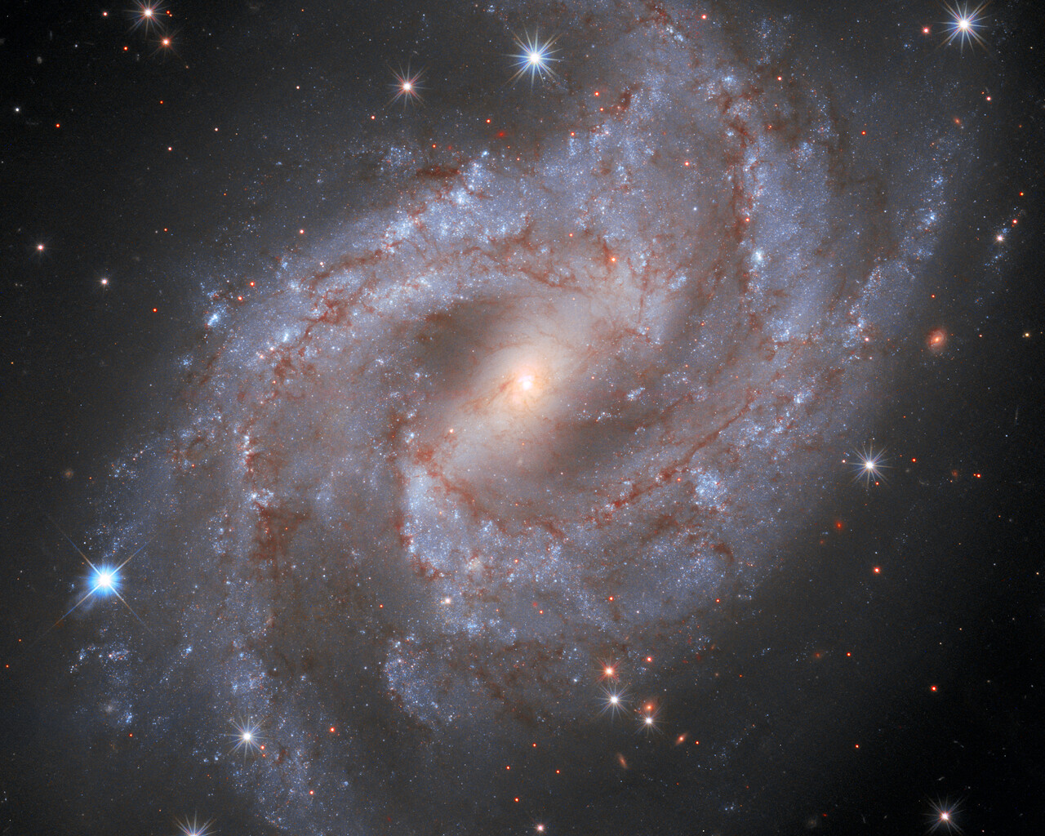

We observe: Anarchy=0.

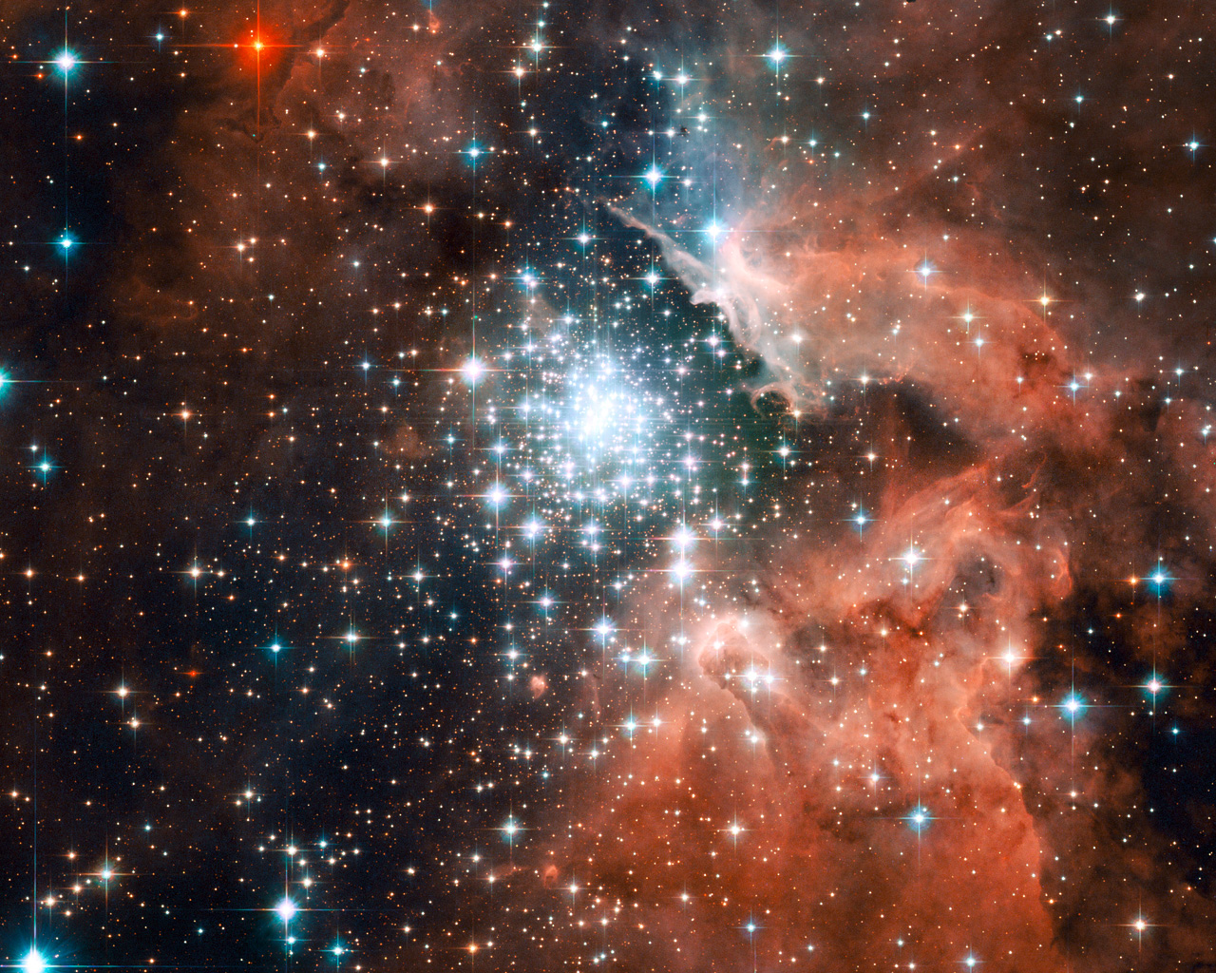

I don’t think it is hard to observe why anarchy=0 is a true physical axiom in the picture or in the following pictures.

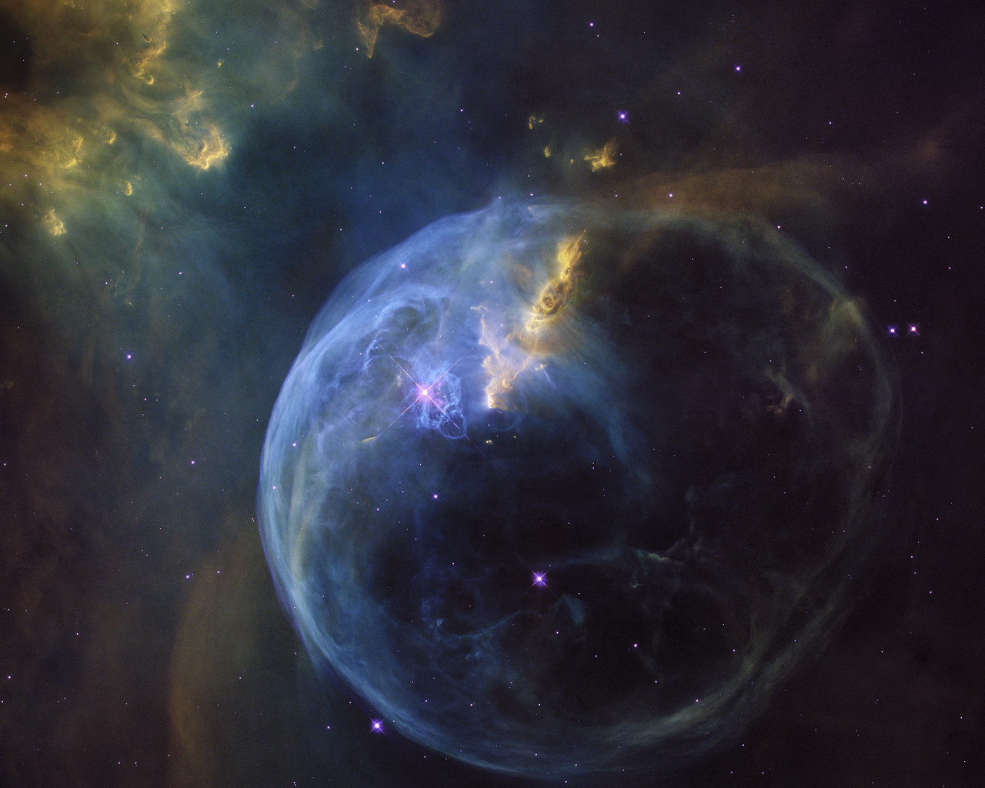

Same here. Anarchy=0.

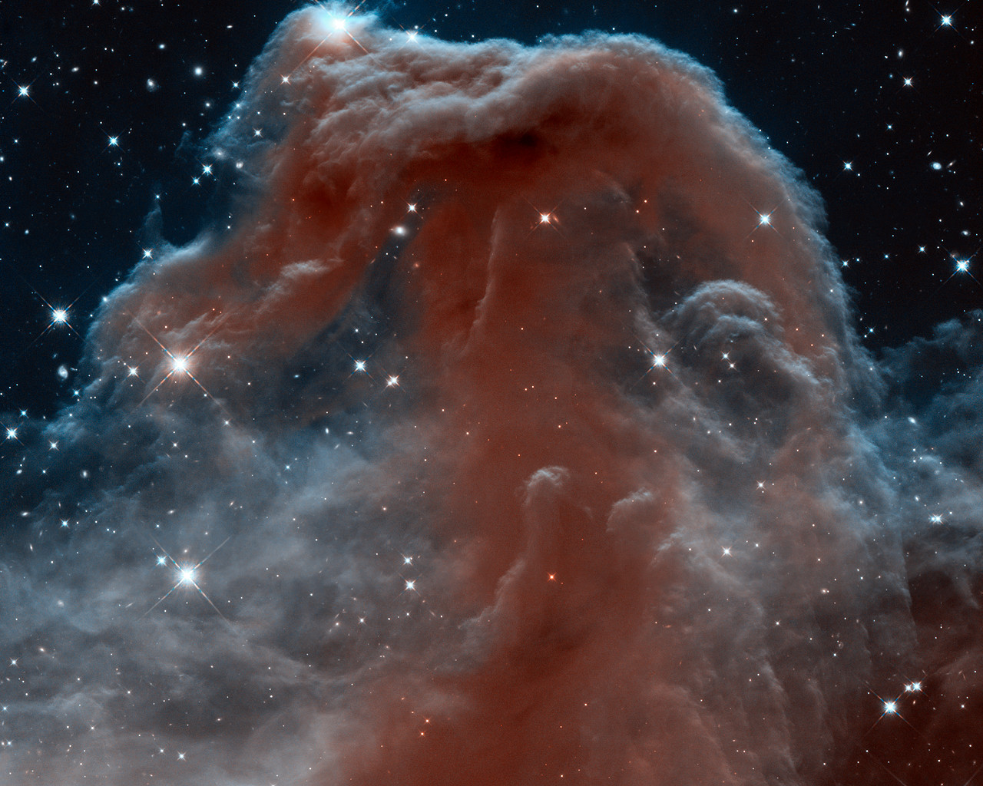

Same here.

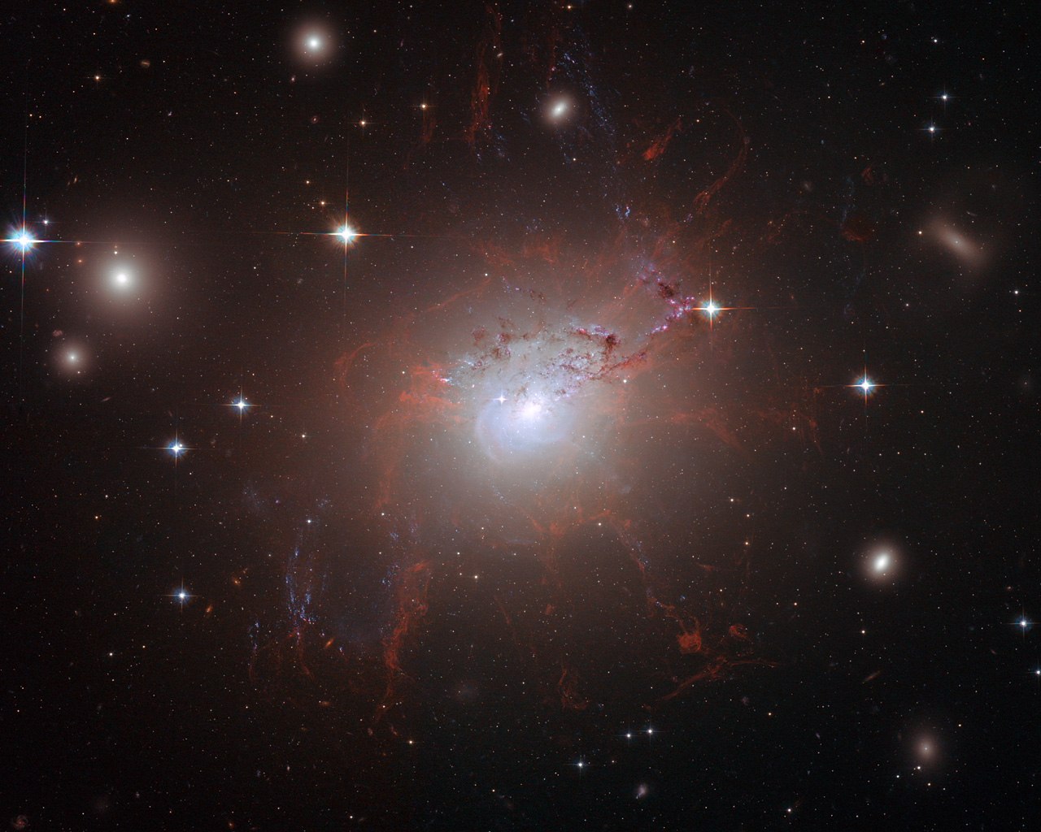

Same.

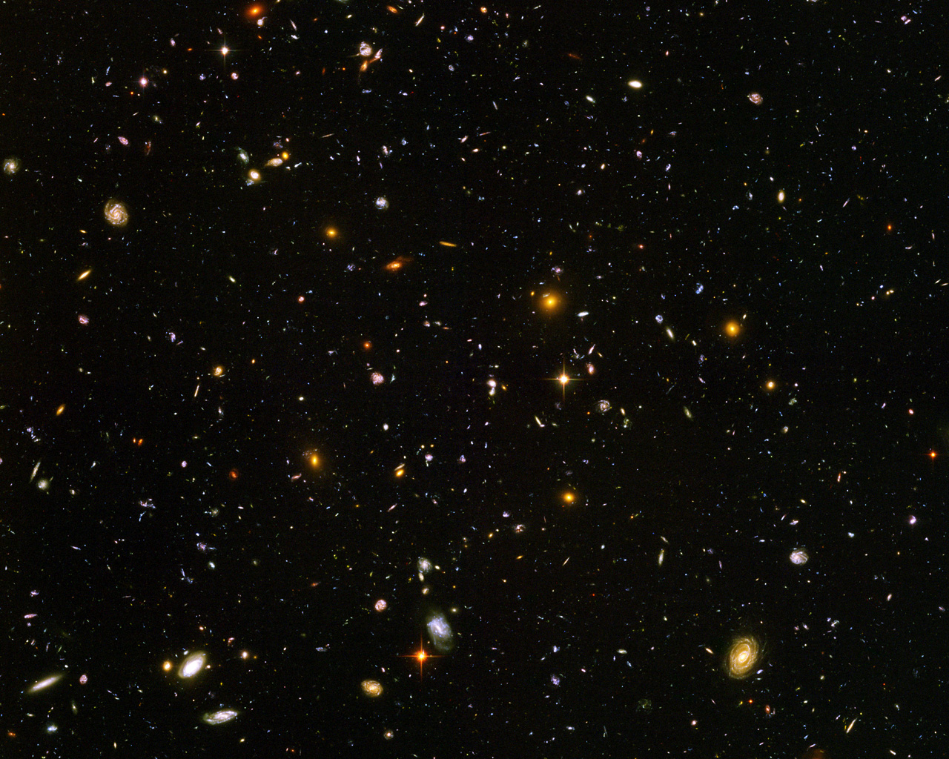

Same.

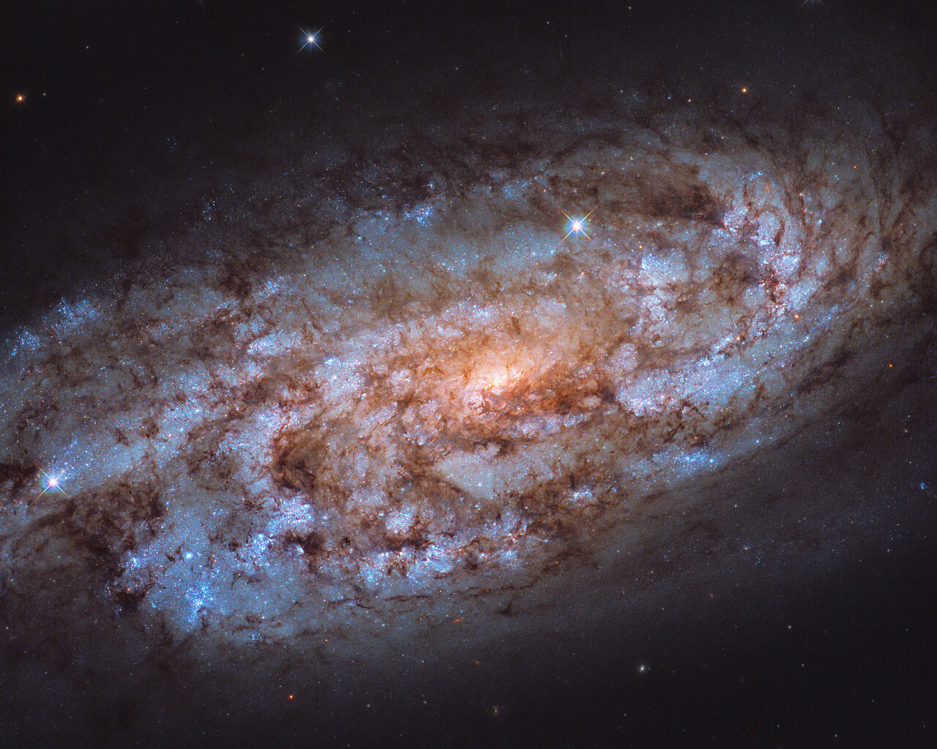

Same.

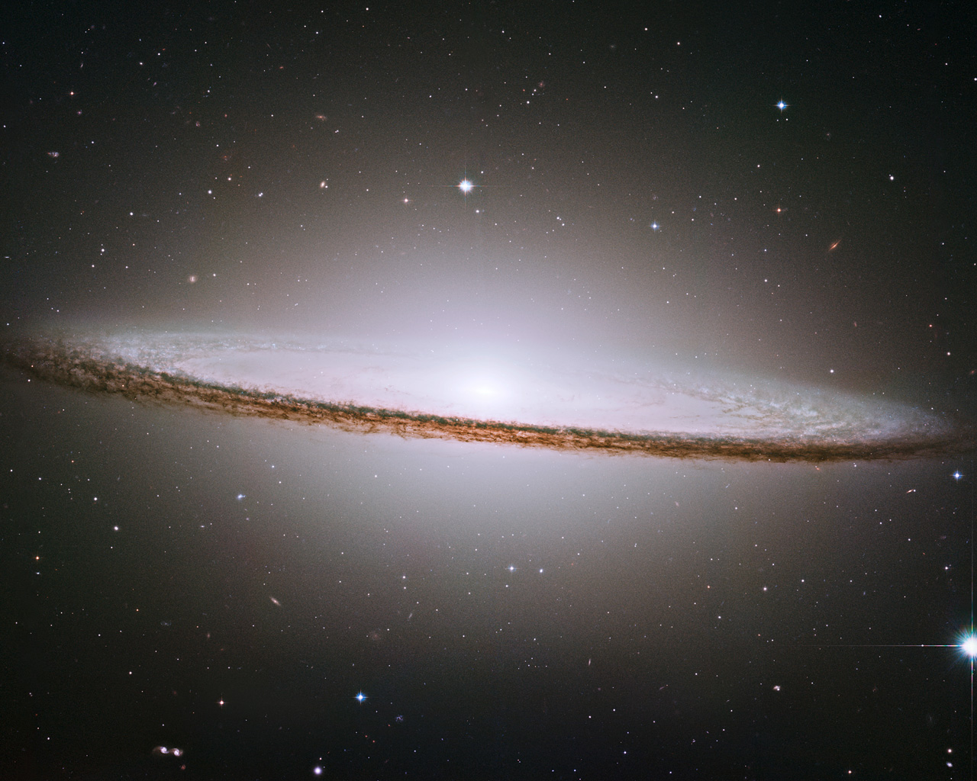

Same.

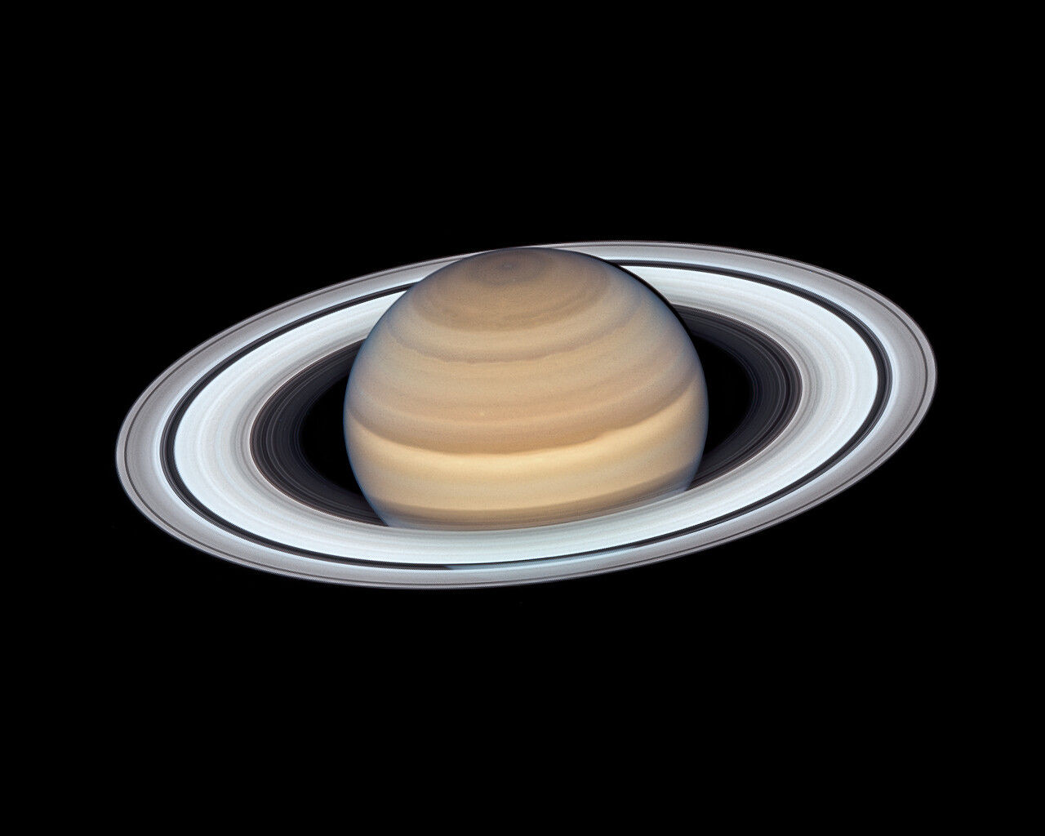

Same.

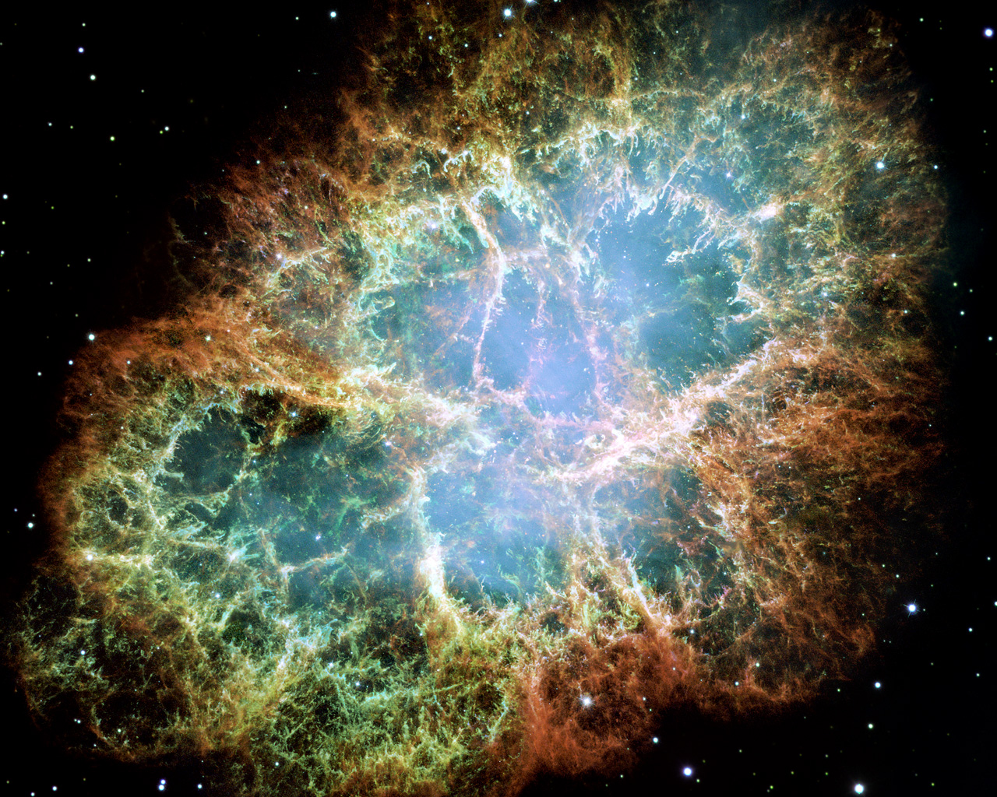

Even the Crab Nebula falls victim to the mathematical physical law.
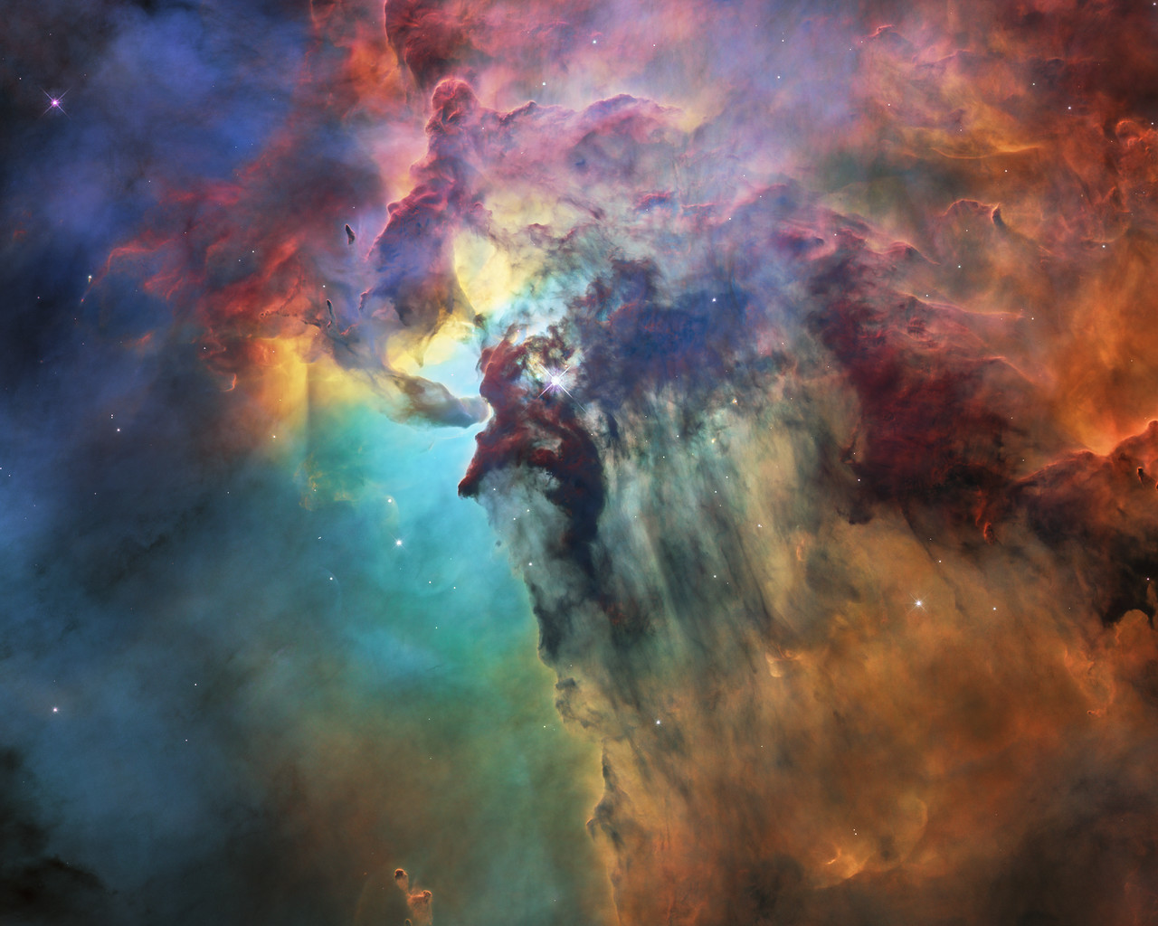

Same.
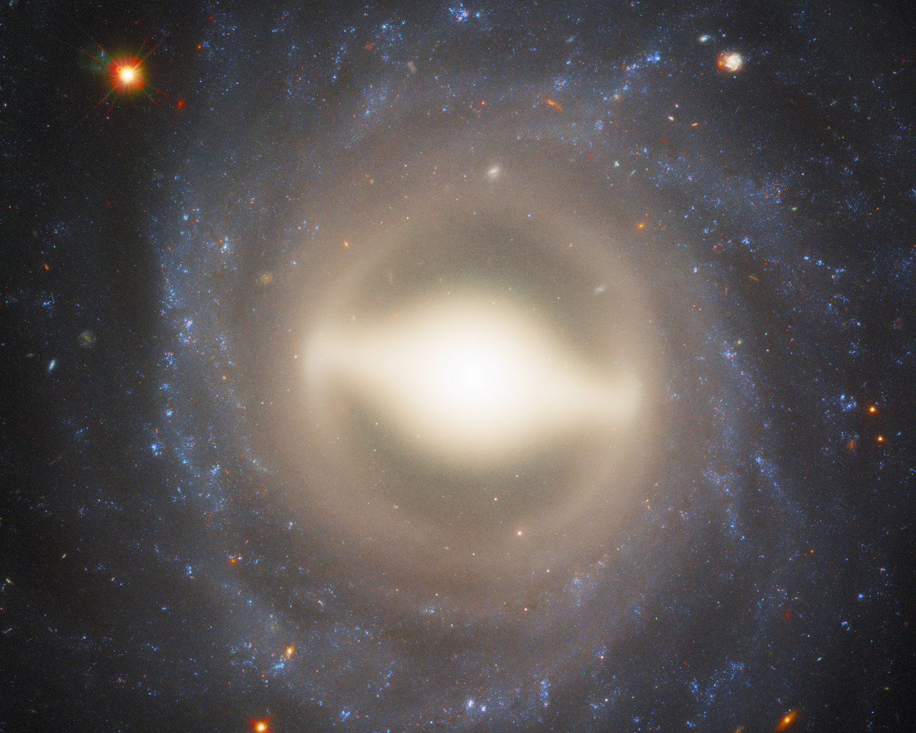

Even the spirals and supernova.

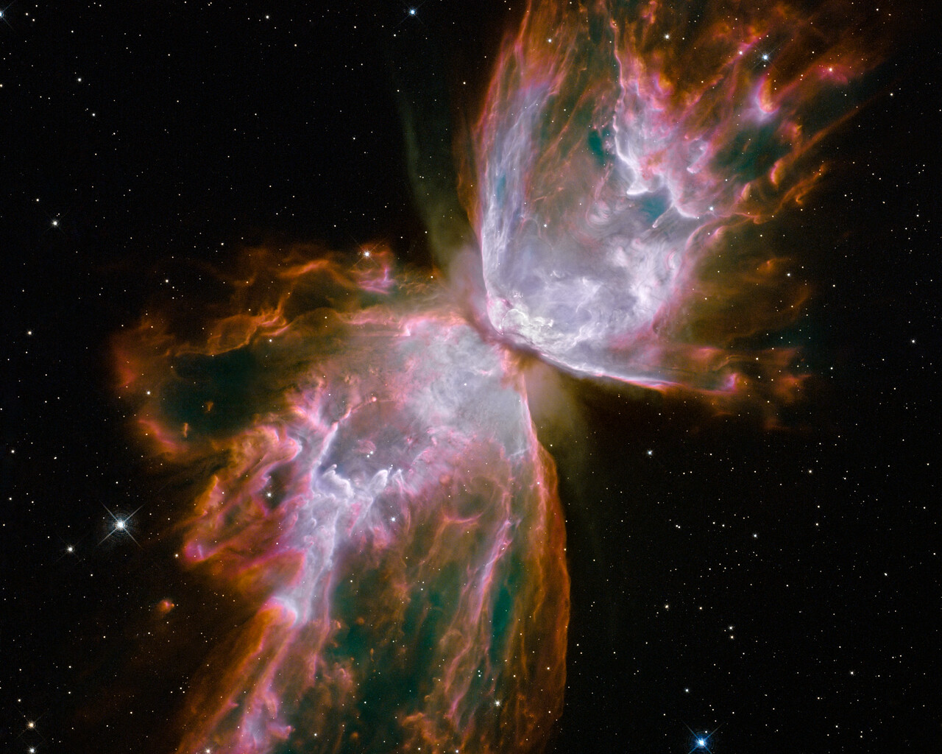

Anarchy=0 is true.

There are many pictures in which you can test the physical, observable, and measurable law. The other pictures are manifestations of the same physically grounded logic.

https://esahubble.org/images/archive/top100/. These pictures are shared by ESA/HUBBLE. They are also co-credited by NASA.

